UNITED STATES
SECURITIES AND EXCHANGE COMMISSION
WASHINGTON, D.C. 20549

FORM 8-K

Current Report
Pursuant to Section 13 or 15(d)
of the Securities Exchange Act of 1934

Date of Report (date of earliest event reported):
May 1, 2026

TPG Inc.
(Exact name of registrant as specified in its charter)

Delaware |  |  |  |  |  | 001-41222 |  |  | 87-2063362
(State or other jurisdiction  of incorporation) |  |  |  |  |  | (Commission File Number) |  |  | (IRS Employer  Identification No.)
301 Commerce Street, Suite 3300 |  |  |  |  |  |  |  |  | 76102
Fort Worth, TX |  |  |  |  |  |  |  |  | (Zip Code)
(817) 871-4000
(Registrant’s telephone number, including area code)

Not Applicable
(Former Name or Former Address, if Changed Since Last Report)

Check the appropriate box below if the Form 8-K filing is intended to simultaneously satisfy the filing obligation of the registrant under any of the following provisions:
☐ Written communications pursuant to Rule 425 under the Securities Act (17 CFR 230.425)
☐ Soliciting material pursuant to Rule 14a-12 under the Exchange Act (17 CFR 240.14a-12)
☐ Pre-commencement communications pursuant to Rule 14d-2(b) under the Exchange Act (17 CFR 240.14d-2(b))
☐ Pre-commencement communications pursuant to Rule 13e-4(c) under the Exchange Act (17 CFR 240.13e-4(c))

Securities registered pursuant to Section 12(b) of the Act:
Title of each class |  |  |  |  |  | Trading Symbol(s) |  |  |  |  |  | Name of each exchange on which registered
Class A common stock |  |  |  |  |  | TPG |  |  |  |  |  | The Nasdaq Stock Market LLC  (Nasdaq Global Select Market)
6.950% Subordinated Notes due 2064 |  |  |  |  |  | TPGXL |  |  |  |  |  | The Nasdaq Stock Market LLC  (Nasdaq Global Market)
Indicate by check mark whether the registrant is an emerging growth company as defined in Rule 405 of the Securities Act of 1933 (§230.405 of this chapter) or Rule 12b-2 of the Securities Exchange Act of 1934 (§240.12b-2 of this chapter).
Emerging growth company ☐
If an emerging growth company, indicate by check mark if the registrant has elected not to use the extended transition period for complying with any new or revised financial accounting standards provided pursuant to Section 13(a) of the Exchange Act. ☐

Item 2.02 Results of Operations and Financial Condition.
On May 1, 2026, TPG Inc. issued a summary press release and a detailed earnings presentation announcing financial results for its first quarter ended March 31, 2026. The summary press release and the earnings presentation are furnished as Exhibits 99.1 and 99.2, respectively, to this report.
As provided in General Instruction B.2 of Form 8-K, the information in this Item 2.02 and Exhibits 99.1 and 99.2 incorporated in this Form 8-K shall not be deemed to be “filed” for purposes of Section 18 of the Securities Exchange Act of 1934, as amended (the “Exchange Act”), or otherwise subject to the liabilities of that section, nor shall such information or Exhibits 99.1 and 99.2 be deemed to be incorporated by reference in any filing under the Securities Act of 1933, as amended, or the Exchange Act, regardless of any general incorporation language in such filing.
Item 9.01 Financial Statements and Exhibits.
(d) Exhibits

Exhibit No. |  |  |  |  |  | Description
99.1 |  |  |  |  |  | Summary press release of TPG Inc., dated May 1, 2026.
99.2 |  |  |  |  |  | Earnings presentation of TPG Inc., dated May 1, 2026.
104 |  |  |  |  |  | Cover Page Interactive Data File (embedded within the Inline XBRL document).

SIGNATURES
Pursuant to the requirements of the Securities Exchange Act of 1934, the Registrant has duly caused this report to be signed on its behalf by the undersigned thereto duly authorized.

TPG INC.
By: |  |  |  |  |  | /s/ Jack Weingart
Name: |  |  |  |  |  | Jack Weingart
Title: |  |  |  |  |  | Chief Financial Officer
Date: May 1, 2026

TPG Reports First Quarter 2026 Results

San Francisco and Fort Worth, Texas – May 1, 2026 – TPG Inc. (NASDAQ: TPG), a leading global alternative asset management firm, today reported its unaudited results for the first quarter ended March 31, 2026. A detailed presentation is available through the Investor Relations section of TPG’s website at shareholders.tpg.com.

"TPG’s strong first quarter performance reflects the significant momentum across our global platform, as the scale of our franchise and consistent execution continue to translate into powerful results. Over the past year, despite an uncertain macro environment, we delivered step function growth across capital formation, deployment, and realizations,” said Jon Winkelried, Chief Executive Officer. “Our resilient business model is intentionally built to navigate complexity and capitalize on opportunity. As our clients deepen their engagement with TPG, we are confident in our positioning and ability to deliver long-term growth and differentiated value for our stakeholders."

Dividend
TPG has declared a quarterly dividend of $0.59 per share of Class A common stock to holders of record at the close of business on May 11, 2026, payable on May 26, 2026.

Conference Call
TPG will host a conference call and live webcast today at 10:00 am ET. It may be accessed by dialing (800) 343-4849 (US toll-free) or (203) 518-9848 (international), using the conference ID TPGQ126. The number should be dialed at least ten minutes prior to the start of the call. A simultaneous webcast will also be available and can be accessed through the Investor Relations section of TPG’s website at shareholders.tpg.com. A webcast replay will be made available on the Events page in the Investor Relations section of TPG’s website.

About TPG
TPG is a leading global alternative asset management firm, founded in San Francisco in 1992, with $306 billion of assets under management and investment and operational teams around the world. TPG invests across a broadly diversified set of strategies, including private equity, impact, credit, real estate, and market solutions, and our unique strategy is driven by collaboration, innovation, and inclusion. Our teams combine deep product and sector experience with broad capabilities and expertise to develop differentiated insights and add value for our fund investors, portfolio companies, management teams, and communities.

Shareholders |  |  | Media
Gary Stein and Evanny Huang |  |  | Luke Barrett and Ethan Cherry
shareholders@tpg.com |  |  | media@tpg.com

Forward Looking Statements; No Offers
This document may contain “forward-looking” statements. Forward-looking statements can be identified by words such as “anticipates,” “intends,” “plans,” “seeks,” “believes,” “estimates,” “expects” and similar references to future periods, or by the inclusion of forecasts or projections. Examples of forward-looking statements include, but are not limited to, statements we make regarding the outlook for our future business and financial performance, estimated operational metrics, business strategy and plans and objectives of management for future operations, including, among other things, statements regarding expected growth, future capital expenditures, fund performance, dividends and dividend policy, and debt service obligations.

Forward-looking statements are based on our current expectations and assumptions regarding our business, the economy and other future conditions. Because forward-looking statements relate to the future, by their nature, they are subject to inherent uncertainties, risks and changes in circumstances that

are difficult to predict. As a result, our actual results may differ materially from those contemplated by any forward-looking statements. Important factors that could cause actual results to differ materially from those in the forward-looking statements include the inability to recognize the anticipated benefits, or unexpected costs related to the integration, of acquired companies; our ability to manage growth and execute our business plan; and regional, national or global political, economic, business, competitive, market and regulatory conditions and uncertainties, among various other risks discussed in the Company’s SEC filings.

For the reasons described above, we caution you against relying on any forward-looking statements, which should be read in conjunction with the other cautionary statements included elsewhere in this document and risk factors discussed from time to time in the Company’s filings with the SEC, which can be found at the SEC’s website at http://www.sec.gov. Any forward-looking statement in this document speaks only as of the date of this document. Factors or events that could cause our actual results to differ may emerge from time to time, and it is not possible for us to predict all of them. We undertake no obligation to update or revise any forward-looking statement after the date of this document, whether as a result of new information, future developments or otherwise, except as may be required by law. No recipient should, therefore, rely on these forward-looking statements as representing the views of the Company or its management as of any date subsequent to the date of the document.

This document does not constitute an offer of any TPG fund.
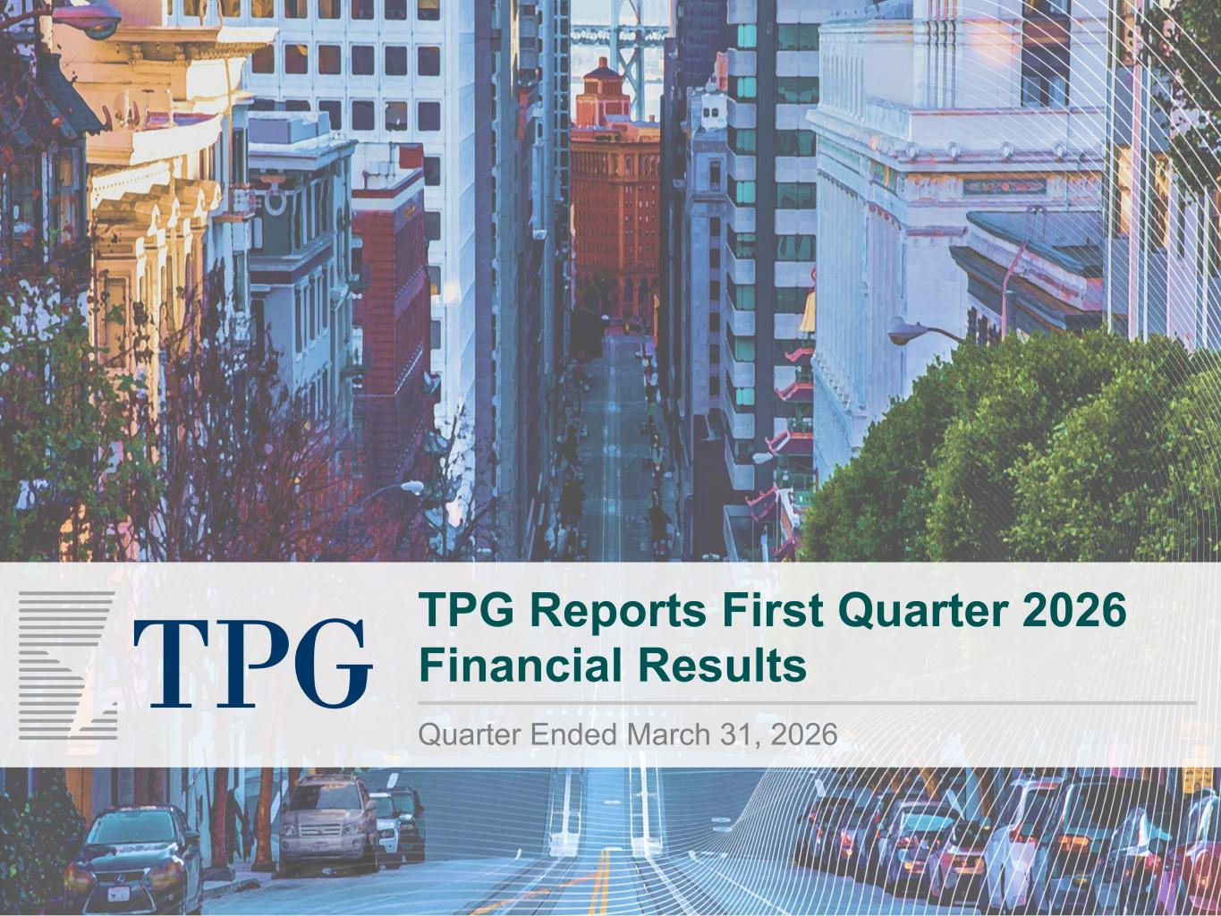

TPG Reports First Quarter 2026 Financial Results Quarter Ended March 31, 2026

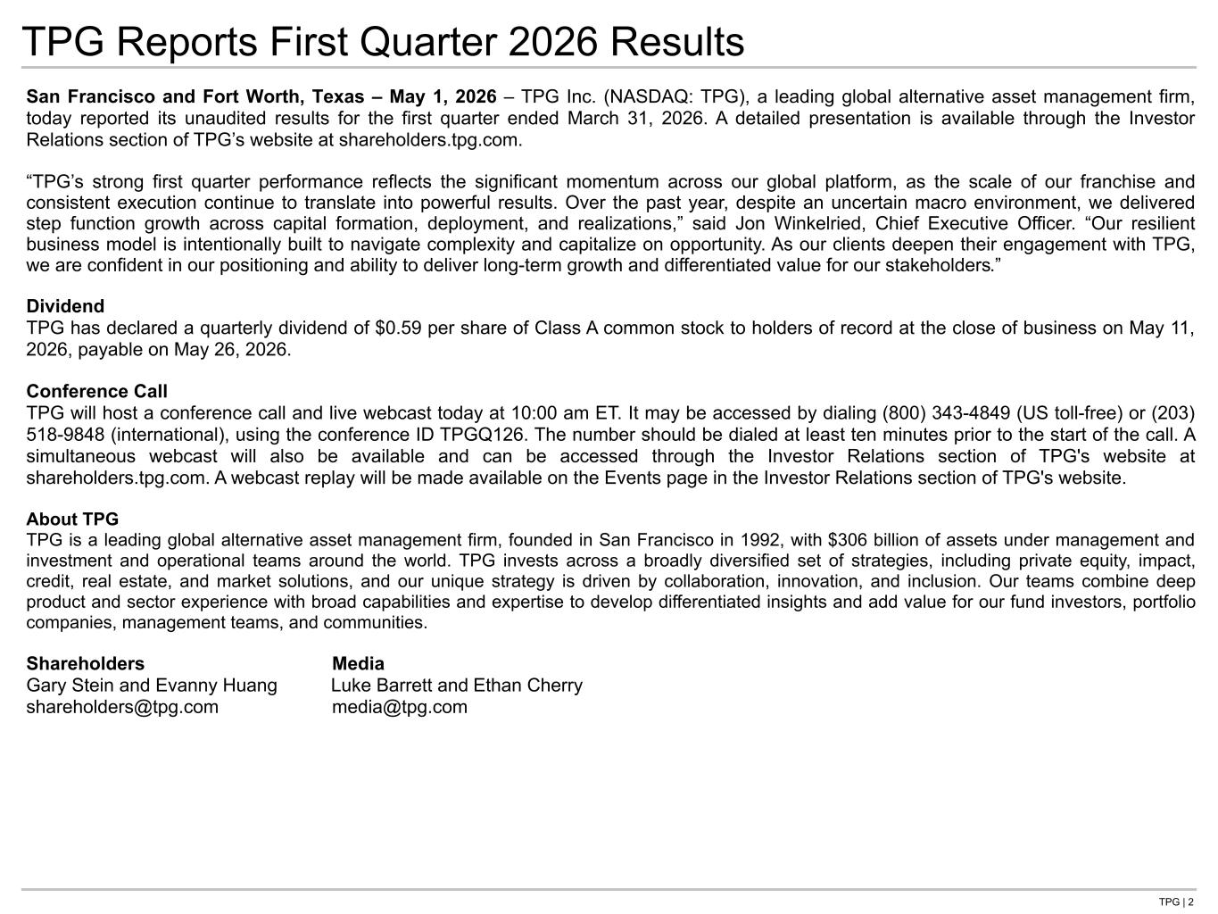
TPG | 2 San Francisco and Fort Worth, Texas – May 1, 2026 – TPG Inc. (NASDAQ: TPG), a leading global alternative asset management firm, today reported its unaudited results for the first quarter ended March 31, 2026. A detailed presentation is available through the Investor Relations section of TPG’s website at shareholders.tpg.com. “TPG’s strong first quarter performance reflects the significant momentum across our global platform, as the scale of our franchise and consistent execution continue to translate into powerful results. Over the past year, despite an uncertain macro environment, we delivered step function growth across capital formation, deployment, and realizations,” said Jon Winkelried, Chief Executive Officer. “Our resilient business model is intentionally built to navigate complexity and capitalize on opportunity. As our clients deepen their engagement with TPG, we are confident in our positioning and ability to deliver long-term growth and differentiated value for our stakeholders.” Dividend TPG has declared a quarterly dividend of $0.59 per share of Class A common stock to holders of record at the close of business on May 11, 2026, payable on May 26, 2026. Conference Call TPG will host a conference call and live webcast today at 10:00 am ET. It may be accessed by dialing (800) 343-4849 (US toll-free) or (203) 518-9848 (international), using the conference ID TPGQ126. The number should be dialed at least ten minutes prior to the start of the call. A simultaneous webcast will also be available and can be accessed through the Investor Relations section of TPG's website at shareholders.tpg.com. A webcast replay will be made available on the Events page in the Investor Relations section of TPG's website. About TPG TPG is a leading global alternative asset management firm, founded in San Francisco in 1992, with $306 billion of assets under management and investment and operational teams around the world. TPG invests across a broadly diversified set of strategies, including private equity, impact, credit, real estate, and market solutions, and our unique strategy is driven by collaboration, innovation, and inclusion. Our teams combine deep product and sector experience with broad capabilities and expertise to develop differentiated insights and add value for our fund investors, portfolio companies, management teams, and communities. Shareholders Media Gary Stein and Evanny Huang Luke Barrett and Ethan Cherry shareholders@tpg.com media@tpg.com TPG Reports First Quarter 2026 Results

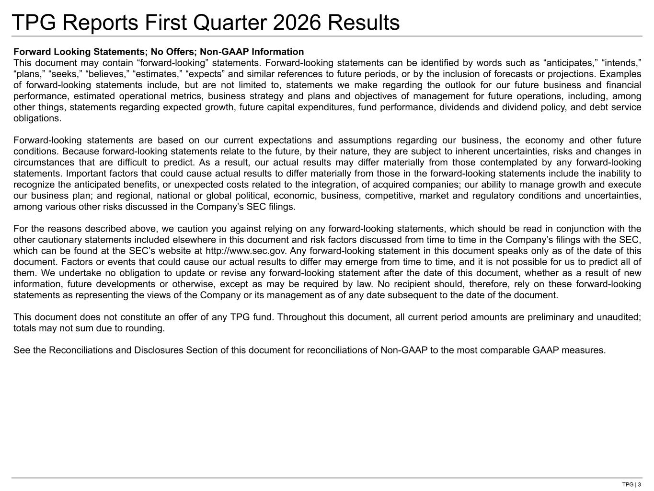
TPG | 3 TPG Reports First Quarter 2026 Results Forward Looking Statements; No Offers; Non-GAAP Information This document may contain “forward-looking” statements. Forward-looking statements can be identified by words such as “anticipates,” “intends,” “plans,” “seeks,” “believes,” “estimates,” “expects” and similar references to future periods, or by the inclusion of forecasts or projections. Examples of forward-looking statements include, but are not limited to, statements we make regarding the outlook for our future business and financial performance, estimated operational metrics, business strategy and plans and objectives of management for future operations, including, among other things, statements regarding expected growth, future capital expenditures, fund performance, dividends and dividend policy, and debt service obligations. Forward-looking statements are based on our current expectations and assumptions regarding our business, the economy and other future conditions. Because forward-looking statements relate to the future, by their nature, they are subject to inherent uncertainties, risks and changes in circumstances that are difficult to predict. As a result, our actual results may differ materially from those contemplated by any forward-looking statements. Important factors that could cause actual results to differ materially from those in the forward-looking statements include the inability to recognize the anticipated benefits, or unexpected costs related to the integration, of acquired companies; our ability to manage growth and execute our business plan; and regional, national or global political, economic, business, competitive, market and regulatory conditions and uncertainties, among various other risks discussed in the Company’s SEC filings. For the reasons described above, we caution you against relying on any forward-looking statements, which should be read in conjunction with the other cautionary statements included elsewhere in this document and risk factors discussed from time to time in the Company’s filings with the SEC, which can be found at the SEC’s website at http://www.sec.gov. Any forward-looking statement in this document speaks only as of the date of this document. Factors or events that could cause our actual results to differ may emerge from time to time, and it is not possible for us to predict all of them. We undertake no obligation to update or revise any forward-looking statement after the date of this document, whether as a result of new information, future developments or otherwise, except as may be required by law. No recipient should, therefore, rely on these forward-looking statements as representing the views of the Company or its management as of any date subsequent to the date of the document. This document does not constitute an offer of any TPG fund. Throughout this document, all current period amounts are preliminary and unaudited; totals may not sum due to rounding. See the Reconciliations and Disclosures Section of this document for reconciliations of Non-GAAP to the most comparable GAAP measures.


First Quarter 2026 Results

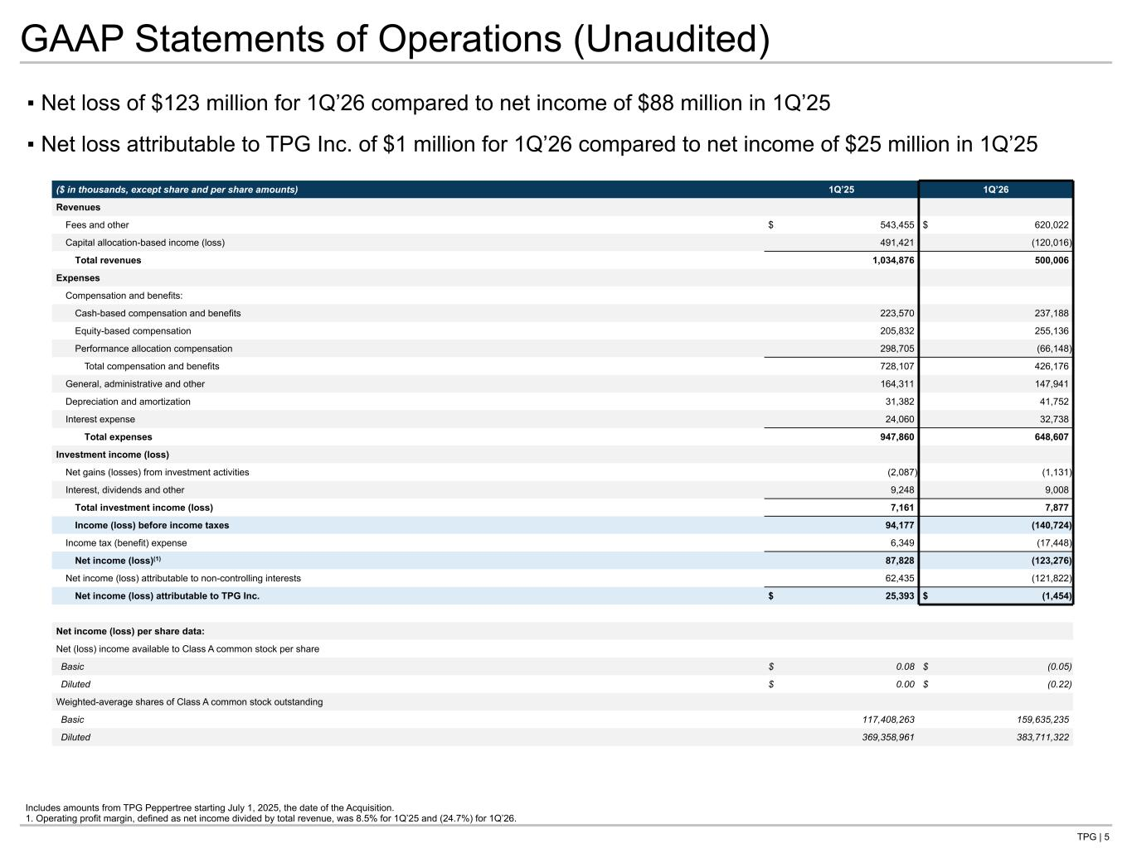
TPG | 5 ▪ Net loss of $123 million for 1Q’26 compared to net income of $88 million in 1Q’25 ▪ Net loss attributable to TPG Inc. of $1 million for 1Q’26 compared to net income of $25 million in 1Q’25 GAAP Statements of Operations (Unaudited) Includes amounts from TPG Peppertree starting July 1, 2025, the date of the Acquisition. 1. Operating profit margin, defined as net income divided by total revenue, was 8.5% for 1Q’25 and (24.7%) for 1Q’26. ($ in thousands, except share and per share amounts) 1Q’25 1Q’26 Revenues Fees and other $ 543,455 $ 620,022 Capital allocation-based income (loss) 491,421 (120,016) Total revenues 1,034,876 500,006 Expenses Compensation and benefits: Cash-based compensation and benefits 223,570 237,188 Equity-based compensation 205,832 255,136 Performance allocation compensation 298,705 (66,148) Total compensation and benefits 728,107 426,176 General, administrative and other 164,311 147,941 Depreciation and amortization 31,382 41,752 Interest expense 24,060 32,738 Total expenses 947,860 648,607 Investment income (loss) Net gains (losses) from investment activities (2,087) (1,131) Interest, dividends and other 9,248 9,008 Total investment income (loss) 7,161 7,877 Income (loss) before income taxes 94,177 (140,724) Income tax (benefit) expense 6,349 (17,448) Net income (loss)(1) 87,828 (123,276) Net income (loss) attributable to non-controlling interests 62,435 (121,822) Net income (loss) attributable to TPG Inc. $ 25,393 $ (1,454) Net income (loss) per share data: Net (loss) income available to Class A common stock per share Basic $ 0.08 $ (0.05) Diluted $ 0.00 $ (0.22) Weighted-average shares of Class A common stock outstanding Basic 117,408,263 159,635,235 Diluted 369,358,961 383,711,322 Tie to Qtrly statements at back

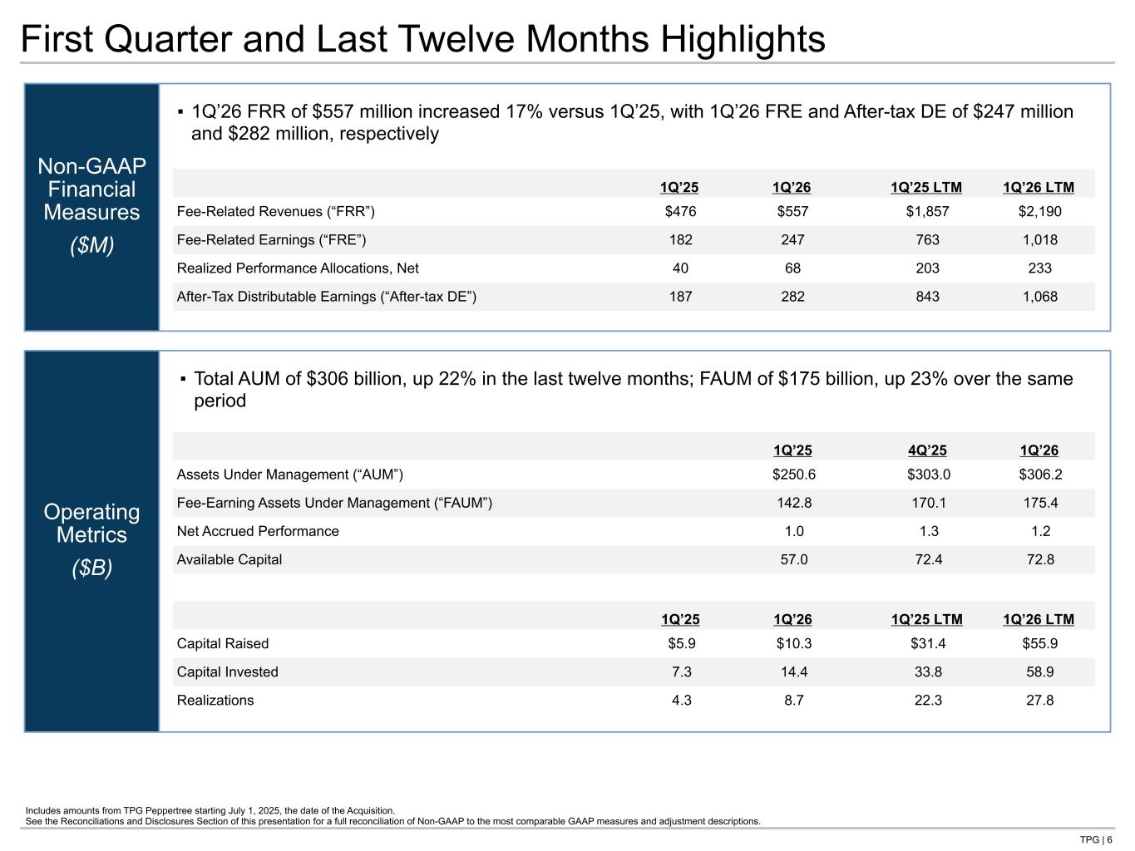
TPG | 6 Operating Metrics ($B) Non-GAAP Financial Measures ($M) First Quarter and Last Twelve Months Highlights 1Q’25 1Q’26 1Q’25 LTM 1Q’26 LTM Fee-Related Revenues (“FRR”) $476 $557 $1,857 $2,190 Fee-Related Earnings (“FRE”) 182 247 763 1,018 Realized Performance Allocations, Net 40 68 203 233 After-Tax Distributable Earnings (“After-tax DE”) 187 282 843 1,068 1Q’25 4Q’25 1Q’26 Assets Under Management (“AUM”) $250.6 $303.0 $306.2 Fee-Earning Assets Under Management (“FAUM”) 142.8 170.1 175.4 Net Accrued Performance 1.0 1.3 1.2 Available Capital 57.0 72.4 72.8 1Q’25 1Q’26 1Q’25 LTM 1Q’26 LTM Capital Raised $5.9 $10.3 $31.4 $55.9 Capital Invested 7.3 14.4 33.8 58.9 Realizations 4.3 8.7 22.3 27.8 ▪ 1Q’26 FRR of $557 million increased 17% versus 1Q’25, with 1Q’26 FRE and After-tax DE of $247 million and $282 million, respectively ▪ Total AUM of $306 billion, up 22% in the last twelve months; FAUM of $175 billion, up 23% over the same period Includes amounts from TPG Peppertree starting July 1, 2025, the date of the Acquisition. See the Reconciliations and Disclosures Section of this presentation for a full reconciliation of Non-GAAP to the most comparable GAAP measures and adjustment descriptions. Tie to next page Tie to OM section

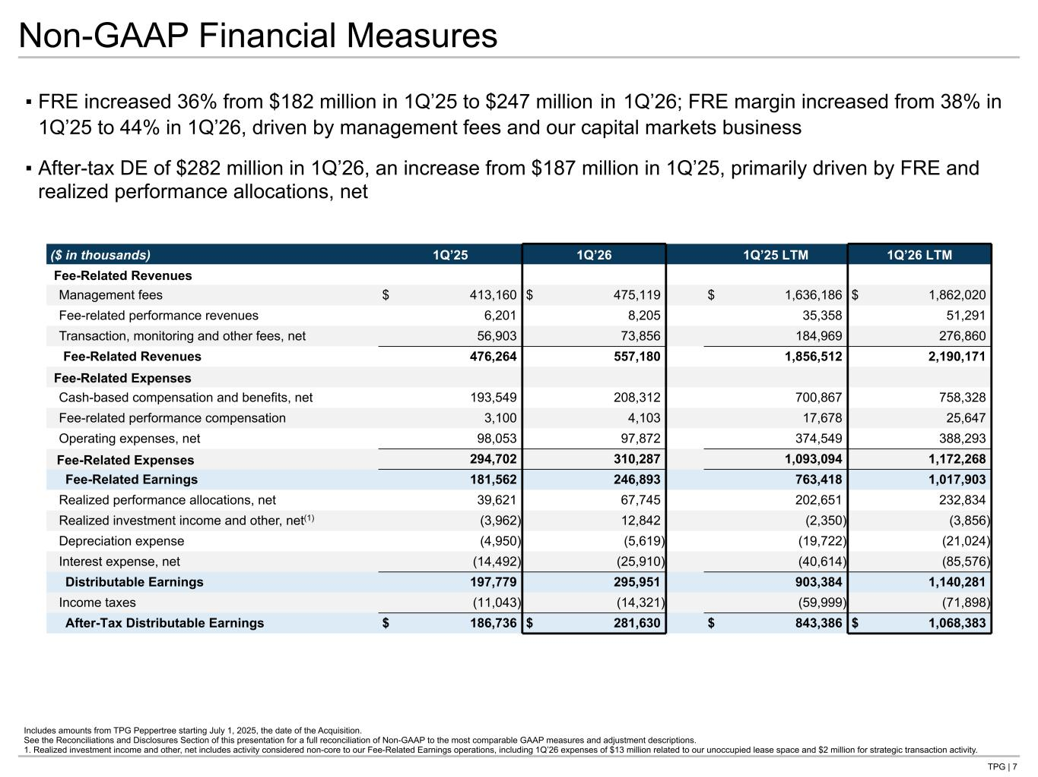
TPG | 7 Non-GAAP Financial Measures ▪ FRE increased 36% from $182 million in 1Q’25 to $247 million in 1Q’26; FRE margin increased from 38% in 1Q’25 to 44% in 1Q’26, driven by management fees and our capital markets business ▪ After-tax DE of $282 million in 1Q’26, an increase from $187 million in 1Q’25, primarily driven by FRE and realized performance allocations, net Includes amounts from TPG Peppertree starting July 1, 2025, the date of the Acquisition. See the Reconciliations and Disclosures Section of this presentation for a full reconciliation of Non-GAAP to the most comparable GAAP measures and adjustment descriptions. 1. Realized investment income and other, net includes activity considered non-core to our Fee-Related Earnings operations, including 1Q’26 expenses of $13 million related to our unoccupied lease space and $2 million for strategic transaction activity. ($ in thousands) 1Q’25 1Q’26 1Q’25 LTM 1Q’26 LTM Fee-Related Revenues Management fees $ 413,160 $ 475,119 $ 1,636,186 $ 1,862,020 Fee-related performance revenues 6,201 8,205 35,358 51,291 Transaction, monitoring and other fees, net 56,903 73,856 184,969 276,860 Fee-Related Revenues 476,264 557,180 1,856,512 2,190,171 Fee-Related Expenses Cash-based compensation and benefits, net 193,549 208,312 700,867 758,328 Fee-related performance compensation 3,100 4,103 17,678 25,647 Operating expenses, net 98,053 97,872 374,549 388,293 Fee-Related Expenses 294,702 310,287 1,093,094 1,172,268 Fee-Related Earnings 181,562 246,893 763,418 1,017,903 Realized performance allocations, net 39,621 67,745 202,651 232,834 Realized investment income and other, net(1) (3,962) 12,842 (2,350) (3,856) Depreciation expense (4,950) (5,619) (19,722) (21,024) Interest expense, net (14,492) (25,910) (40,614) (85,576) Distributable Earnings 197,779 295,951 903,384 1,140,281 Income taxes (11,043) (14,321) (59,999) (71,898) After-Tax Distributable Earnings $ 186,736 $ 281,630 $ 843,386 $ 1,068,383 Tie to: -prior page -qtrly statement in back -G-NG qtrly statment in back

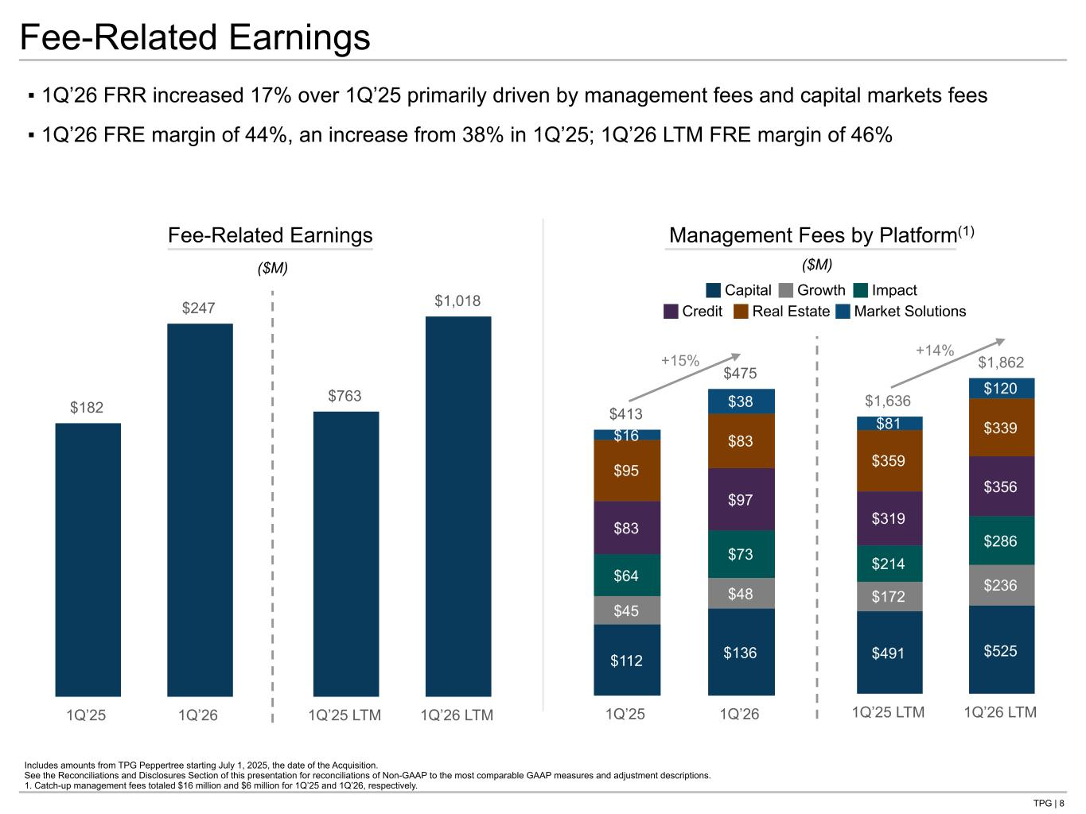
TPG | 8 $1,636 $1,862 $491 $525 $172 $236 $214 $286 $319 $356 $359 $339$81 $120 1Q’25 LTM 1Q’26 LTM $182 $247 1Q’25 1Q’26 $763 $1,018 1Q’25 LTM 1Q’26 LTM $413 $475 $112 $136 $45 $48 $64 $73 $83 $97 $95 $83$16 $38 1Q’25 1Q’26 ▪ 1Q’26 FRR increased 17% over 1Q’25 primarily driven by management fees and capital markets fees ▪ 1Q’26 FRE margin of 44%, an increase from 38% in 1Q’25; 1Q’26 LTM FRE margin of 46% Includes amounts from TPG Peppertree starting July 1, 2025, the date of the Acquisition. See the Reconciliations and Disclosures Section of this presentation for reconciliations of Non-GAAP to the most comparable GAAP measures and adjustment descriptions. 1. Catch-up management fees totaled $16 million and $6 million for 1Q’25 and 1Q’26, respectively. Fee-Related Earnings Management Fees by Platform(1) ($M) ($M) +15% Capital Growth Impact +14% Credit Real Estate Market Solutions Fee-Related Earnings

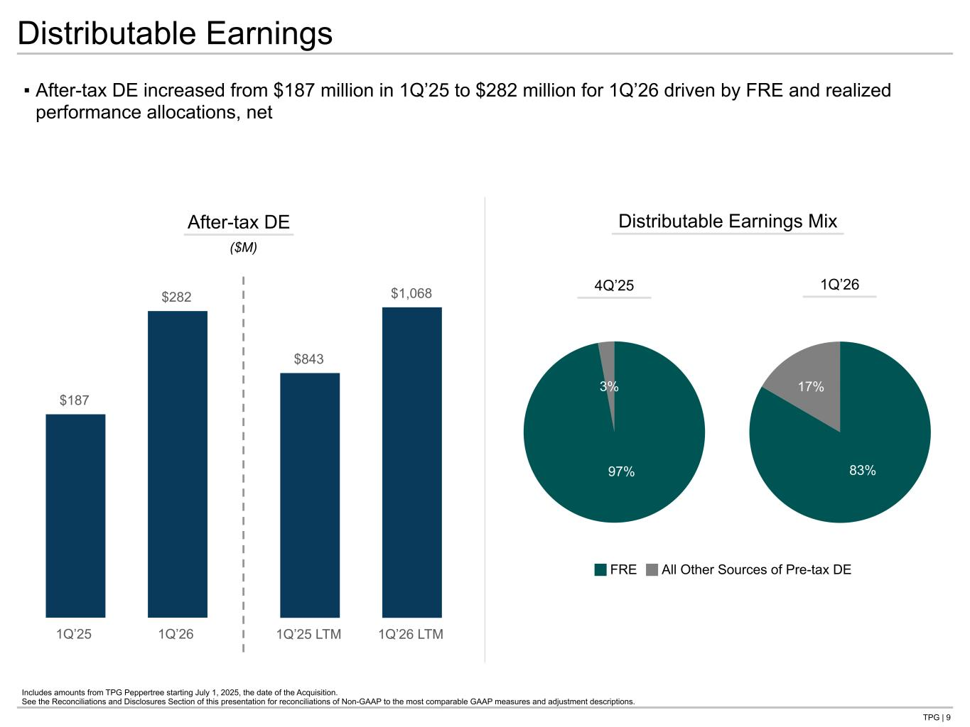
TPG | 9 $187 $282 1Q’25 1Q’26 $843 $1,068 1Q’25 LTM 1Q’26 LTM Distributable Earnings ▪ After-tax DE increased from $187 million in 1Q’25 to $282 million for 1Q’26 driven by FRE and realized performance allocations, net After-tax DE ($M) Includes amounts from TPG Peppertree starting July 1, 2025, the date of the Acquisition. See the Reconciliations and Disclosures Section of this presentation for reconciliations of Non-GAAP to the most comparable GAAP measures and adjustment descriptions. Distributable Earnings Mix FRE All Other Sources of Pre-tax DE 97% 3% 83% 17% 4Q’25 1Q’26

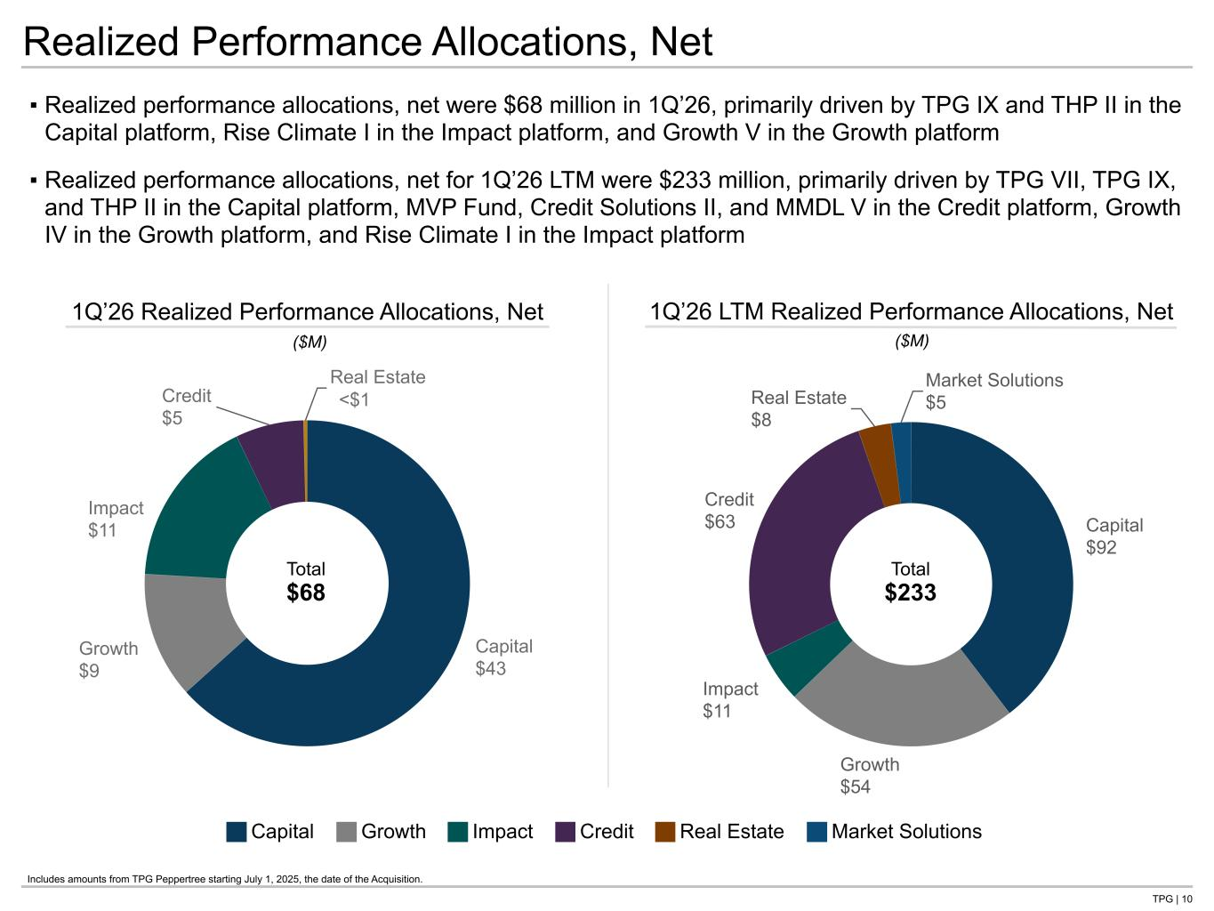
TPG | 10 Capital $92 Growth $54 Impact $11 Credit $63 Real Estate $8 Market Solutions $5 1Q’26 LTM Realized Performance Allocations, Net Capital $43 Growth $9 Impact $11 Credit $5 Real Estate $— ▪ Realized performance allocations, net were $68 million in 1Q’26, primarily driven by TPG IX and THP II in the Capital platform, Rise Climate I in the Impact platform, and Growth V in the Growth platform ▪ Realized performance allocations, net for 1Q’26 LTM were $233 million, primarily driven by TPG VII, TPG IX, and THP II in the Capital platform, MVP Fund, Credit Solutions II, and MMDL V in the Credit platform, Growth IV in the Growth platform, and Rise Climate I in the Impact platform Realized Performance Allocations, Net 1Q’26 Realized Performance Allocations, Net ($M) ($M) Total $233 Total $68 Capital Growth Impact Credit Real Estate Market Solutions Includes amounts from TPG Peppertree starting July 1, 2025, the date of the Acquisition. <$1

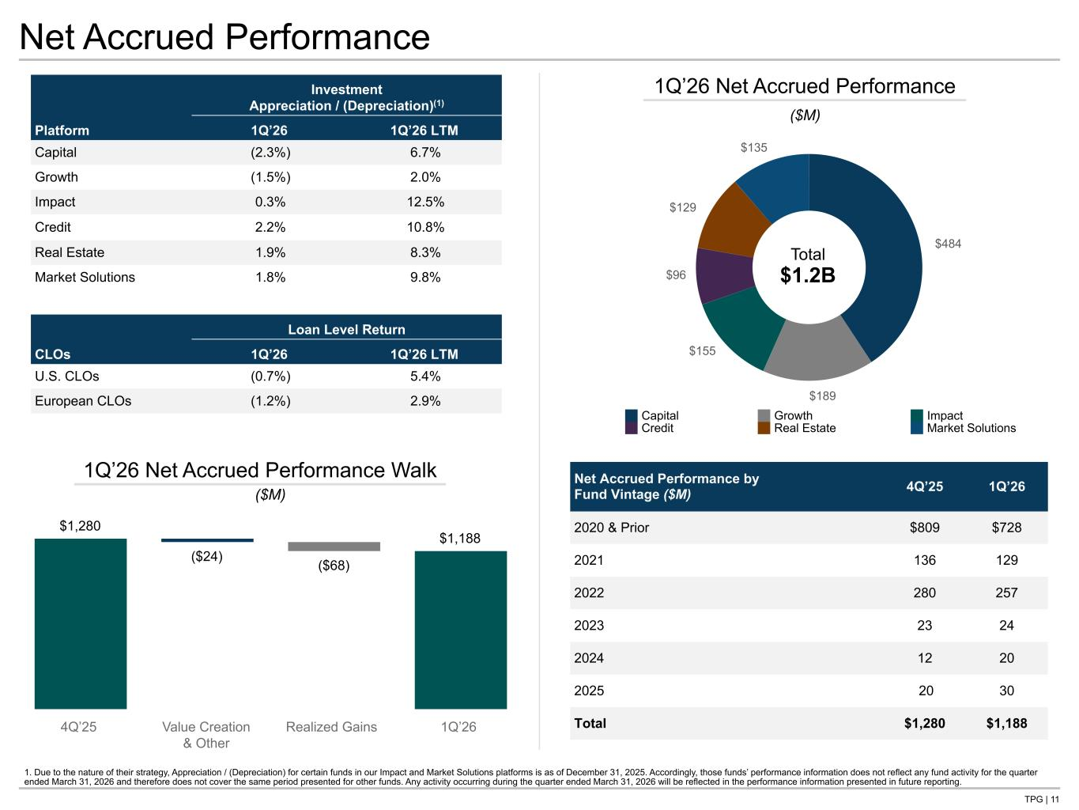
TPG | 11 $484 $189 $155 $96 $129 $135 Net Accrued Performance Net Accrued Performance by Fund Vintage ($M) 4Q’25 1Q’26 2020 & Prior $809 $728 2021 136 129 2022 280 257 2023 23 24 2024 12 20 2025 20 30 Total $1,280 $1,188 1Q’26 Net Accrued Performance Total $1.2B ($M) $1,280 ($24) ($68) $1,188 4Q’25 Value Creation & Other Realized Gains 1Q’26 1Q’26 Net Accrued Performance Walk ($M) Investment Appreciation / (Depreciation)(1) Platform 1Q’26 1Q’26 LTM Capital (2.3%) 6.7% Growth (1.5%) 2.0% Impact 0.3% 12.5% Credit 2.2% 10.8% Real Estate 1.9% 8.3% Market Solutions 1.8% 9.8% Loan Level Return CLOs 1Q’26 1Q’26 LTM U.S. CLOs (0.7%) 5.4% European CLOs (1.2%) 2.9% 1. Due to the nature of their strategy, Appreciation / (Depreciation) for certain funds in our Impact and Market Solutions platforms is as of December 31, 2025. Accordingly, those funds’ performance information does not reflect any fund activity for the quarter ended March 31, 2026 and therefore does not cover the same period presented for other funds. Any activity occurring during the quarter ended March 31, 2026 will be reflected in the performance information presented in future reporting. Capital Growth Impact Credit Real Estate Market Solutions Tie all 3 Net APF totals to NG BS

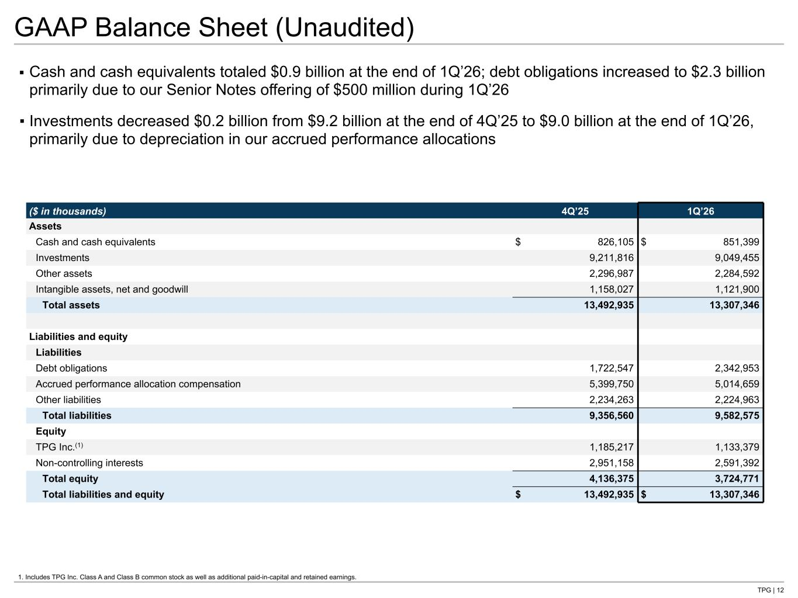
TPG | 12 GAAP Balance Sheet (Unaudited) ▪ Cash and cash equivalents totaled $0.9 billion at the end of 1Q’26; debt obligations increased to $2.3 billion primarily due to our Senior Notes offering of $500 million during 1Q’26 ▪ Investments decreased $0.2 billion from $9.2 billion at the end of 4Q’25 to $9.0 billion at the end of 1Q’26, primarily due to depreciation in our accrued performance allocations 1. Includes TPG Inc. Class A and Class B common stock as well as additional paid-in-capital and retained earnings. ($ in thousands) 4Q’25 1Q’26 Assets Cash and cash equivalents $ 826,105 $ 851,399 Investments 9,211,816 9,049,455 Other assets 2,296,987 2,284,592 Intangible assets, net and goodwill 1,158,027 1,121,900 Total assets 13,492,935 13,307,346 Liabilities and equity Liabilities Debt obligations 1,722,547 2,342,953 Accrued performance allocation compensation 5,399,750 5,014,659 Other liabilities 2,234,263 2,224,963 Total liabilities 9,356,560 9,582,575 Equity TPG Inc.(1) 1,185,217 1,133,379 Non-controlling interests 2,951,158 2,591,392 Total equity 4,136,375 3,724,771 Total liabilities and equity $ 13,492,935 $ 13,307,346 Tie to B/S G- NG in back

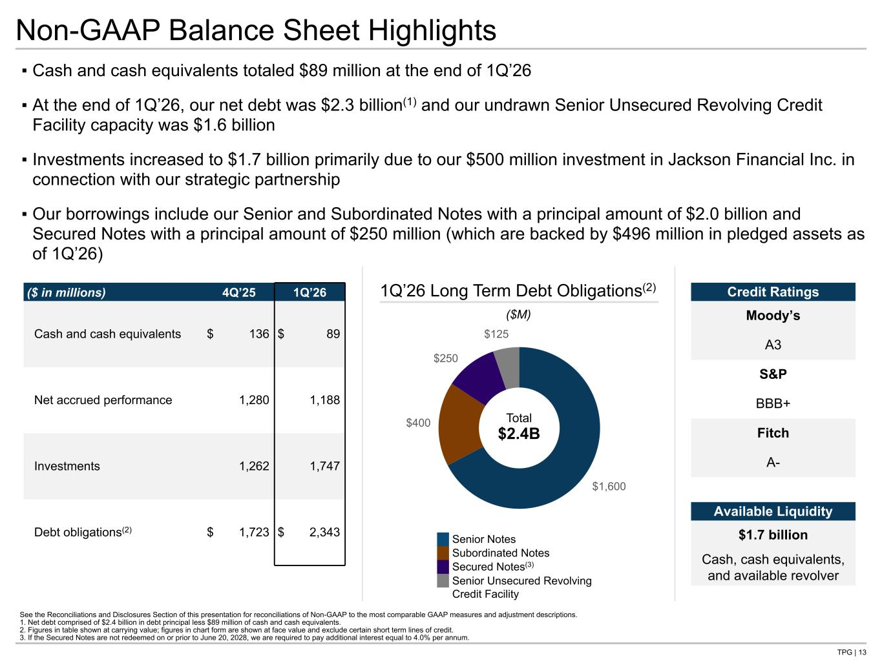
TPG | 13 ▪ Cash and cash equivalents totaled $89 million at the end of 1Q’26 ▪ At the end of 1Q’26, our net debt was $2.3 billion(1) and our undrawn Senior Unsecured Revolving Credit Facility capacity was $1.6 billion ▪ Investments increased to $1.7 billion primarily due to our $500 million investment in Jackson Financial Inc. in connection with our strategic partnership ▪ Our borrowings include our Senior and Subordinated Notes with a principal amount of $2.0 billion and Secured Notes with a principal amount of $250 million (which are backed by $496 million in pledged assets as of 1Q’26) Senior Notes Subordinated Notes Secured Notes(3) Senior Unsecured Revolving Credit Facility Non-GAAP Balance Sheet Highlights See the Reconciliations and Disclosures Section of this presentation for reconciliations of Non-GAAP to the most comparable GAAP measures and adjustment descriptions. 1. Net debt comprised of $2.4 billion in debt principal less $89 million of cash and cash equivalents. 2. Figures in table shown at carrying value; figures in chart form are shown at face value and exclude certain short term lines of credit. 3. If the Secured Notes are not redeemed on or prior to June 20, 2028, we are required to pay additional interest equal to 4.0% per annum. ($ in millions) 4Q’25 1Q’26 Cash and cash equivalents $ 136 $ 89 Net accrued performance 1,280 1,188 Investments 1,262 1,747 Debt obligations(2) $ 1,723 $ 2,343 $1,600 $400 $250 $125 1Q’26 Long Term Debt Obligations(2) Total $2.4B ($M) Credit Ratings Moody’s A3 S&P BBB+ Fitch A- Available Liquidity $1.7 billion Cash, cash equivalents, and available revolver Tie to B/S G- NG in back


Operating Metrics

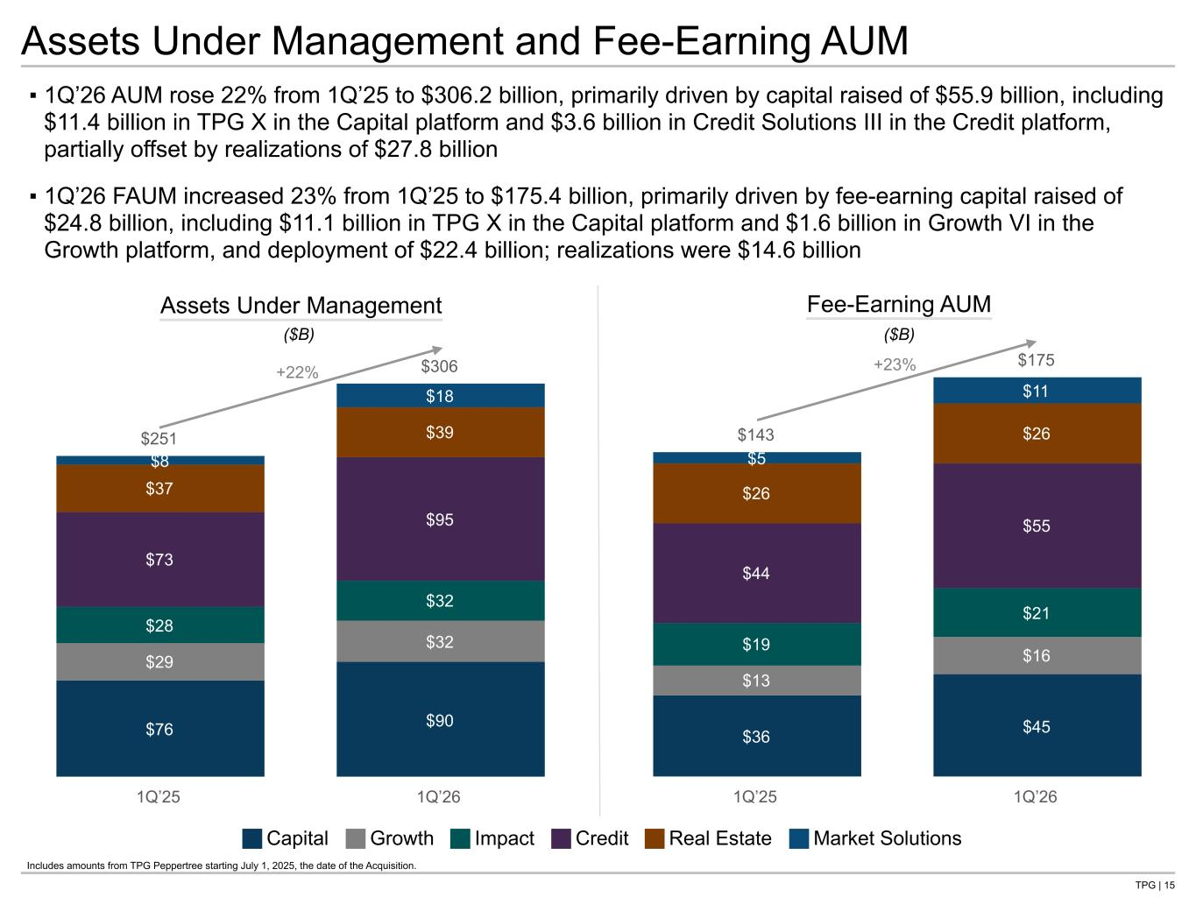
TPG | 15 $143 $175 $36 $45 $13 $16 $19 $21 $44 $55 $26 $26 $5 $11 1Q’25 1Q’26 $251 $306 $76 $90 $29 $32 $28 $32 $73 $95 $37 $39 $8 $18 1Q’25 1Q’26 Assets Under Management and Fee-Earning AUM ▪ 1Q’26 AUM rose 22% from 1Q’25 to $306.2 billion, primarily driven by capital raised of $55.9 billion, including $11.4 billion in TPG X in the Capital platform and $3.6 billion in Credit Solutions III in the Credit platform, partially offset by realizations of $27.8 billion ▪ 1Q’26 FAUM increased 23% from 1Q’25 to $175.4 billion, primarily driven by fee-earning capital raised of $24.8 billion, including $11.1 billion in TPG X in the Capital platform and $1.6 billion in Growth VI in the Growth platform, and deployment of $22.4 billion; realizations were $14.6 billion Assets Under Management Fee-Earning AUM ($B) ($B) +22% +23% Capital Growth Impact Credit Real Estate Market Solutions Includes amounts from TPG Peppertree starting July 1, 2025, the date of the Acquisition.

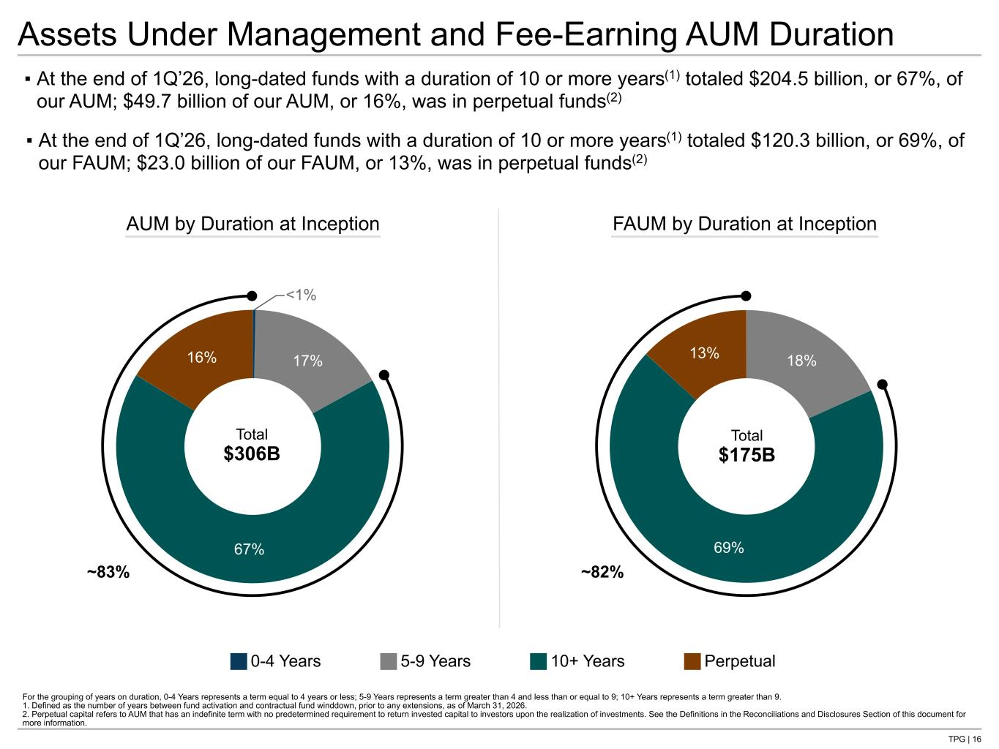
TPG | 16 Assets Under Management and Fee-Earning AUM Duration For the grouping of years on duration, 0-4 Years represents a term equal to 4 years or less; 5-9 Years represents a term greater than 4 and less than or equal to 9; 10+ Years represents a term greater than 9. 1. Defined as the number of years between fund activation and contractual fund winddown, prior to any extensions, as of March 31, 2026. 2. Perpetual capital refers to AUM that has an indefinite term with no predetermined requirement to return invested capital to investors upon the realization of investments. See the Definitions in the Reconciliations and Disclosures Section of this document for more information. ▪ At the end of 1Q’26, long-dated funds with a duration of 10 or more years(1) totaled $204.5 billion, or 67%, of our AUM; $49.7 billion of our AUM, or 16%, was in perpetual funds(2) ▪ At the end of 1Q’26, long-dated funds with a duration of 10 or more years(1) totaled $120.3 billion, or 69%, of our FAUM; $23.0 billion of our FAUM, or 13%, was in perpetual funds(2) 0-4 Years 5-9 Years 10+ Years Perpetual 18% 69% 13% 0.34% 17% 67% 16% AUM by Duration at Inception Total $306B FAUM by Duration at Inception Total $175B <1% ~83% ~82%

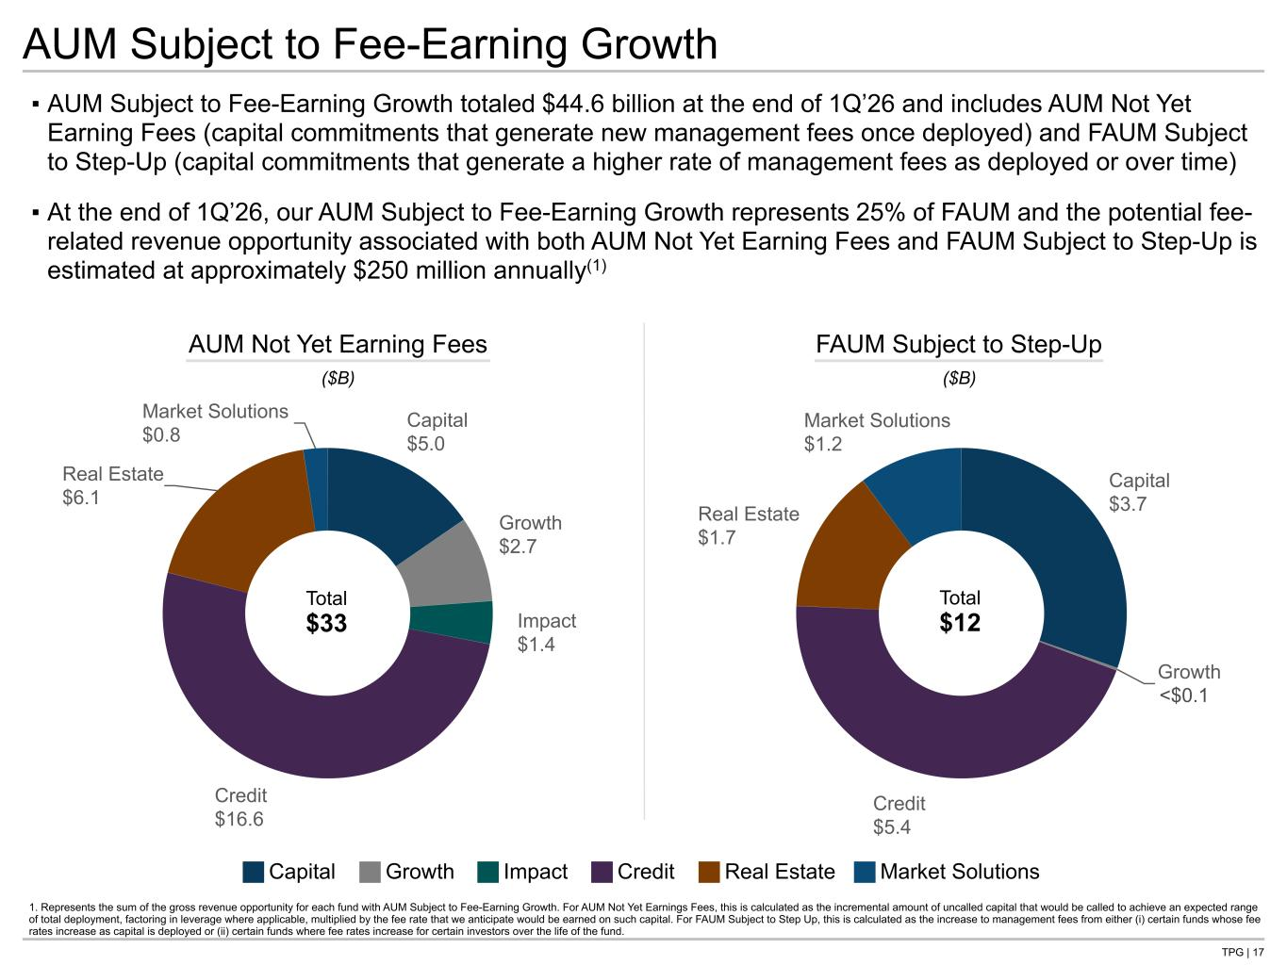
TPG | 17 Capital $3.7 Growth $0.0 Credit $5.4 Real Estate $1.7 Market Solutions $1.2 Capital $5.0 Growth $2.7 Impact $1.4 Credit $16.6 Real Estate $6.1 Market Solutions $0.8 ▪ AUM Subject to Fee-Earning Growth totaled $44.6 billion at the end of 1Q’26 and includes AUM Not Yet Earning Fees (capital commitments that generate new management fees once deployed) and FAUM Subject to Step-Up (capital commitments that generate a higher rate of management fees as deployed or over time) ▪ At the end of 1Q’26, our AUM Subject to Fee-Earning Growth represents 25% of FAUM and the potential fee- related revenue opportunity associated with both AUM Not Yet Earning Fees and FAUM Subject to Step-Up is estimated at approximately $250 million annually(1) AUM Not Yet Earning Fees FAUM Subject to Step-Up ($B) ($B) Total $33 Total $12 AUM Subject to Fee-Earning Growth 1. Represents the sum of the gross revenue opportunity for each fund with AUM Subject to Fee-Earning Growth. For AUM Not Yet Earnings Fees, this is calculated as the incremental amount of uncalled capital that would be called to achieve an expected range of total deployment, factoring in leverage where applicable, multiplied by the fee rate that we anticipate would be earned on such capital. For FAUM Subject to Step Up, this is calculated as the increase to management fees from either (i) certain funds whose fee rates increase as capital is deployed or (ii) certain funds where fee rates increase for certain investors over the life of the fund. Capital Growth Impact Credit Real Estate Market Solutions <$ .1

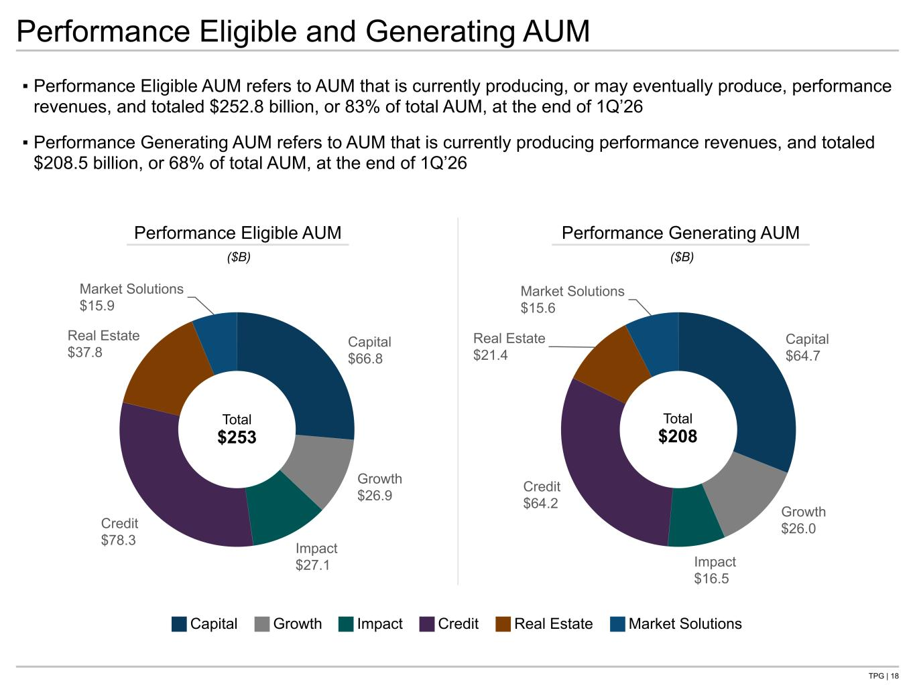
TPG | 18 Capital $64.7 Growth $26.0 Impact $16.5 Credit $64.2 Real Estate $21.4 Market Solutions $15.6 Capital $66.8 Growth $26.9 Impact $27.1 Credit $78.3 Real Estate $37.8 Market Solutions $15.9 ▪ Performance Eligible AUM refers to AUM that is currently producing, or may eventually produce, performance revenues, and totaled $252.8 billion, or 83% of total AUM, at the end of 1Q’26 ▪ Performance Generating AUM refers to AUM that is currently producing performance revenues, and totaled $208.5 billion, or 68% of total AUM, at the end of 1Q’26 Performance Eligible AUM Performance Generating AUM ($B) ($B) Total $253 Total $208 Performance Eligible and Generating AUM Capital Growth Impact Credit Real Estate Market Solutions

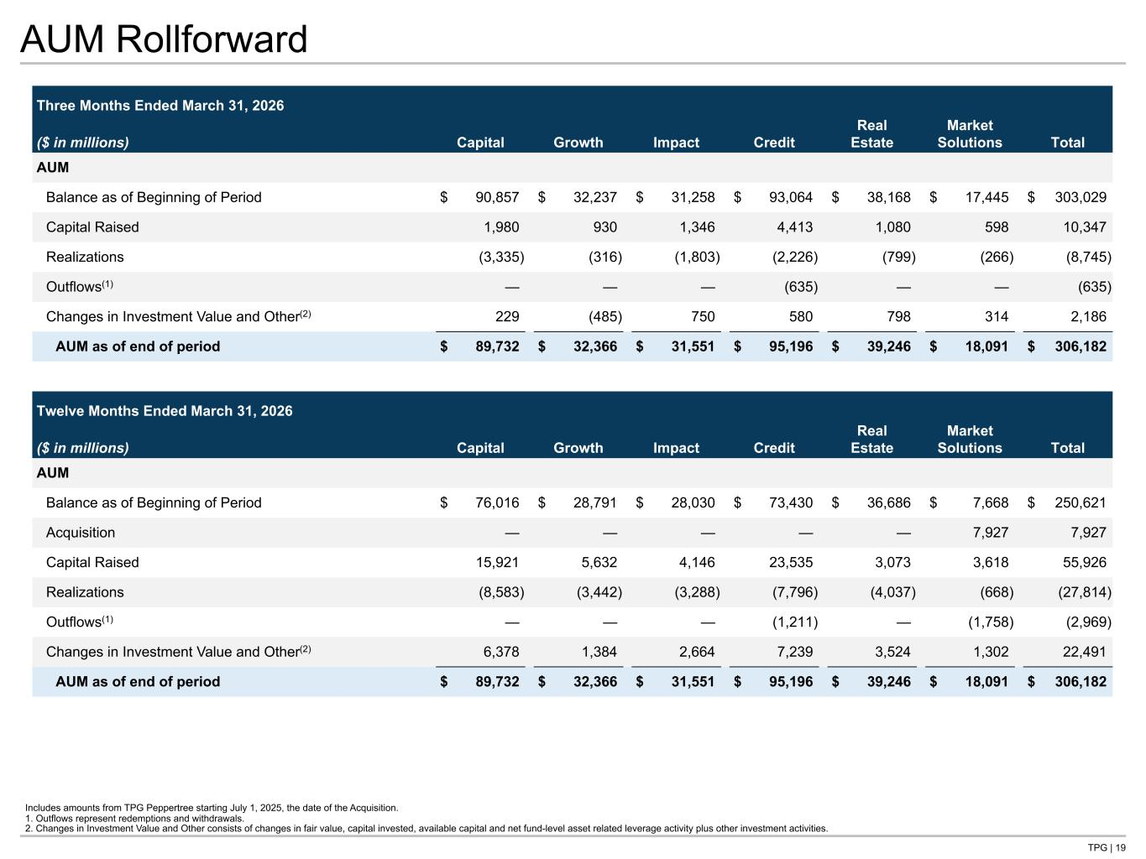
TPG | 19 AUM Rollforward Three Months Ended March 31, 2026 ($ in millions) Capital Growth Impact Credit Real Estate Market Solutions Total AUM Balance as of Beginning of Period $ 90,857 $ 32,237 $ 31,258 $ 93,064 $ 38,168 $ 17,445 $ 303,029 Capital Raised 1,980 930 1,346 4,413 1,080 598 10,347 Realizations (3,335) (316) (1,803) (2,226) (799) (266) (8,745) Outflows(1) — — — (635) — — (635) Changes in Investment Value and Other(2) 229 (485) 750 580 798 314 2,186 AUM as of end of period $ 89,732 $ 32,366 $ 31,551 $ 95,196 $ 39,246 $ 18,091 $ 306,182 Twelve Months Ended March 31, 2026 ($ in millions) Capital Growth Impact Credit Real Estate Market Solutions Total AUM Balance as of Beginning of Period $ 76,016 $ 28,791 $ 28,030 $ 73,430 $ 36,686 $ 7,668 $ 250,621 Acquisition — — — — — 7,927 7,927 Capital Raised 15,921 5,632 4,146 23,535 3,073 3,618 55,926 Realizations (8,583) (3,442) (3,288) (7,796) (4,037) (668) (27,814) Outflows(1) — — — (1,211) — (1,758) (2,969) Changes in Investment Value and Other(2) 6,378 1,384 2,664 7,239 3,524 1,302 22,491 AUM as of end of period $ 89,732 $ 32,366 $ 31,551 $ 95,196 $ 39,246 $ 18,091 $ 306,182 Includes amounts from TPG Peppertree starting July 1, 2025, the date of the Acquisition. 1. Outflows represent redemptions and withdrawals. 2. Changes in Investment Value and Other consists of changes in fair value, capital invested, available capital and net fund-level asset related leverage activity plus other investment activities. Tie to 4sq page

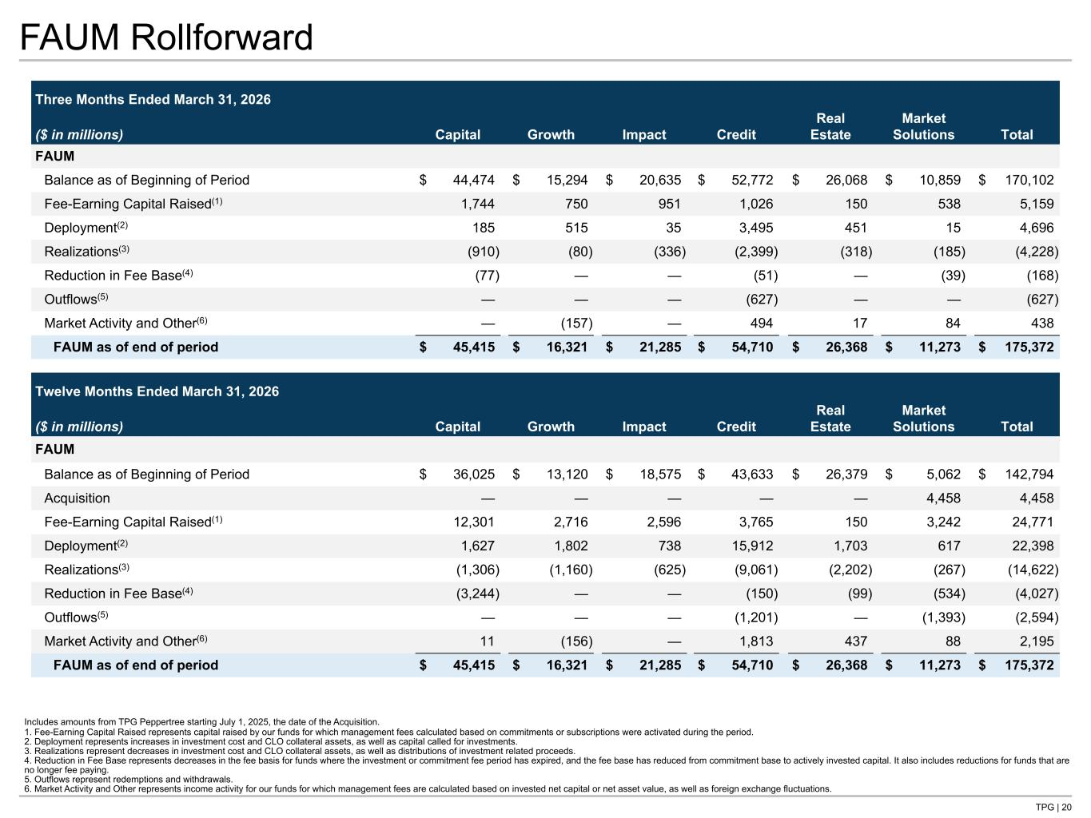
TPG | 20 FAUM Rollforward Three Months Ended March 31, 2026 ($ in millions) Capital Growth Impact Credit Real Estate Market Solutions Total FAUM Balance as of Beginning of Period $ 44,474 $ 15,294 $ 20,635 $ 52,772 $ 26,068 $ 10,859 $ 170,102 Fee-Earning Capital Raised(1) 1,744 750 951 1,026 150 538 5,159 Deployment(2) 185 515 35 3,495 451 15 4,696 Realizations(3) (910) (80) (336) (2,399) (318) (185) (4,228) Reduction in Fee Base(4) (77) — — (51) — (39) (168) Outflows(5) — — — (627) — — (627) Market Activity and Other(6) — (157) — 494 17 84 438 FAUM as of end of period $ 45,415 $ 16,321 $ 21,285 $ 54,710 $ 26,368 $ 11,273 $ 175,372 Twelve Months Ended March 31, 2026 ($ in millions) Capital Growth Impact Credit Real Estate Market Solutions Total FAUM Balance as of Beginning of Period $ 36,025 $ 13,120 $ 18,575 $ 43,633 $ 26,379 $ 5,062 $ 142,794 Acquisition — — — — — 4,458 4,458 Fee-Earning Capital Raised(1) 12,301 2,716 2,596 3,765 150 3,242 24,771 Deployment(2) 1,627 1,802 738 15,912 1,703 617 22,398 Realizations(3) (1,306) (1,160) (625) (9,061) (2,202) (267) (14,622) Reduction in Fee Base(4) (3,244) — — (150) (99) (534) (4,027) Outflows(5) — — — (1,201) — (1,393) (2,594) Market Activity and Other(6) 11 (156) — 1,813 437 88 2,195 FAUM as of end of period $ 45,415 $ 16,321 $ 21,285 $ 54,710 $ 26,368 $ 11,273 $ 175,372 Includes amounts from TPG Peppertree starting July 1, 2025, the date of the Acquisition. 1. Fee-Earning Capital Raised represents capital raised by our funds for which management fees calculated based on commitments or subscriptions were activated during the period. 2. Deployment represents increases in investment cost and CLO collateral assets, as well as capital called for investments. 3. Realizations represent decreases in investment cost and CLO collateral assets, as well as distributions of investment related proceeds. 4. Reduction in Fee Base represents decreases in the fee basis for funds where the investment or commitment fee period has expired, and the fee base has reduced from commitment base to actively invested capital. It also includes reductions for funds that are no longer fee paying. 5. Outflows represent redemptions and withdrawals. 6. Market Activity and Other represents income activity for our funds for which management fees are calculated based on invested net capital or net asset value, as well as foreign exchange fluctuations.

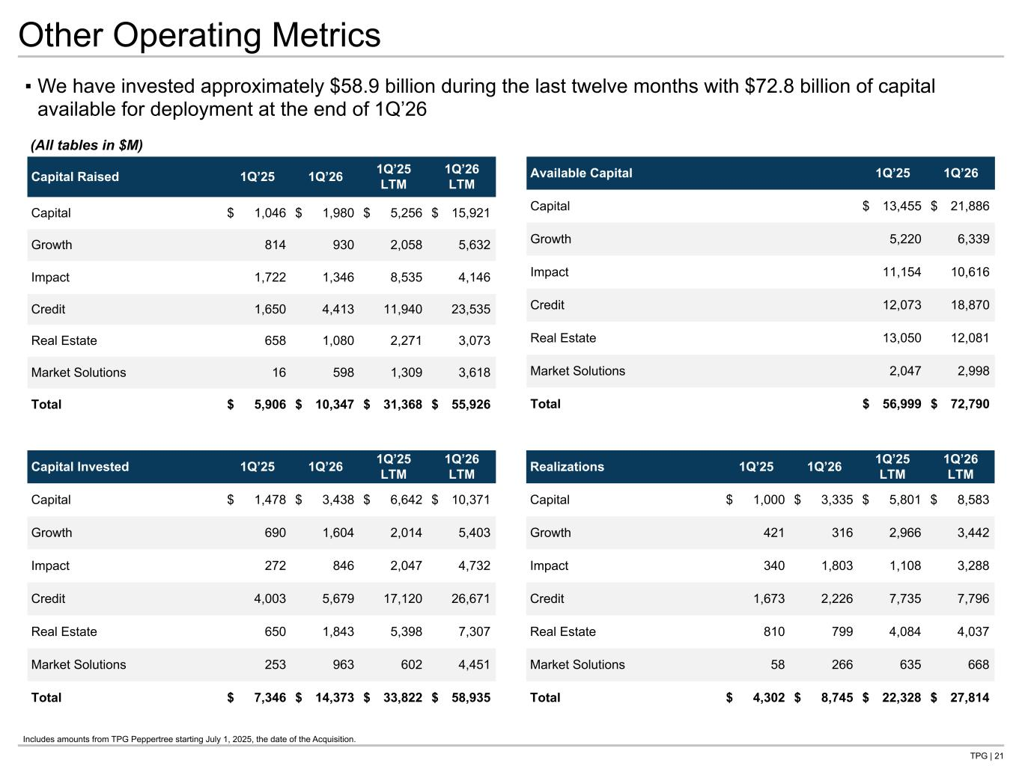
TPG | 21 Other Operating Metrics Capital Raised 1Q’25 1Q’26 1Q’25 LTM 1Q’26 LTM Capital $ 1,046 $ 1,980 $ 5,256 $ 15,921 Growth 814 930 2,058 5,632 Impact 1,722 1,346 8,535 4,146 Credit 1,650 4,413 11,940 23,535 Real Estate 658 1,080 2,271 3,073 Market Solutions 16 598 1,309 3,618 Total $ 5,906 $ 10,347 $ 31,368 $ 55,926 ▪ We have invested approximately $58.9 billion during the last twelve months with $72.8 billion of capital available for deployment at the end of 1Q’26 Available Capital 1Q’25 1Q’26 Capital $ 13,455 $ 21,886 Growth 5,220 6,339 Impact 11,154 10,616 Credit 12,073 18,870 Real Estate 13,050 12,081 Market Solutions 2,047 2,998 Total $ 56,999 $ 72,790 Capital Invested 1Q’25 1Q’26 1Q’25 LTM 1Q’26 LTM Capital $ 1,478 $ 3,438 $ 6,642 $ 10,371 Growth 690 1,604 2,014 5,403 Impact 272 846 2,047 4,732 Credit 4,003 5,679 17,120 26,671 Real Estate 650 1,843 5,398 7,307 Market Solutions 253 963 602 4,451 Total $ 7,346 $ 14,373 $ 33,822 $ 58,935 Realizations 1Q’25 1Q’26 1Q’25 LTM 1Q’26 LTM Capital $ 1,000 $ 3,335 $ 5,801 $ 8,583 Growth 421 316 2,966 3,442 Impact 340 1,803 1,108 3,288 Credit 1,673 2,226 7,735 7,796 Real Estate 810 799 4,084 4,037 Market Solutions 58 266 635 668 Total $ 4,302 $ 8,745 $ 22,328 $ 27,814 (All tables in $M) Tie to AUM roll Includes amounts from TPG Peppertree starting July 1, 2025, the date of the Acquisition.


Supplemental Details

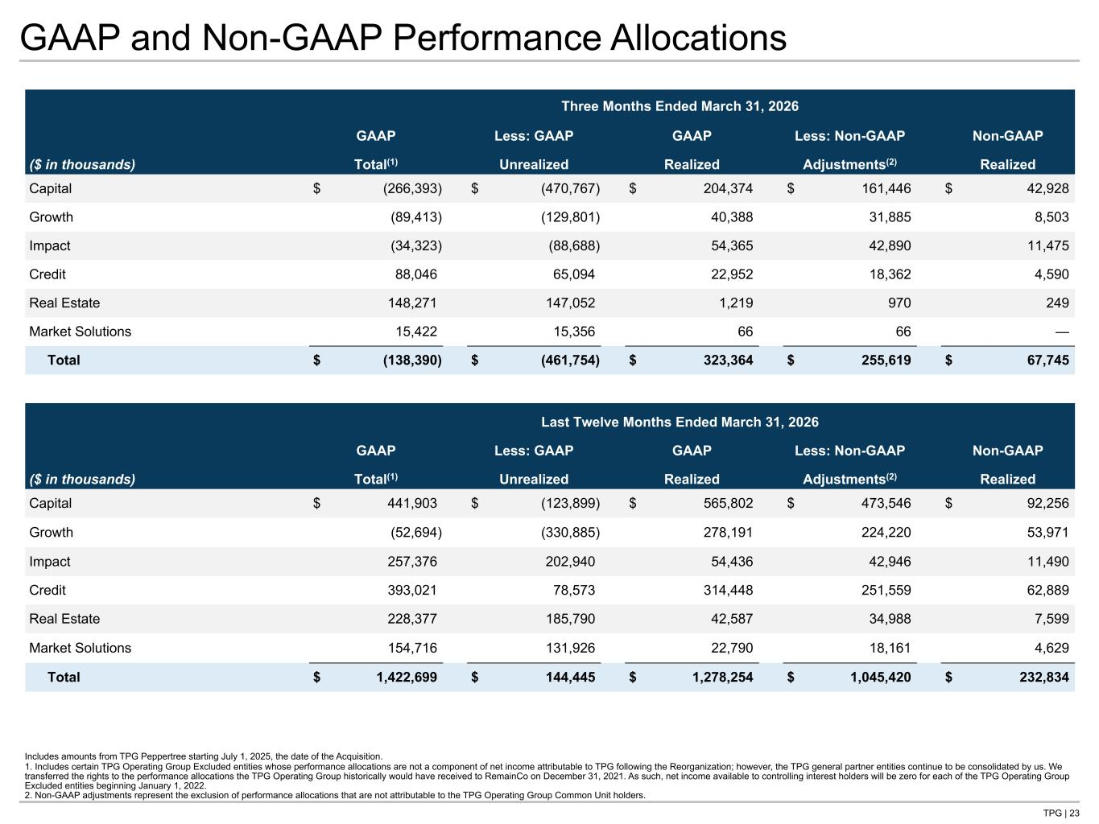
TPG | 23 GAAP and Non-GAAP Performance Allocations Includes amounts from TPG Peppertree starting July 1, 2025, the date of the Acquisition. 1. Includes certain TPG Operating Group Excluded entities whose performance allocations are not a component of net income attributable to TPG following the Reorganization; however, the TPG general partner entities continue to be consolidated by us. We transferred the rights to the performance allocations the TPG Operating Group historically would have received to RemainCo on December 31, 2021. As such, net income available to controlling interest holders will be zero for each of the TPG Operating Group Excluded entities beginning January 1, 2022. 2. Non-GAAP adjustments represent the exclusion of performance allocations that are not attributable to the TPG Operating Group Common Unit holders. Three Months Ended March 31, 2026 GAAP Less: GAAP GAAP Less: Non-GAAP Non-GAAP ($ in thousands) Total(1) Unrealized Realized Adjustments(2) Realized Capital $ (266,393) $ (470,767) $ 204,374 $ 161,446 $ 42,928 Growth (89,413) (129,801) 40,388 31,885 8,503 Impact (34,323) (88,688) 54,365 42,890 11,475 Credit 88,046 65,094 22,952 18,362 4,590 Real Estate 148,271 147,052 1,219 970 249 Market Solutions 15,422 15,356 66 66 — Total $ (138,390) $ (461,754) $ 323,364 $ 255,619 $ 67,745 Last Twelve Months Ended March 31, 2026 GAAP Less: GAAP GAAP Less: Non-GAAP Non-GAAP ($ in thousands) Total(1) Unrealized Realized Adjustments(2) Realized Capital $ 441,903 $ (123,899) $ 565,802 $ 473,546 $ 92,256 Growth (52,694) (330,885) 278,191 224,220 53,971 Impact 257,376 202,940 54,436 42,946 11,490 Credit 393,021 78,573 314,448 251,559 62,889 Real Estate 228,377 185,790 42,587 34,988 7,599 Market Solutions 154,716 131,926 22,790 18,161 4,629 Total $ 1,422,699 $ 144,445 $ 1,278,254 $ 1,045,420 $ 232,834 Tie to NG P&L

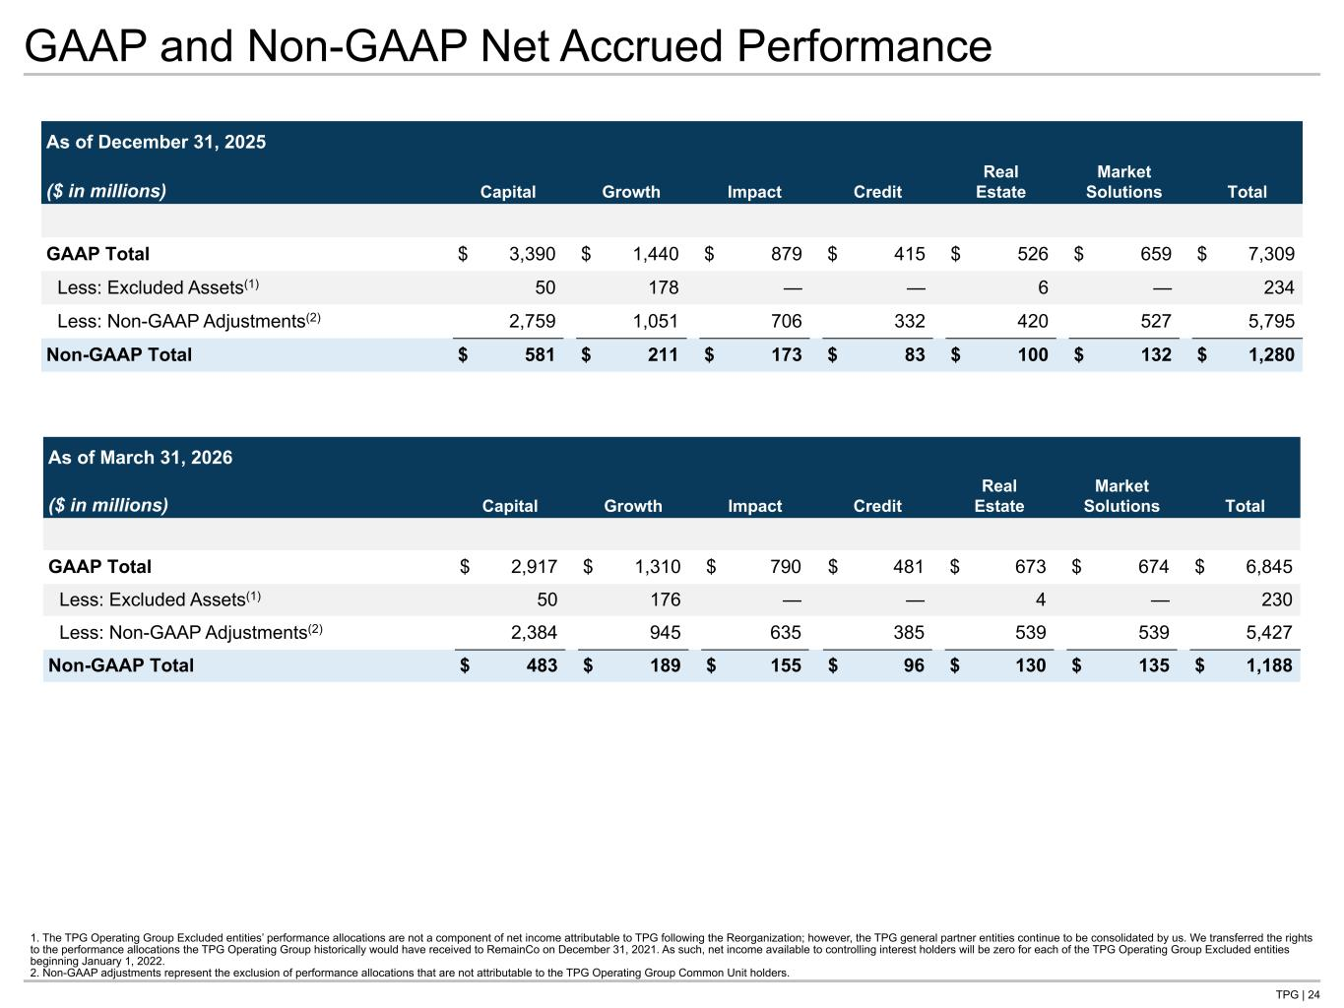
TPG | 24 GAAP and Non-GAAP Net Accrued Performance As of December 31, 2025 ($ in millions) Capital Growth Impact Credit Real Estate Market Solutions Total GAAP Total $ 3,390 $ 1,440 $ 879 $ 415 $ 526 $ 659 $ 7,309 Less: Excluded Assets(1) 50 178 — — 6 — 234 Less: Non-GAAP Adjustments(2) 2,759 1,051 706 332 420 527 5,795 Non-GAAP Total $ 581 $ 211 $ 173 $ 83 $ 100 $ 132 $ 1,280 1. The TPG Operating Group Excluded entities’ performance allocations are not a component of net income attributable to TPG following the Reorganization; however, the TPG general partner entities continue to be consolidated by us. We transferred the rights to the performance allocations the TPG Operating Group historically would have received to RemainCo on December 31, 2021. As such, net income available to controlling interest holders will be zero for each of the TPG Operating Group Excluded entities beginning January 1, 2022. 2. Non-GAAP adjustments represent the exclusion of performance allocations that are not attributable to the TPG Operating Group Common Unit holders. As of March 31, 2026 ($ in millions) Capital Growth Impact Credit Real Estate Market Solutions Total GAAP Total $ 2,917 $ 1,310 $ 790 $ 481 $ 673 $ 674 $ 6,845 Less: Excluded Assets(1) 50 176 — — 4 — 230 Less: Non-GAAP Adjustments(2) 2,384 945 635 385 539 539 5,427 Non-GAAP Total $ 483 $ 189 $ 155 $ 96 $ 130 $ 135 $ 1,188 Tie to Net Accrued Performance page

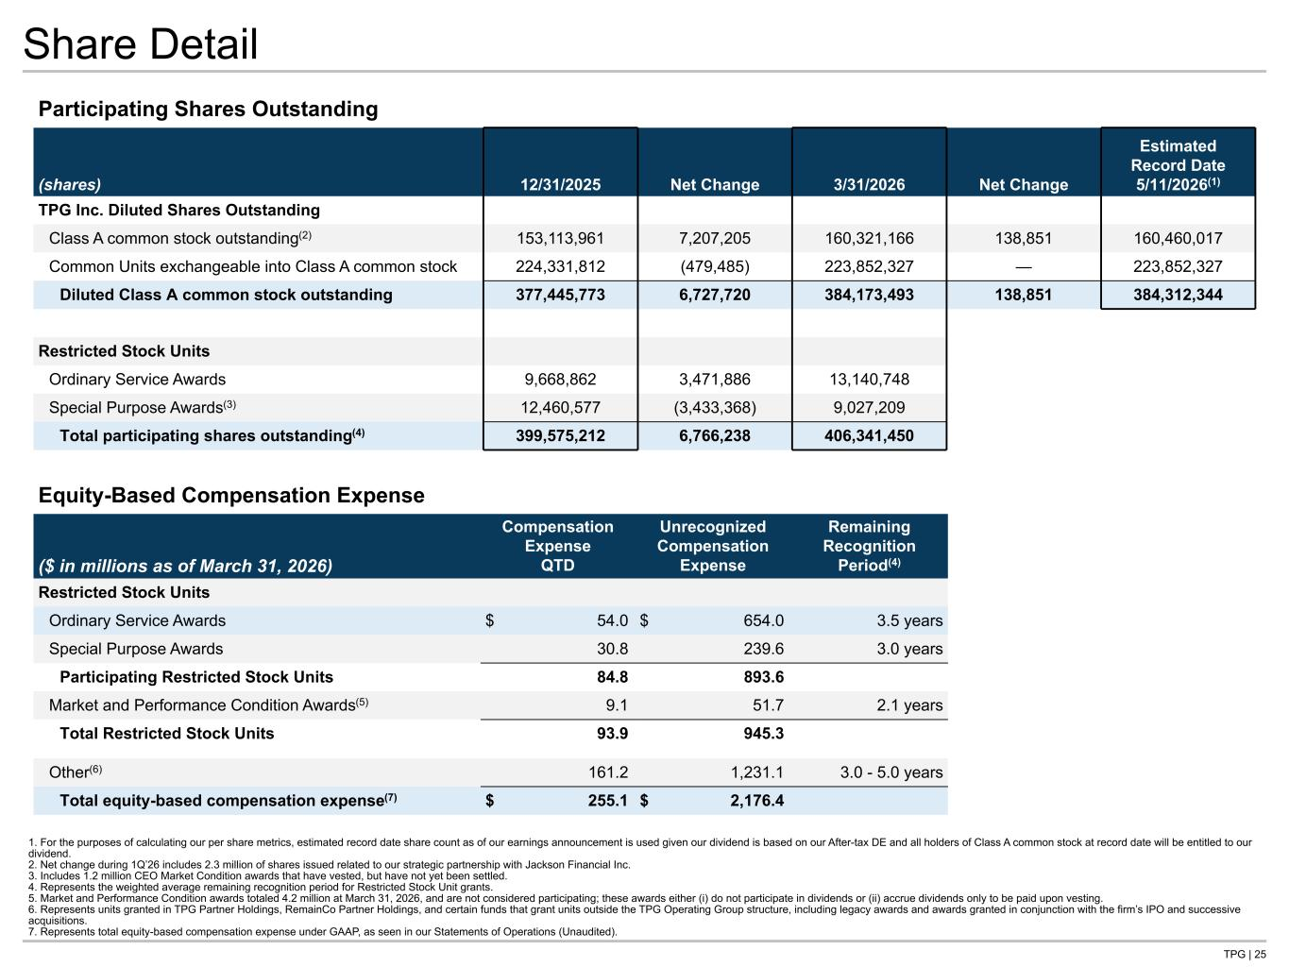
TPG | 25 Share Detail Participating Shares Outstanding (shares) 12/31/2025 Net Change 3/31/2026 Net Change Estimated Record Date 5/11/2026(1) TPG Inc. Diluted Shares Outstanding Class A common stock outstanding(2) 153,113,961 7,207,205 160,321,166 138,851 160,460,017 Common Units exchangeable into Class A common stock 224,331,812 (479,485) 223,852,327 — 223,852,327 Diluted Class A common stock outstanding 377,445,773 6,727,720 384,173,493 138,851 384,312,344 Restricted Stock Units Ordinary Service Awards 9,668,862 3,471,886 13,140,748 Special Purpose Awards(3) 12,460,577 (3,433,368) 9,027,209 Total participating shares outstanding(4) 399,575,212 6,766,238 406,341,450 1. For the purposes of calculating our per share metrics, estimated record date share count as of our earnings announcement is used given our dividend is based on our After-tax DE and all holders of Class A common stock at record date will be entitled to our dividend. 2. Net change during 1Q’26 includes 2.3 million of shares issued related to our strategic partnership with Jackson Financial Inc. 3. Includes 1.2 million CEO Market Condition awards that have vested, but have not yet been settled. 4. Represents the weighted average remaining recognition period for Restricted Stock Unit grants. 5. Market and Performance Condition awards totaled 4.2 million at March 31, 2026, and are not considered participating; these awards either (i) do not participate in dividends or (ii) accrue dividends only to be paid upon vesting. 6. Represents units granted in TPG Partner Holdings, RemainCo Partner Holdings, and certain funds that grant units outside the TPG Operating Group structure, including legacy awards and awards granted in conjunction with the firm’s IPO and successive acquisitions. 7. Represents total equity-based compensation expense under GAAP, as seen in our Statements of Operations (Unaudited). Tie to Dividends page Equity-Based Compensation Expense ($ in millions as of March 31, 2026) Compensation Expense QTD Unrecognized Compensation Expense Remaining Recognition Period(4) Restricted Stock Units Ordinary Service Awards $ 54.0 $ 654.0 3.5 years Special Purpose Awards 30.8 239.6 3.0 years Participating Restricted Stock Units 84.8 893.6 Market and Performance Condition Awards(5) 9.1 51.7 2.1 years Total Restricted Stock Units 93.9 945.3 Other(6) 161.2 1,231.1 3.0 - 5.0 years Total equity-based compensation expense(7) $ 255.1 $ 2,176.4

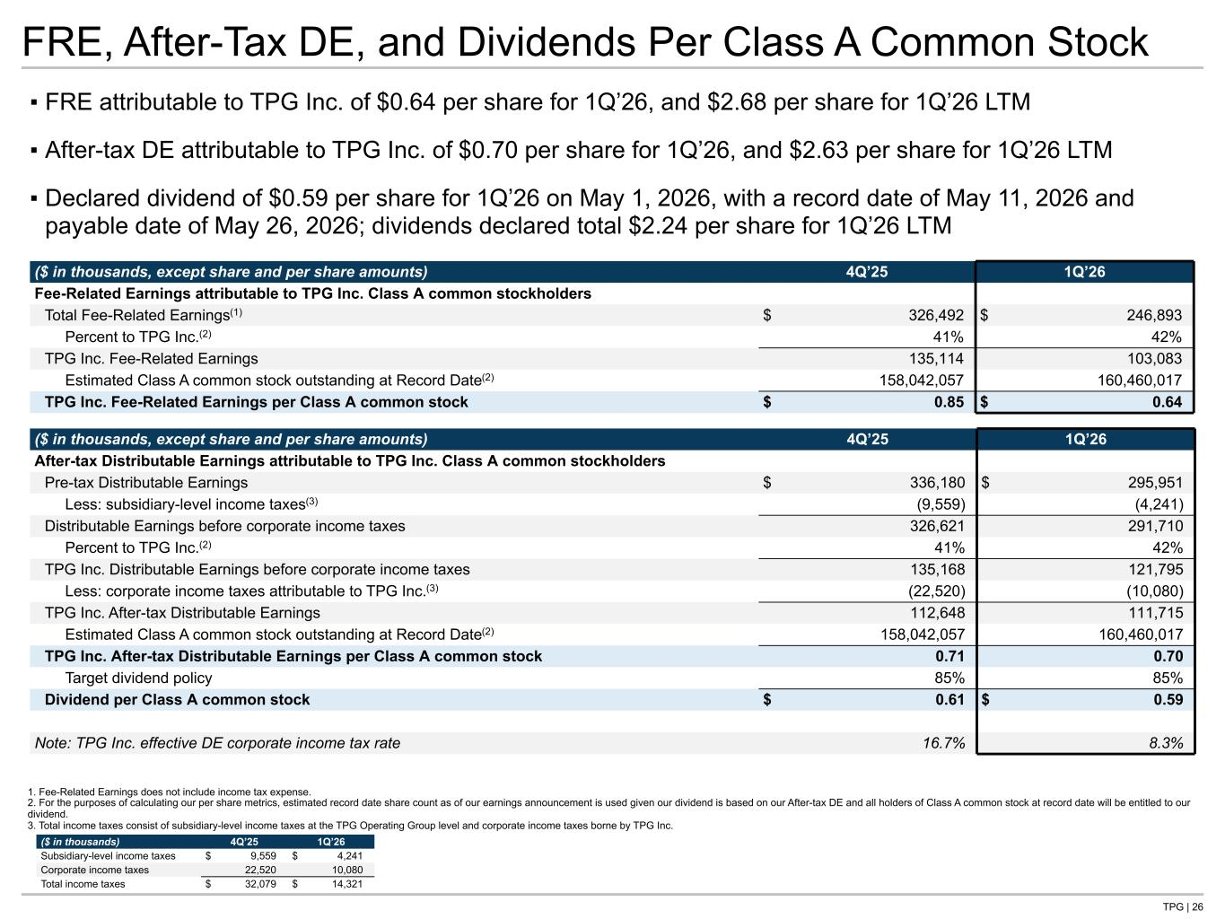
TPG | 26 FRE, After-Tax DE, and Dividends Per Class A Common Stock ▪ FRE attributable to TPG Inc. of $0.64 per share for 1Q’26, and $2.68 per share for 1Q’26 LTM ▪ After-tax DE attributable to TPG Inc. of $0.70 per share for 1Q’26, and $2.63 per share for 1Q’26 LTM ▪ Declared dividend of $0.59 per share for 1Q’26 on May 1, 2026, with a record date of May 11, 2026 and payable date of May 26, 2026; dividends declared total $2.24 per share for 1Q’26 LTM ($ in thousands, except share and per share amounts) 4Q’25 1Q’26 After-tax Distributable Earnings attributable to TPG Inc. Class A common stockholders Pre-tax Distributable Earnings $ 336,180 $ 295,951 Less: subsidiary-level income taxes(3) (9,559) (4,241) Distributable Earnings before corporate income taxes 326,621 291,710 Percent to TPG Inc.(2) 41% 42% TPG Inc. Distributable Earnings before corporate income taxes 135,168 121,795 Less: corporate income taxes attributable to TPG Inc.(3) (22,520) (10,080) TPG Inc. After-tax Distributable Earnings 112,648 111,715 Estimated Class A common stock outstanding at Record Date(2) 158,042,057 160,460,017 TPG Inc. After-tax Distributable Earnings per Class A common stock 0.71 0.70 Target dividend policy 85% 85% Dividend per Class A common stock $ 0.61 $ 0.59 Note: TPG Inc. effective DE corporate income tax rate 16.7% 8.3% 1. Fee-Related Earnings does not include income tax expense. 2. For the purposes of calculating our per share metrics, estimated record date share count as of our earnings announcement is used given our dividend is based on our After-tax DE and all holders of Class A common stock at record date will be entitled to our dividend. 3. Total income taxes consist of subsidiary-level income taxes at the TPG Operating Group level and corporate income taxes borne by TPG Inc. ($ in thousands) 4Q’25 1Q’26 Subsidiary-level income taxes $ 9,559 $ 4,241 Corporate income taxes 22,520 10,080 Total income taxes $ 32,079 $ 14,321 ($ in thousands, except share and per share amounts) 4Q’25 1Q’26 Fee-Related Earnings attributable to TPG Inc. Class A common stockholders Total Fee-Related Earnings(1) $ 326,492 $ 246,893 Percent to TPG Inc.(2) 41% 42% TPG Inc. Fee-Related Earnings 135,114 103,083 Estimated Class A common stock outstanding at Record Date(2) 158,042,057 160,460,017 TPG Inc. Fee-Related Earnings per Class A common stock $ 0.85 $ 0.64 Tie to: -Share Roll page for Shares -NG P&L for FRE, taxes, and Pretax DE

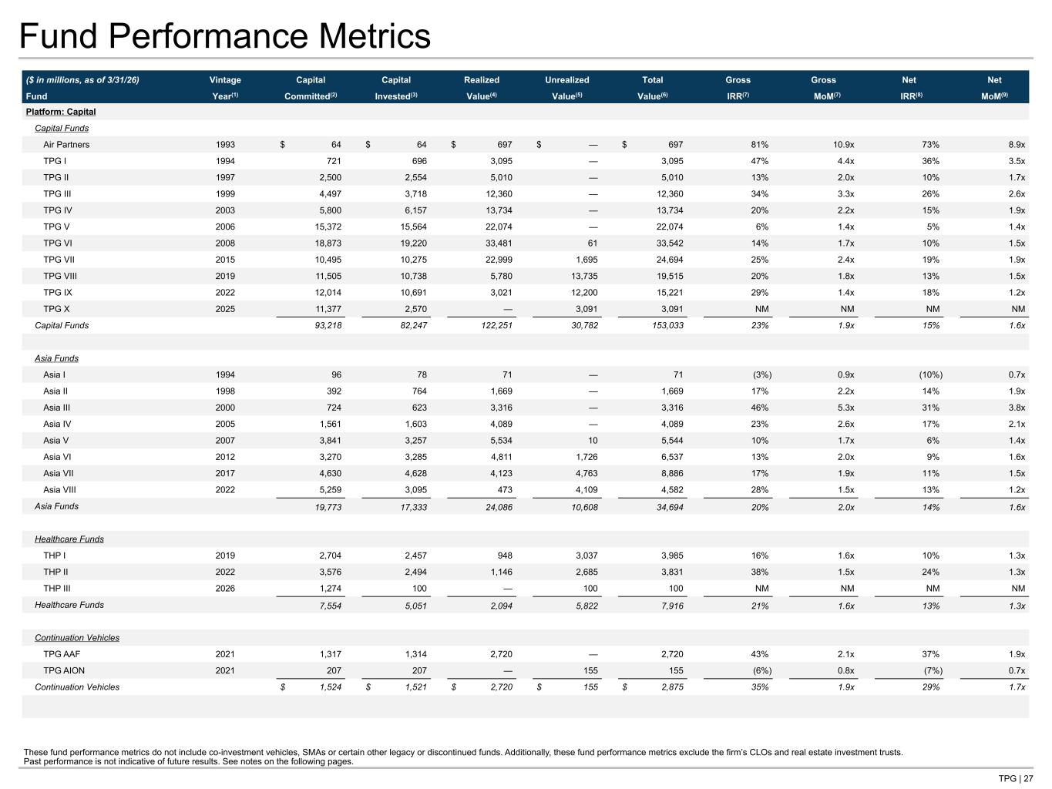
TPG | 27 Fund Performance Metrics ($ in millions, as of 3/31/26) Vintage Capital Capital Realized Unrealized Total Gross Gross Net Net Fund Year(1) Committed(2) Invested(3) Value(4) Value(5) Value(6) IRR(7) MoM(7) IRR(8) MoM(9) Platform: Capital Capital Funds Air Partners 1993 $ 64 $ 64 $ 697 $ — $ 697 81% 10.9x 73% 8.9x TPG I 1994 721 696 3,095 — 3,095 47% 4.4x 36% 3.5x TPG II 1997 2,500 2,554 5,010 — 5,010 13% 2.0x 10% 1.7x TPG III 1999 4,497 3,718 12,360 — 12,360 34% 3.3x 26% 2.6x TPG IV 2003 5,800 6,157 13,734 — 13,734 20% 2.2x 15% 1.9x TPG V 2006 15,372 15,564 22,074 — 22,074 6% 1.4x 5% 1.4x TPG VI 2008 18,873 19,220 33,481 61 33,542 14% 1.7x 10% 1.5x TPG VII 2015 10,495 10,275 22,999 1,695 24,694 25% 2.4x 19% 1.9x TPG VIII 2019 11,505 10,738 5,780 13,735 19,515 20% 1.8x 13% 1.5x TPG IX 2022 12,014 10,691 3,021 12,200 15,221 29% 1.4x 18% 1.2x TPG X 2025 11,377 2,570 — 3,091 3,091 NM NM NM NM Capital Funds 93,218 82,247 122,251 30,782 153,033 23% 1.9x 15% 1.6x Asia Funds Asia I 1994 96 78 71 — 71 (3%) 0.9x (10%) 0.7x Asia II 1998 392 764 1,669 — 1,669 17% 2.2x 14% 1.9x Asia III 2000 724 623 3,316 — 3,316 46% 5.3x 31% 3.8x Asia IV 2005 1,561 1,603 4,089 — 4,089 23% 2.6x 17% 2.1x Asia V 2007 3,841 3,257 5,534 10 5,544 10% 1.7x 6% 1.4x Asia VI 2012 3,270 3,285 4,811 1,726 6,537 13% 2.0x 9% 1.6x Asia VII 2017 4,630 4,628 4,123 4,763 8,886 17% 1.9x 11% 1.5x Asia VIII 2022 5,259 3,095 473 4,109 4,582 28% 1.5x 13% 1.2x Asia Funds 19,773 17,333 24,086 10,608 34,694 20% 2.0x 14% 1.6x Healthcare Funds THP I 2019 2,704 2,457 948 3,037 3,985 16% 1.6x 10% 1.3x THP II 2022 3,576 2,494 1,146 2,685 3,831 38% 1.5x 24% 1.3x THP III 2026 1,274 100 — 100 100 NM NM NM NM Healthcare Funds 7,554 5,051 2,094 5,822 7,916 21% 1.6x 13% 1.3x Continuation Vehicles TPG AAF 2021 1,317 1,314 2,720 — 2,720 43% 2.1x 37% 1.9x TPG AION 2021 207 207 — 155 155 (6%) 0.8x (7%) 0.7x Continuation Vehicles $ 1,524 $ 1,521 $ 2,720 $ 155 $ 2,875 35% 1.9x 29% 1.7x These fund performance metrics do not include co-investment vehicles, SMAs or certain other legacy or discontinued funds. Additionally, these fund performance metrics exclude the firm’s CLOs and real estate investment trusts. Past performance is not indicative of future results. See notes on the following pages.

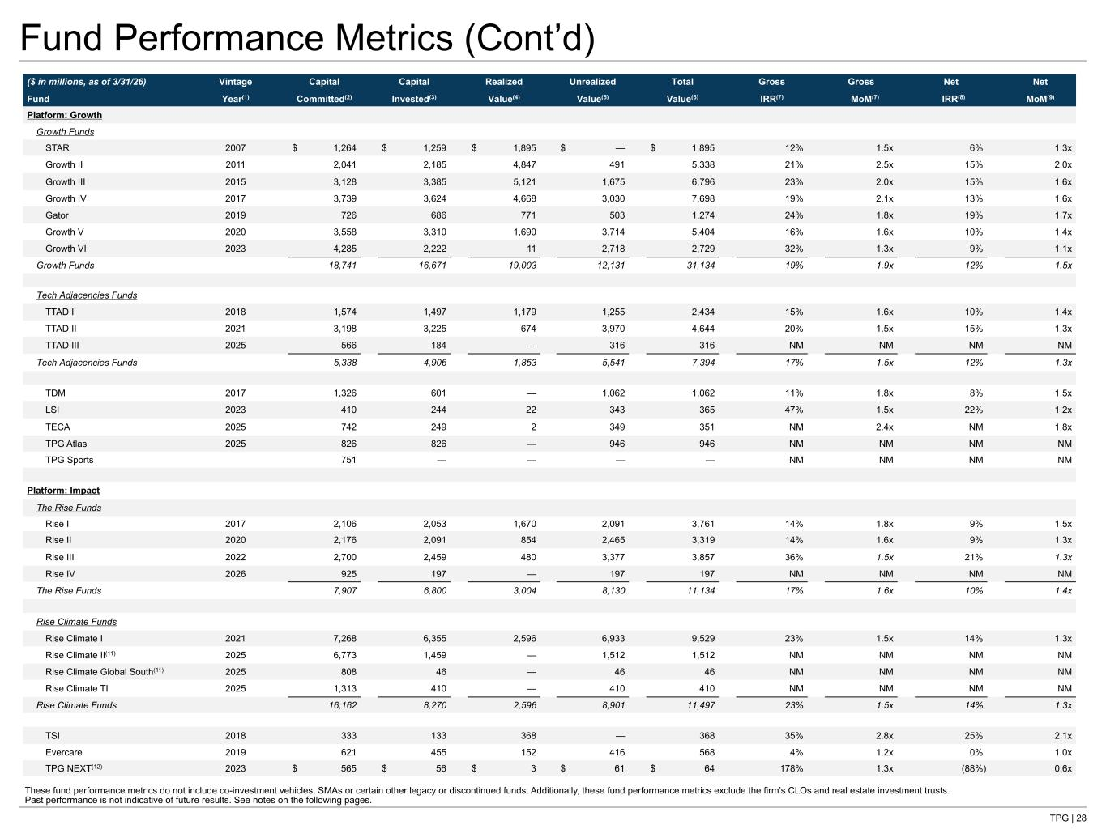
TPG | 28 Fund Performance Metrics (Cont’d) ($ in millions, as of 3/31/26) Vintage Capital Capital Realized Unrealized Total Gross Gross Net Net Fund Year(1) Committed(2) Invested(3) Value(4) Value(5) Value(6) IRR(7) MoM(7) IRR(8) MoM(9) Platform: Growth Growth Funds STAR 2007 $ 1,264 $ 1,259 $ 1,895 $ — $ 1,895 12% 1.5x 6% 1.3x Growth II 2011 2,041 2,185 4,847 491 5,338 21% 2.5x 15% 2.0x Growth III 2015 3,128 3,385 5,121 1,675 6,796 23% 2.0x 15% 1.6x Growth IV 2017 3,739 3,624 4,668 3,030 7,698 19% 2.1x 13% 1.6x Gator 2019 726 686 771 503 1,274 24% 1.8x 19% 1.7x Growth V 2020 3,558 3,310 1,690 3,714 5,404 16% 1.6x 10% 1.4x Growth VI 2023 4,285 2,222 11 2,718 2,729 32% 1.3x 9% 1.1x Growth Funds 18,741 16,671 19,003 12,131 31,134 19% 1.9x 12% 1.5x Tech Adjacencies Funds TTAD I 2018 1,574 1,497 1,179 1,255 2,434 15% 1.6x 10% 1.4x TTAD II 2021 3,198 3,225 674 3,970 4,644 20% 1.5x 15% 1.3x TTAD III 2025 566 184 — 316 316 NM NM NM NM Tech Adjacencies Funds 5,338 4,906 1,853 5,541 7,394 17% 1.5x 12% 1.3x TDM 2017 1,326 601 — 1,062 1,062 11% 1.8x 8% 1.5x LSI 2023 410 244 22 343 365 47% 1.5x 22% 1.2x TECA 2025 742 249 2 349 351 NM 2.4x NM 1.8x TPG Atlas 2025 826 826 — 946 946 NM NM NM NM TPG Sports 751 — — — — NM NM NM NM Platform: Impact The Rise Funds Rise I 2017 2,106 2,053 1,670 2,091 3,761 14% 1.8x 9% 1.5x Rise II 2020 2,176 2,091 854 2,465 3,319 14% 1.6x 9% 1.3x Rise III 2022 2,700 2,459 480 3,377 3,857 36% 1.5x 21% 1.3x Rise IV 2026 925 197 — 197 197 NM NM NM NM The Rise Funds 7,907 6,800 3,004 8,130 11,134 17% 1.6x 10% 1.4x Rise Climate Funds Rise Climate I 2021 7,268 6,355 2,596 6,933 9,529 23% 1.5x 14% 1.3x Rise Climate II(11) 2025 6,773 1,459 — 1,512 1,512 NM NM NM NM Rise Climate Global South(11) 2025 808 46 — 46 46 NM NM NM NM Rise Climate TI 2025 1,313 410 — 410 410 NM NM NM NM Rise Climate Funds 16,162 8,270 2,596 8,901 11,497 23% 1.5x 14% 1.3x TSI 2018 333 133 368 — 368 35% 2.8x 25% 2.1x Evercare 2019 621 455 152 416 568 4% 1.2x 0% 1.0x TPG NEXT(12) 2023 $ 565 $ 56 $ 3 $ 61 $ 64 178% 1.3x (88%) 0.6x These fund performance metrics do not include co-investment vehicles, SMAs or certain other legacy or discontinued funds. Additionally, these fund performance metrics exclude the firm’s CLOs and real estate investment trusts. Past performance is not indicative of future results. See notes on the following pages.

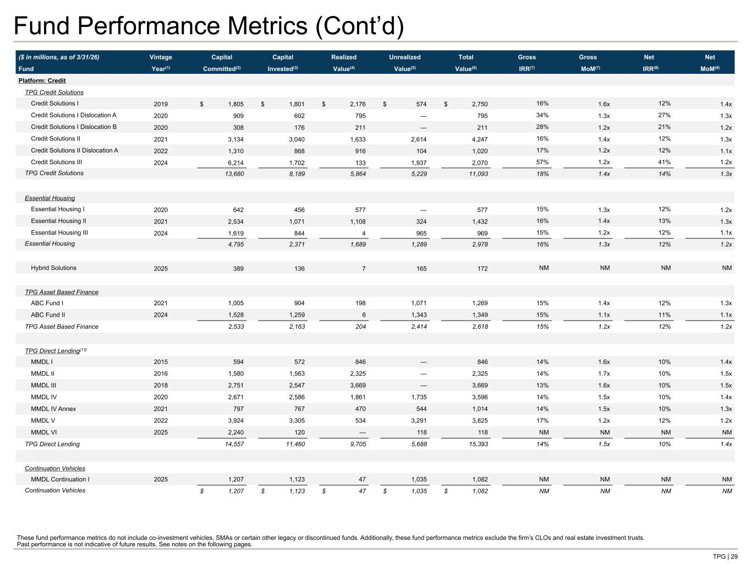
TPG | 29 Fund Performance Metrics (Cont’d) ($ in millions, as of 3/31/26) Vintage Capital Capital Realized Unrealized Total Gross Gross Net Net Fund Year(1) Committed(2) Invested(3) Value(4) Value(5) Value(6) IRR(7) MoM(7) IRR(8) MoM(9) Platform: Credit TPG Credit Solutions Credit Solutions I 2019 $ 1,805 $ 1,801 $ 2,176 $ 574 $ 2,750 16% 1.6x 12% 1.4x Credit Solutions I Dislocation A 2020 909 602 795 — 795 34% 1.3x 27% 1.3x Credit Solutions I Dislocation B 2020 308 176 211 — 211 28% 1.2x 21% 1.2x Credit Solutions II 2021 3,134 3,040 1,633 2,614 4,247 16% 1.4x 12% 1.3x Credit Solutions II Dislocation A 2022 1,310 868 916 104 1,020 17% 1.2x 12% 1.1x Credit Solutions III 2024 6,214 1,702 133 1,937 2,070 57% 1.2x 41% 1.2x TPG Credit Solutions 13,680 8,189 5,864 5,229 11,093 18% 1.4x 14% 1.3x Essential Housing Essential Housing I 2020 642 456 577 — 577 15% 1.3x 12% 1.2x Essential Housing II 2021 2,534 1,071 1,108 324 1,432 16% 1.4x 13% 1.3x Essential Housing III 2024 1,619 844 4 965 969 15% 1.2x 12% 1.1x Essential Housing 4,795 2,371 1,689 1,289 2,978 16% 1.3x 12% 1.2x Hybrid Solutions 2025 389 136 7 165 172 NM NM NM NM TPG Asset Based Finance ABC Fund I 2021 1,005 904 198 1,071 1,269 15% 1.4x 12% 1.3x ABC Fund II 2024 1,528 1,259 6 1,343 1,349 15% 1.1x 11% 1.1x TPG Asset Based Finance 2,533 2,163 204 2,414 2,618 15% 1.2x 12% 1.2x TPG Direct Lending(13) MMDL I 2015 594 572 846 — 846 14% 1.6x 10% 1.4x MMDL II 2016 1,580 1,563 2,325 — 2,325 14% 1.7x 10% 1.5x MMDL III 2018 2,751 2,547 3,669 — 3,669 13% 1.6x 10% 1.5x MMDL IV 2020 2,671 2,586 1,861 1,735 3,596 14% 1.5x 10% 1.4x MMDL IV Annex 2021 797 767 470 544 1,014 14% 1.5x 10% 1.3x MMDL V 2022 3,924 3,305 534 3,291 3,825 17% 1.2x 12% 1.2x MMDL VI 2025 2,240 120 — 118 118 NM NM NM NM TPG Direct Lending 14,557 11,460 9,705 5,688 15,393 14% 1.5x 10% 1.4x Continuation Vehicles MMDL Continuation I 2025 1,207 1,123 47 1,035 1,082 NM NM NM NM Continuation Vehicles $ 1,207 $ 1,123 $ 47 $ 1,035 $ 1,082 NM NM NM NM These fund performance metrics do not include co-investment vehicles, SMAs or certain other legacy or discontinued funds. Additionally, these fund performance metrics exclude the firm’s CLOs and real estate investment trusts. Past performance is not indicative of future results. See notes on the following pages.

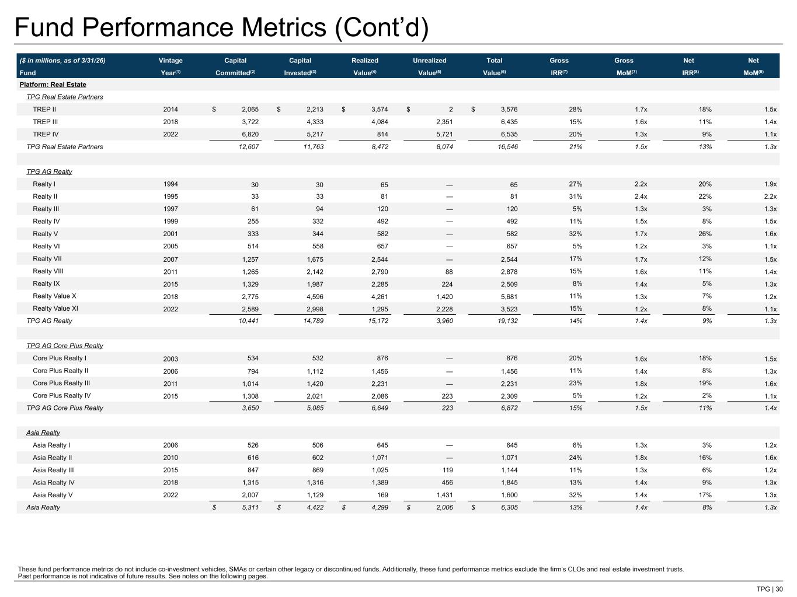
TPG | 30 Fund Performance Metrics (Cont’d) ($ in millions, as of 3/31/26) Vintage Capital Capital Realized Unrealized Total Gross Gross Net Net Fund Year(1) Committed(2) Invested(3) Value(4) Value(5) Value(6) IRR(7) MoM(7) IRR(8) MoM(9) Platform: Real Estate TPG Real Estate Partners TREP II 2014 $ 2,065 $ 2,213 $ 3,574 $ 2 $ 3,576 28% 1.7x 18% 1.5x TREP III 2018 3,722 4,333 4,084 2,351 6,435 15% 1.6x 11% 1.4x TREP IV 2022 6,820 5,217 814 5,721 6,535 20% 1.3x 9% 1.1x TPG Real Estate Partners 12,607 11,763 8,472 8,074 16,546 21% 1.5x 13% 1.3x TPG AG Realty Realty I 1994 30 30 65 — 65 27% 2.2x 20% 1.9x Realty II 1995 33 33 81 — 81 31% 2.4x 22% 2.2x Realty III 1997 61 94 120 — 120 5% 1.3x 3% 1.3x Realty IV 1999 255 332 492 — 492 11% 1.5x 8% 1.5x Realty V 2001 333 344 582 — 582 32% 1.7x 26% 1.6x Realty VI 2005 514 558 657 — 657 5% 1.2x 3% 1.1x Realty VII 2007 1,257 1,675 2,544 — 2,544 17% 1.7x 12% 1.5x Realty VIII 2011 1,265 2,142 2,790 88 2,878 15% 1.6x 11% 1.4x Realty IX 2015 1,329 1,987 2,285 224 2,509 8% 1.4x 5% 1.3x Realty Value X 2018 2,775 4,596 4,261 1,420 5,681 11% 1.3x 7% 1.2x Realty Value XI 2022 2,589 2,998 1,295 2,228 3,523 15% 1.2x 8% 1.1x TPG AG Realty 10,441 14,789 15,172 3,960 19,132 14% 1.4x 9% 1.3x TPG AG Core Plus Realty Core Plus Realty I 2003 534 532 876 — 876 20% 1.6x 18% 1.5x Core Plus Realty II 2006 794 1,112 1,456 — 1,456 11% 1.4x 8% 1.3x Core Plus Realty III 2011 1,014 1,420 2,231 — 2,231 23% 1.8x 19% 1.6x Core Plus Realty IV 2015 1,308 2,021 2,086 223 2,309 5% 1.2x 2% 1.1x TPG AG Core Plus Realty 3,650 5,085 6,649 223 6,872 15% 1.5x 11% 1.4x Asia Realty Asia Realty I 2006 526 506 645 — 645 6% 1.3x 3% 1.2x Asia Realty II 2010 616 602 1,071 — 1,071 24% 1.8x 16% 1.6x Asia Realty III 2015 847 869 1,025 119 1,144 11% 1.3x 6% 1.2x Asia Realty IV 2018 1,315 1,316 1,389 456 1,845 13% 1.4x 9% 1.3x Asia Realty V 2022 2,007 1,129 169 1,431 1,600 32% 1.4x 17% 1.3x Asia Realty $ 5,311 $ 4,422 $ 4,299 $ 2,006 $ 6,305 13% 1.4x 8% 1.3x These fund performance metrics do not include co-investment vehicles, SMAs or certain other legacy or discontinued funds. Additionally, these fund performance metrics exclude the firm’s CLOs and real estate investment trusts. Past performance is not indicative of future results. See notes on the following pages.

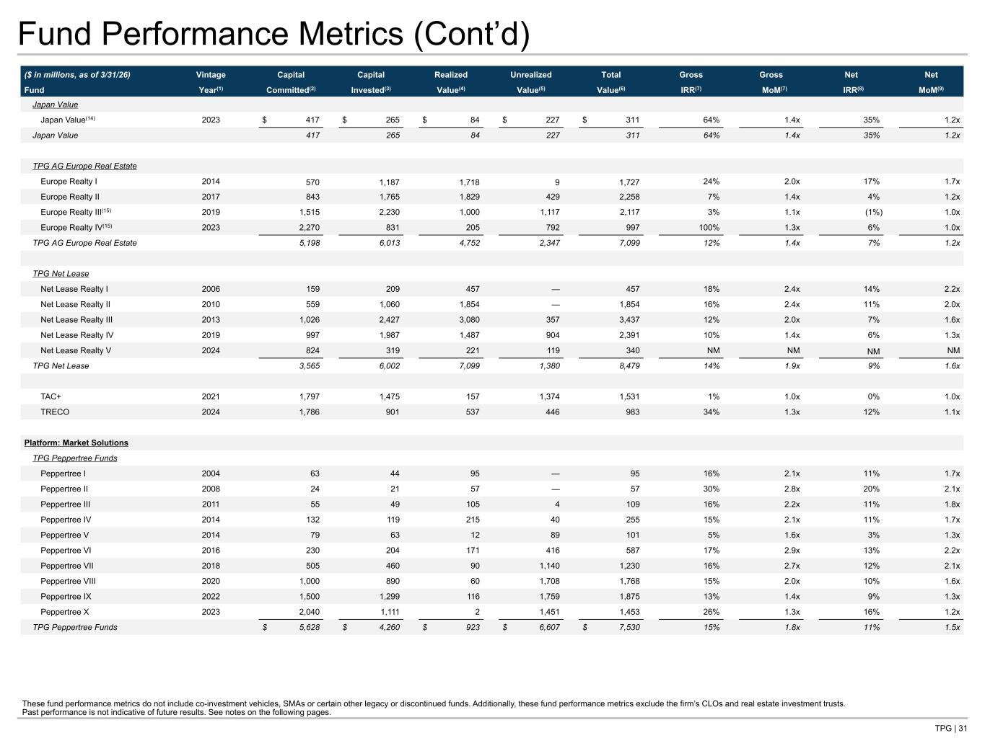
TPG | 31 Fund Performance Metrics (Cont’d) ($ in millions, as of 3/31/26) Vintage Capital Capital Realized Unrealized Total Gross Gross Net Net Fund Year(1) Committed(2) Invested(3) Value(4) Value(5) Value(6) IRR(7) MoM(7) IRR(8) MoM(9) Japan Value Japan Value(14) 2023 $ 417 $ 265 $ 84 $ 227 $ 311 64% 1.4x 35% 1.2x Japan Value 417 265 84 227 311 64% 1.4x 35% 1.2x TPG AG Europe Real Estate Europe Realty I 2014 570 1,187 1,718 9 1,727 24% 2.0x 17% 1.7x Europe Realty II 2017 843 1,765 1,829 429 2,258 7% 1.4x 4% 1.2x Europe Realty III(15) 2019 1,515 2,230 1,000 1,117 2,117 3% 1.1x (1%) 1.0x Europe Realty IV(15) 2023 2,270 831 205 792 997 100% 1.3x 6% 1.0x TPG AG Europe Real Estate 5,198 6,013 4,752 2,347 7,099 12% 1.4x 7% 1.2x TPG Net Lease Net Lease Realty I 2006 159 209 457 — 457 18% 2.4x 14% 2.2x Net Lease Realty II 2010 559 1,060 1,854 — 1,854 16% 2.4x 11% 2.0x Net Lease Realty III 2013 1,026 2,427 3,080 357 3,437 12% 2.0x 7% 1.6x Net Lease Realty IV 2019 997 1,987 1,487 904 2,391 10% 1.4x 6% 1.3x Net Lease Realty V 2024 824 319 221 119 340 NM NM NM NM TPG Net Lease 3,565 6,002 7,099 1,380 8,479 14% 1.9x 9% 1.6x TAC+ 2021 1,797 1,475 157 1,374 1,531 1% 1.0x 0% 1.0x TRECO 2024 1,786 901 537 446 983 34% 1.3x 12% 1.1x Platform: Market Solutions TPG Peppertree Funds Peppertree I 2004 63 44 95 — 95 16% 2.1x 11% 1.7x Peppertree II 2008 24 21 57 — 57 30% 2.8x 20% 2.1x Peppertree III 2011 55 49 105 4 109 16% 2.2x 11% 1.8x Peppertree IV 2014 132 119 215 40 255 15% 2.1x 11% 1.7x Peppertree V 2014 79 63 12 89 101 5% 1.6x 3% 1.3x Peppertree VI 2016 230 204 171 416 587 17% 2.9x 13% 2.2x Peppertree VII 2018 505 460 90 1,140 1,230 16% 2.7x 12% 2.1x Peppertree VIII 2020 1,000 890 60 1,708 1,768 15% 2.0x 10% 1.6x Peppertree IX 2022 1,500 1,299 116 1,759 1,875 13% 1.4x 9% 1.3x Peppertree X 2023 2,040 1,111 2 1,451 1,453 26% 1.3x 16% 1.2x TPG Peppertree Funds $ 5,628 $ 4,260 $ 923 $ 6,607 $ 7,530 15% 1.8x 11% 1.5x These fund performance metrics do not include co-investment vehicles, SMAs or certain other legacy or discontinued funds. Additionally, these fund performance metrics exclude the firm’s CLOs and real estate investment trusts. Past performance is not indicative of future results. See notes on the following pages.

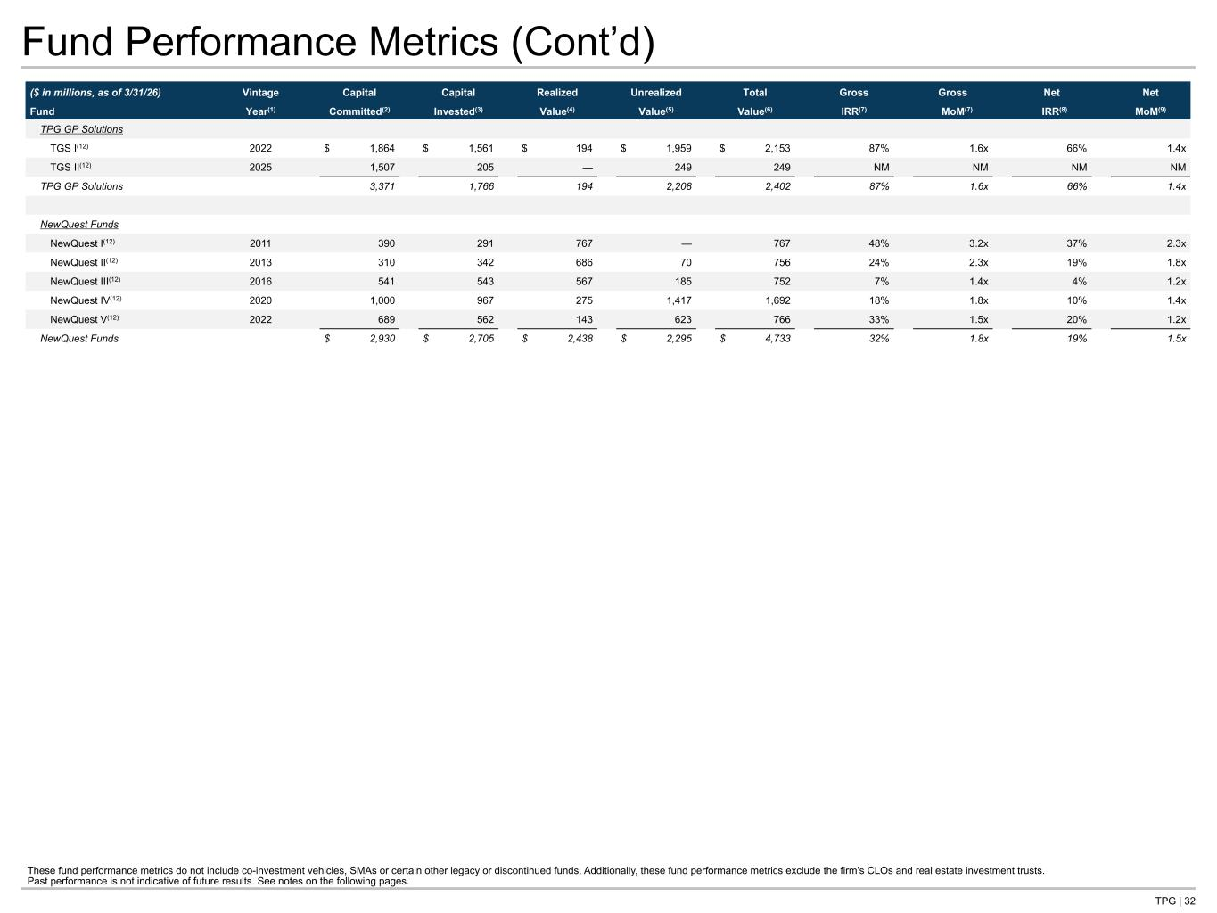
TPG | 32 Fund Performance Metrics (Cont’d) ($ in millions, as of 3/31/26) Vintage Capital Capital Realized Unrealized Total Gross Gross Net Net Fund Year(1) Committed(2) Invested(3) Value(4) Value(5) Value(6) IRR(7) MoM(7) IRR(8) MoM(9) TPG GP Solutions TGS I(12) 2022 $ 1,864 $ 1,561 $ 194 $ 1,959 $ 2,153 87% 1.6x 66% 1.4x TGS II(12) 2025 1,507 205 — 249 249 NM NM NM NM TPG GP Solutions 3,371 1,766 194 2,208 2,402 87% 1.6x 66% 1.4x NewQuest Funds NewQuest I(12) 2011 390 291 767 — 767 48% 3.2x 37% 2.3x NewQuest II(12) 2013 310 342 686 70 756 24% 2.3x 19% 1.8x NewQuest III(12) 2016 541 543 567 185 752 7% 1.4x 4% 1.2x NewQuest IV(12) 2020 1,000 967 275 1,417 1,692 18% 1.8x 10% 1.4x NewQuest V(12) 2022 689 562 143 623 766 33% 1.5x 20% 1.2x NewQuest Funds $ 2,930 $ 2,705 $ 2,438 $ 2,295 $ 4,733 32% 1.8x 19% 1.5x These fund performance metrics do not include co-investment vehicles, SMAs or certain other legacy or discontinued funds. Additionally, these fund performance metrics exclude the firm’s CLOs and real estate investment trusts. Past performance is not indicative of future results. See notes on the following pages.

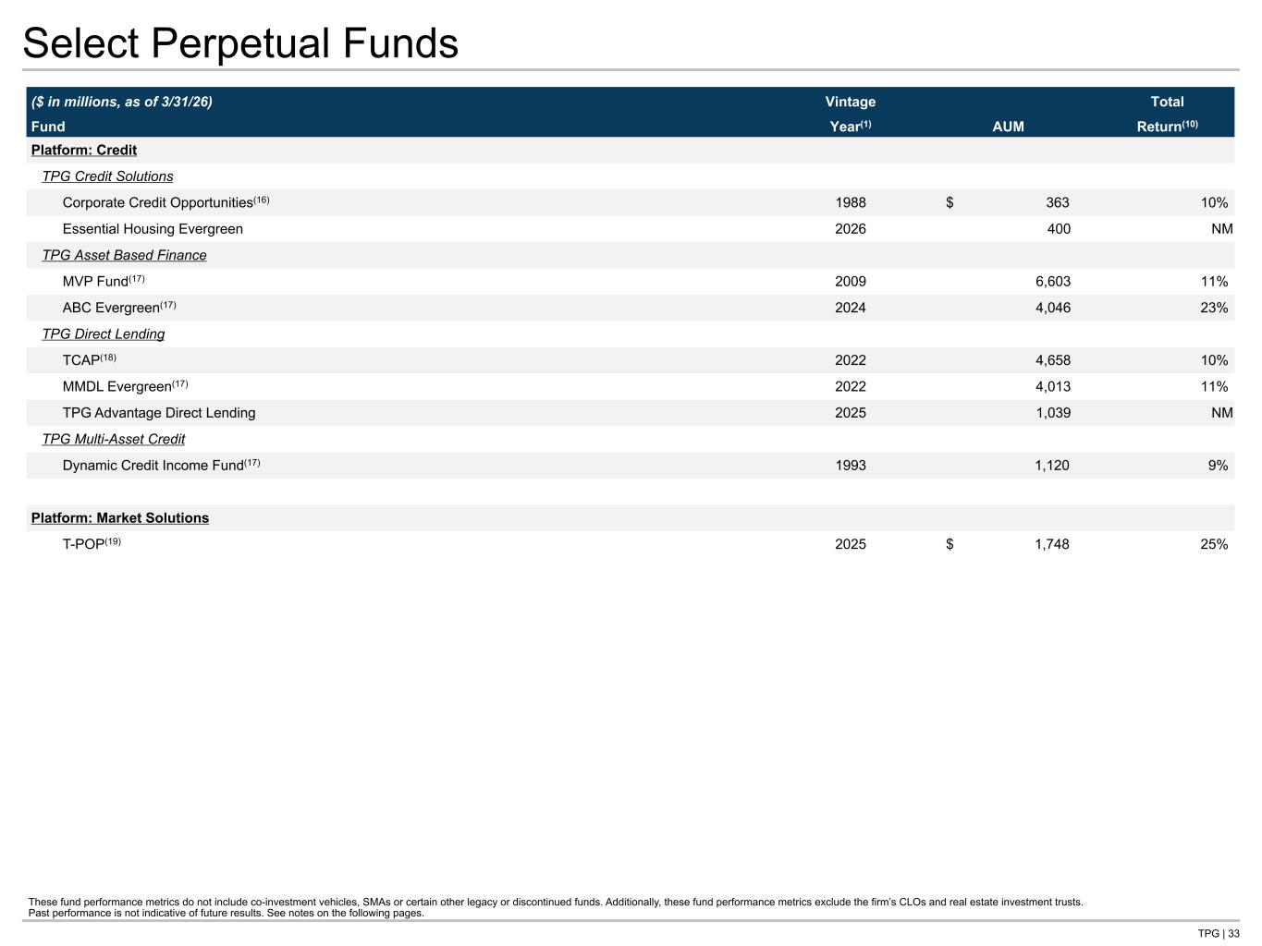
TPG | 33 Select Perpetual Funds ($ in millions, as of 3/31/26) Vintage AUM Total Fund Year(1) Return(10) Platform: Credit TPG Credit Solutions Corporate Credit Opportunities(16) 1988 $ 363 10% Essential Housing Evergreen 2026 400 NM TPG Asset Based Finance MVP Fund(17) 2009 6,603 11% ABC Evergreen(17) 2024 4,046 23% TPG Direct Lending TCAP(18) 2022 4,658 10% MMDL Evergreen(17) 2022 4,013 11% TPG Advantage Direct Lending 2025 1,039 NM TPG Multi-Asset Credit Dynamic Credit Income Fund(17) 1993 1,120 9% Platform: Market Solutions T-POP(19) 2025 $ 1,748 25% These fund performance metrics do not include co-investment vehicles, SMAs or certain other legacy or discontinued funds. Additionally, these fund performance metrics exclude the firm’s CLOs and real estate investment trusts. Past performance is not indicative of future results. See notes on the following pages.

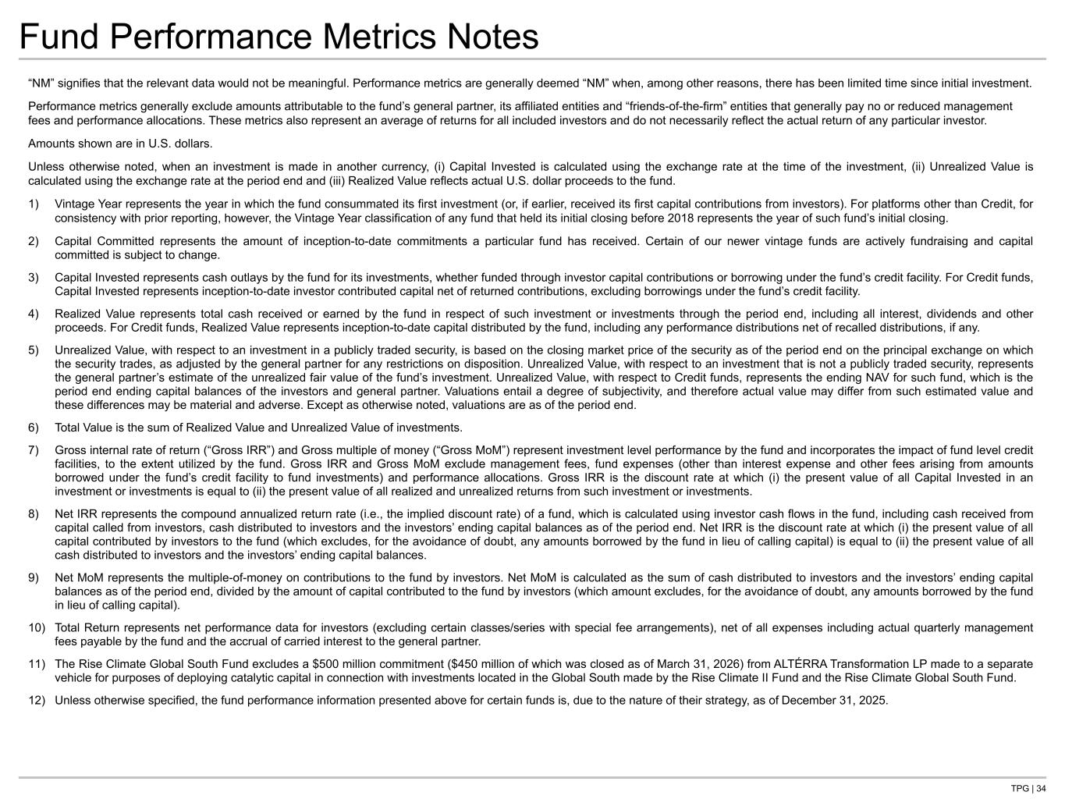
TPG | 34 Fund Performance Metrics Notes “NM” signifies that the relevant data would not be meaningful. Performance metrics are generally deemed “NM” when, among other reasons, there has been limited time since initial investment. Performance metrics generally exclude amounts attributable to the fund’s general partner, its affiliated entities and “friends-of-the-firm” entities that generally pay no or reduced management fees and performance allocations. These metrics also represent an average of returns for all included investors and do not necessarily reflect the actual return of any particular investor. Amounts shown are in U.S. dollars. Unless otherwise noted, when an investment is made in another currency, (i) Capital Invested is calculated using the exchange rate at the time of the investment, (ii) Unrealized Value is calculated using the exchange rate at the period end and (iii) Realized Value reflects actual U.S. dollar proceeds to the fund. 1) Vintage Year represents the year in which the fund consummated its first investment (or, if earlier, received its first capital contributions from investors). For platforms other than Credit, for consistency with prior reporting, however, the Vintage Year classification of any fund that held its initial closing before 2018 represents the year of such fund’s initial closing. 2) Capital Committed represents the amount of inception-to-date commitments a particular fund has received. Certain of our newer vintage funds are actively fundraising and capital committed is subject to change. 3) Capital Invested represents cash outlays by the fund for its investments, whether funded through investor capital contributions or borrowing under the fund’s credit facility. For Credit funds, Capital Invested represents inception-to-date investor contributed capital net of returned contributions, excluding borrowings under the fund’s credit facility. 4) Realized Value represents total cash received or earned by the fund in respect of such investment or investments through the period end, including all interest, dividends and other proceeds. For Credit funds, Realized Value represents inception-to-date capital distributed by the fund, including any performance distributions net of recalled distributions, if any. 5) Unrealized Value, with respect to an investment in a publicly traded security, is based on the closing market price of the security as of the period end on the principal exchange on which the security trades, as adjusted by the general partner for any restrictions on disposition. Unrealized Value, with respect to an investment that is not a publicly traded security, represents the general partner’s estimate of the unrealized fair value of the fund’s investment. Unrealized Value, with respect to Credit funds, represents the ending NAV for such fund, which is the period end ending capital balances of the investors and general partner. Valuations entail a degree of subjectivity, and therefore actual value may differ from such estimated value and these differences may be material and adverse. Except as otherwise noted, valuations are as of the period end. 6) Total Value is the sum of Realized Value and Unrealized Value of investments. 7) Gross internal rate of return (“Gross IRR”) and Gross multiple of money (“Gross MoM”) represent investment level performance by the fund and incorporates the impact of fund level credit facilities, to the extent utilized by the fund. Gross IRR and Gross MoM exclude management fees, fund expenses (other than interest expense and other fees arising from amounts borrowed under the fund’s credit facility to fund investments) and performance allocations. Gross IRR is the discount rate at which (i) the present value of all Capital Invested in an investment or investments is equal to (ii) the present value of all realized and unrealized returns from such investment or investments. 8) Net IRR represents the compound annualized return rate (i.e., the implied discount rate) of a fund, which is calculated using investor cash flows in the fund, including cash received from capital called from investors, cash distributed to investors and the investors’ ending capital balances as of the period end. Net IRR is the discount rate at which (i) the present value of all capital contributed by investors to the fund (which excludes, for the avoidance of doubt, any amounts borrowed by the fund in lieu of calling capital) is equal to (ii) the present value of all cash distributed to investors and the investors’ ending capital balances. 9) Net MoM represents the multiple-of-money on contributions to the fund by investors. Net MoM is calculated as the sum of cash distributed to investors and the investors’ ending capital balances as of the period end, divided by the amount of capital contributed to the fund by investors (which amount excludes, for the avoidance of doubt, any amounts borrowed by the fund in lieu of calling capital). 10) Total Return represents net performance data for investors (excluding certain classes/series with special fee arrangements), net of all expenses including actual quarterly management fees payable by the fund and the accrual of carried interest to the general partner. 11) The Rise Climate Global South Fund excludes a $500 million commitment ($450 million of which was closed as of March 31, 2026) from ALTÉRRA Transformation LP made to a separate vehicle for purposes of deploying catalytic capital in connection with investments located in the Global South made by the Rise Climate II Fund and the Rise Climate Global South Fund. 12) Unless otherwise specified, the fund performance information presented above for certain funds is, due to the nature of their strategy, as of December 31, 2025. Remember to check with PFT/FF on ALTERRA amount

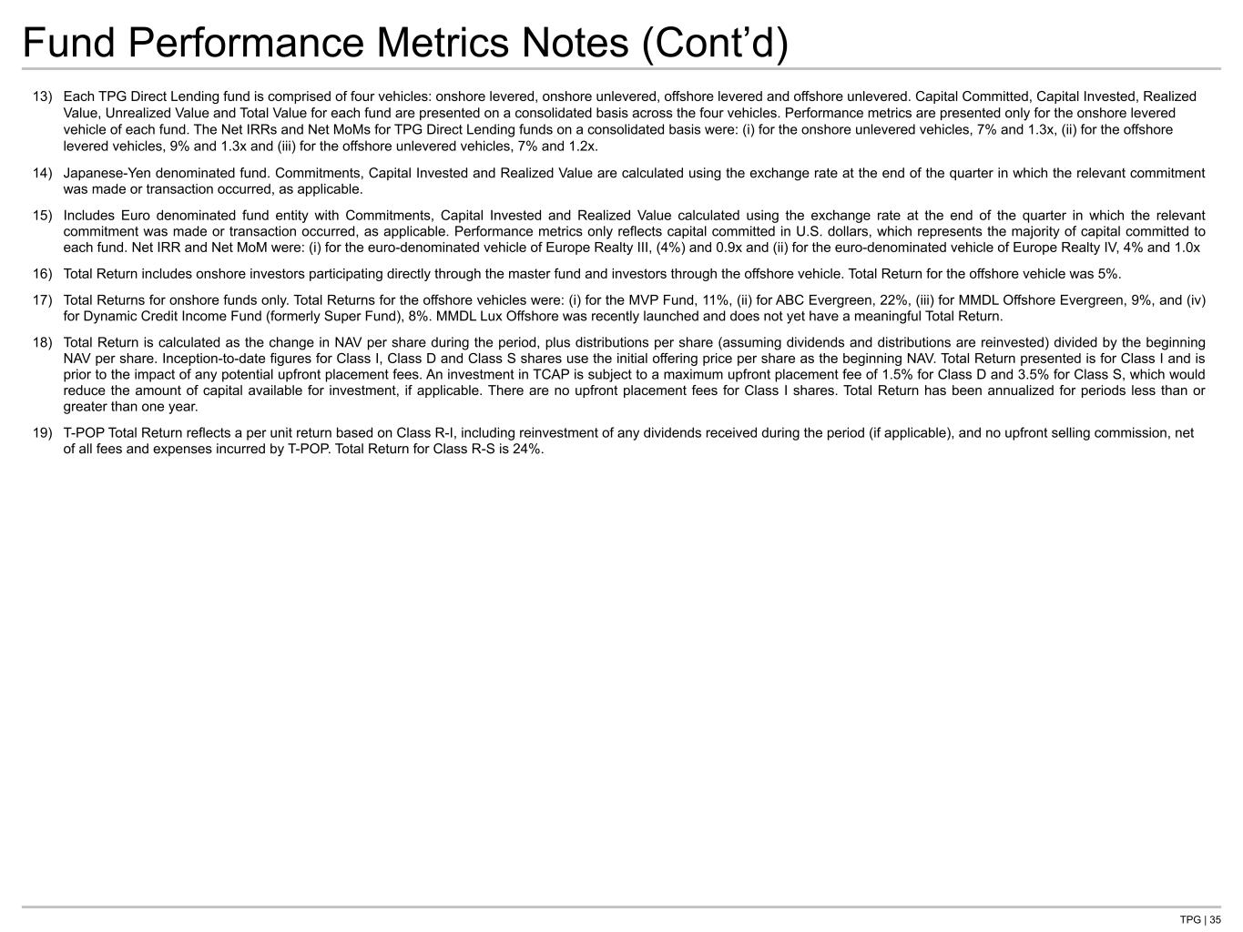
TPG | 35 Fund Performance Metrics Notes (Cont’d) 13) Each TPG Direct Lending fund is comprised of four vehicles: onshore levered, onshore unlevered, offshore levered and offshore unlevered. Capital Committed, Capital Invested, Realized Value, Unrealized Value and Total Value for each fund are presented on a consolidated basis across the four vehicles. Performance metrics are presented only for the onshore levered vehicle of each fund. The Net IRRs and Net MoMs for TPG Direct Lending funds on a consolidated basis were: (i) for the onshore unlevered vehicles, 7% and 1.3x, (ii) for the offshore levered vehicles, 9% and 1.3x and (iii) for the offshore unlevered vehicles, 7% and 1.2x. 14) Japanese-Yen denominated fund. Commitments, Capital Invested and Realized Value are calculated using the exchange rate at the end of the quarter in which the relevant commitment was made or transaction occurred, as applicable. 15) Includes Euro denominated fund entity with Commitments, Capital Invested and Realized Value calculated using the exchange rate at the end of the quarter in which the relevant commitment was made or transaction occurred, as applicable. Performance metrics only reflects capital committed in U.S. dollars, which represents the majority of capital committed to each fund. Net IRR and Net MoM were: (i) for the euro-denominated vehicle of Europe Realty III, (4%) and 0.9x and (ii) for the euro-denominated vehicle of Europe Realty IV, 4% and 1.0x 16) Total Return includes onshore investors participating directly through the master fund and investors through the offshore vehicle. Total Return for the offshore vehicle was 5%. 17) Total Returns for onshore funds only. Total Returns for the offshore vehicles were: (i) for the MVP Fund, 11%, (ii) for ABC Evergreen, 22%, (iii) for MMDL Offshore Evergreen, 9%, and (iv) for Dynamic Credit Income Fund (formerly Super Fund), 8%. MMDL Lux Offshore was recently launched and does not yet have a meaningful Total Return. 18) Total Return is calculated as the change in NAV per share during the period, plus distributions per share (assuming dividends and distributions are reinvested) divided by the beginning NAV per share. Inception-to-date figures for Class I, Class D and Class S shares use the initial offering price per share as the beginning NAV. Total Return presented is for Class I and is prior to the impact of any potential upfront placement fees. An investment in TCAP is subject to a maximum upfront placement fee of 1.5% for Class D and 3.5% for Class S, which would reduce the amount of capital available for investment, if applicable. There are no upfront placement fees for Class I shares. Total Return has been annualized for periods less than or greater than one year. 19) T-POP Total Return reflects a per unit return based on Class R-I, including reinvestment of any dividends received during the period (if applicable), and no upfront selling commission, net of all fees and expenses incurred by T-POP. Total Return for Class R-S is 24%.

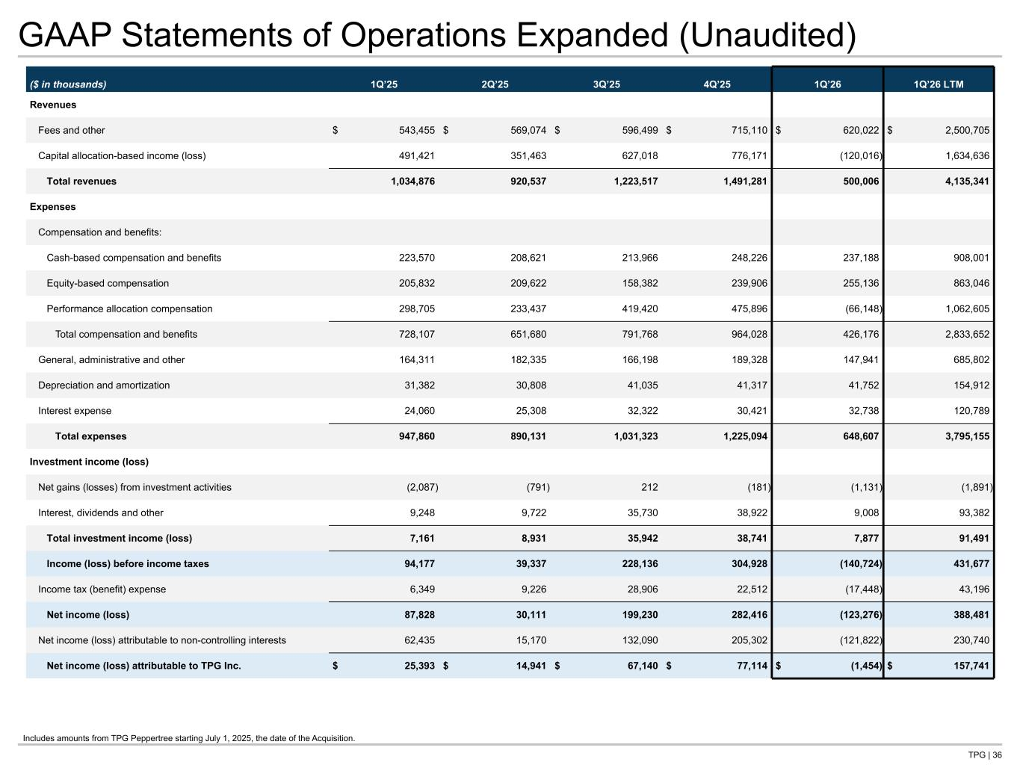
TPG | 36 GAAP Statements of Operations Expanded (Unaudited) ($ in thousands) 1Q’25 2Q’25 3Q’25 4Q’25 1Q’26 1Q’26 LTM Revenues Fees and other $ 543,455 $ 569,074 $ 596,499 $ 715,110 $ 620,022 $ 2,500,705 Capital allocation-based income (loss) 491,421 351,463 627,018 776,171 (120,016) 1,634,636 Total revenues 1,034,876 920,537 1,223,517 1,491,281 500,006 4,135,341 Expenses Compensation and benefits: Cash-based compensation and benefits 223,570 208,621 213,966 248,226 237,188 908,001 Equity-based compensation 205,832 209,622 158,382 239,906 255,136 863,046 Performance allocation compensation 298,705 233,437 419,420 475,896 (66,148) 1,062,605 Total compensation and benefits 728,107 651,680 791,768 964,028 426,176 2,833,652 General, administrative and other 164,311 182,335 166,198 189,328 147,941 685,802 Depreciation and amortization 31,382 30,808 41,035 41,317 41,752 154,912 Interest expense 24,060 25,308 32,322 30,421 32,738 120,789 Total expenses 947,860 890,131 1,031,323 1,225,094 648,607 3,795,155 Investment income (loss) Net gains (losses) from investment activities (2,087) (791) 212 (181) (1,131) (1,891) Interest, dividends and other 9,248 9,722 35,730 38,922 9,008 93,382 Total investment income (loss) 7,161 8,931 35,942 38,741 7,877 91,491 Income (loss) before income taxes 94,177 39,337 228,136 304,928 (140,724) 431,677 Income tax (benefit) expense 6,349 9,226 28,906 22,512 (17,448) 43,196 Net income (loss) 87,828 30,111 199,230 282,416 (123,276) 388,481 Net income (loss) attributable to non-controlling interests 62,435 15,170 132,090 205,302 (121,822) 230,740 Net income (loss) attributable to TPG Inc. $ 25,393 $ 14,941 $ 67,140 $ 77,114 $ (1,454) $ 157,741 Tie to: -G P&L at front of deck -G-NG recon Includes amounts from TPG Peppertree starting July 1, 2025, the date of the Acquisition.

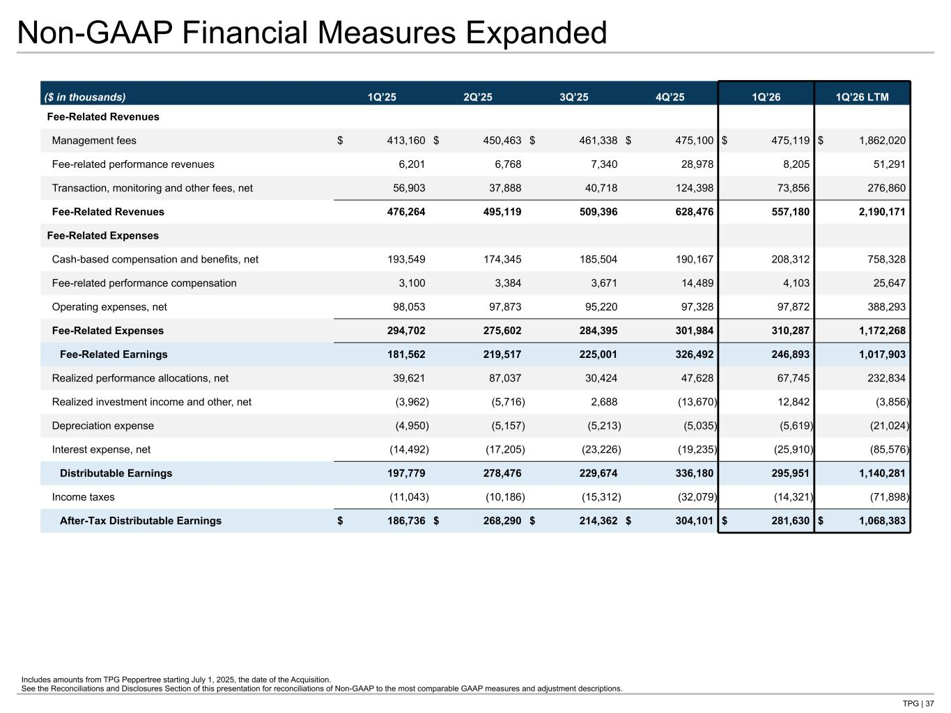
TPG | 37 Non-GAAP Financial Measures Expanded Includes amounts from TPG Peppertree starting July 1, 2025, the date of the Acquisition. See the Reconciliations and Disclosures Section of this presentation for reconciliations of Non-GAAP to the most comparable GAAP measures and adjustment descriptions. ($ in thousands) 1Q’25 2Q’25 3Q’25 4Q’25 1Q’26 1Q’26 LTM Fee-Related Revenues Management fees $ 413,160 $ 450,463 $ 461,338 $ 475,100 $ 475,119 $ 1,862,020 Fee-related performance revenues 6,201 6,768 7,340 28,978 8,205 51,291 Transaction, monitoring and other fees, net 56,903 37,888 40,718 124,398 73,856 276,860 Fee-Related Revenues 476,264 495,119 509,396 628,476 557,180 2,190,171 Fee-Related Expenses Cash-based compensation and benefits, net 193,549 174,345 185,504 190,167 208,312 758,328 Fee-related performance compensation 3,100 3,384 3,671 14,489 4,103 25,647 Operating expenses, net 98,053 97,873 95,220 97,328 97,872 388,293 Fee-Related Expenses 294,702 275,602 284,395 301,984 310,287 1,172,268 Fee-Related Earnings 181,562 219,517 225,001 326,492 246,893 1,017,903 Realized performance allocations, net 39,621 87,037 30,424 47,628 67,745 232,834 Realized investment income and other, net (3,962) (5,716) 2,688 (13,670) 12,842 (3,856) Depreciation expense (4,950) (5,157) (5,213) (5,035) (5,619) (21,024) Interest expense, net (14,492) (17,205) (23,226) (19,235) (25,910) (85,576) Distributable Earnings 197,779 278,476 229,674 336,180 295,951 1,140,281 Income taxes (11,043) (10,186) (15,312) (32,079) (14,321) (71,898) After-Tax Distributable Earnings $ 186,736 $ 268,290 $ 214,362 $ 304,101 $ 281,630 $ 1,068,383 Tie to: -NG P&L at front -G-NG qtrly in recon section


Reconciliations and Disclosures

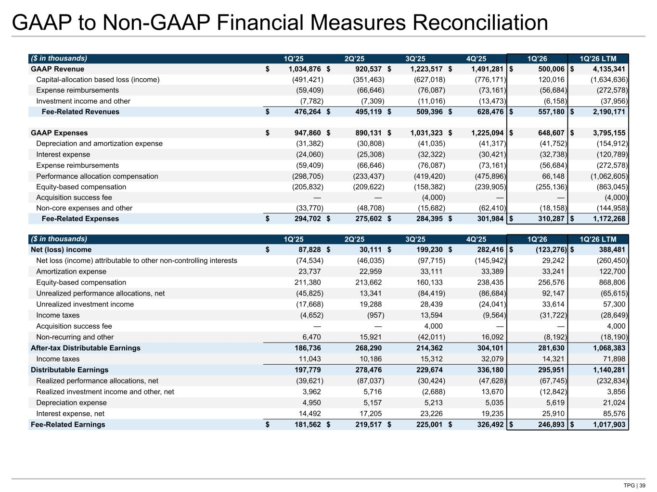
TPG | 39 GAAP to Non-GAAP Financial Measures Reconciliation ($ in thousands) 1Q’25 2Q’25 3Q’25 4Q’25 1Q’26 1Q’26 LTM GAAP Revenue $ 1,034,876 $ 920,537 $ 1,223,517 $ 1,491,281 $ 500,006 $ 4,135,341 Capital-allocation based loss (income) (491,421) (351,463) (627,018) (776,171) 120,016 (1,634,636) Expense reimbursements (59,409) (66,646) (76,087) (73,161) (56,684) (272,578) Investment income and other (7,782) (7,309) (11,016) (13,473) (6,158) (37,956) Fee-Related Revenues $ 476,264 $ 495,119 $ 509,396 $ 628,476 $ 557,180 $ 2,190,171 GAAP Expenses $ 947,860 $ 890,131 $ 1,031,323 $ 1,225,094 $ 648,607 $ 3,795,155 Depreciation and amortization expense (31,382) (30,808) (41,035) (41,317) (41,752) (154,912) Interest expense (24,060) (25,308) (32,322) (30,421) (32,738) (120,789) Expense reimbursements (59,409) (66,646) (76,087) (73,161) (56,684) (272,578) Performance allocation compensation (298,705) (233,437) (419,420) (475,896) 66,148 (1,062,605) Equity-based compensation (205,832) (209,622) (158,382) (239,905) (255,136) (863,045) Acquisition success fee — — (4,000) — — (4,000) Non-core expenses and other (33,770) (48,708) (15,682) (62,410) (18,158) (144,958) Fee-Related Expenses $ 294,702 $ 275,602 $ 284,395 $ 301,984 $ 310,287 $ 1,172,268 ($ in thousands) 1Q’25 2Q’25 3Q’25 4Q’25 1Q’26 1Q’26 LTM Net (loss) income $ 87,828 $ 30,111 $ 199,230 $ 282,416 $ (123,276) $ 388,481 Net loss (income) attributable to other non-controlling interests (74,534) (46,035) (97,715) (145,942) 29,242 (260,450) Amortization expense 23,737 22,959 33,111 33,389 33,241 122,700 Equity-based compensation 211,380 213,662 160,133 238,435 256,576 868,806 Unrealized performance allocations, net (45,825) 13,341 (84,419) (86,684) 92,147 (65,615) Unrealized investment income (17,668) 19,288 28,439 (24,041) 33,614 57,300 Income taxes (4,652) (957) 13,594 (9,564) (31,722) (28,649) Acquisition success fee — — 4,000 — — 4,000 Non-recurring and other 6,470 15,921 (42,011) 16,092 (8,192) (18,190) After-tax Distributable Earnings 186,736 268,290 214,362 304,101 281,630 1,068,383 Income taxes 11,043 10,186 15,312 32,079 14,321 71,898 Distributable Earnings 197,779 278,476 229,674 336,180 295,951 1,140,281 Realized performance allocations, net (39,621) (87,037) (30,424) (47,628) (67,745) (232,834) Realized investment income and other, net 3,962 5,716 (2,688) 13,670 (12,842) 3,856 Depreciation expense 4,950 5,157 5,213 5,035 5,619 21,024 Interest expense, net 14,492 17,205 23,226 19,235 25,910 85,576 Fee-Related Earnings $ 181,562 $ 219,517 $ 225,001 $ 326,492 $ 246,893 $ 1,017,903 Tie to: -NG P&L at front -NG qtrly P&L -G P&L at front -G qtrly P&L

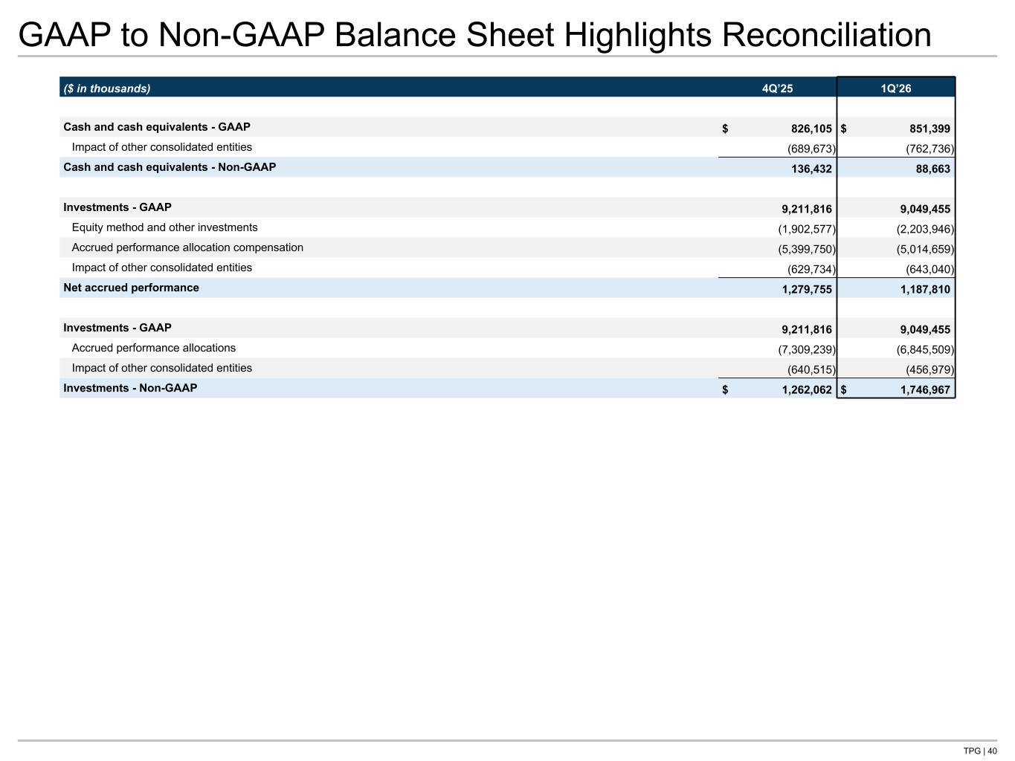
TPG | 40 GAAP to Non-GAAP Balance Sheet Highlights Reconciliation ($ in thousands) 4Q’25 1Q’26 Cash and cash equivalents - GAAP $ 826,105 $ 851,399 Impact of other consolidated entities (689,673) (762,736) Cash and cash equivalents - Non-GAAP 136,432 88,663 Investments - GAAP 9,211,816 9,049,455 Equity method and other investments (1,902,577) (2,203,946) Accrued performance allocation compensation (5,399,750) (5,014,659) Impact of other consolidated entities (629,734) (643,040) Net accrued performance 1,279,755 1,187,810 Investments - GAAP 9,211,816 9,049,455 Accrued performance allocations (7,309,239) (6,845,509) Impact of other consolidated entities (640,515) (456,979) Investments - Non-GAAP $ 1,262,062 $ 1,746,967 Tie to: -G B/S page -NG B/S page

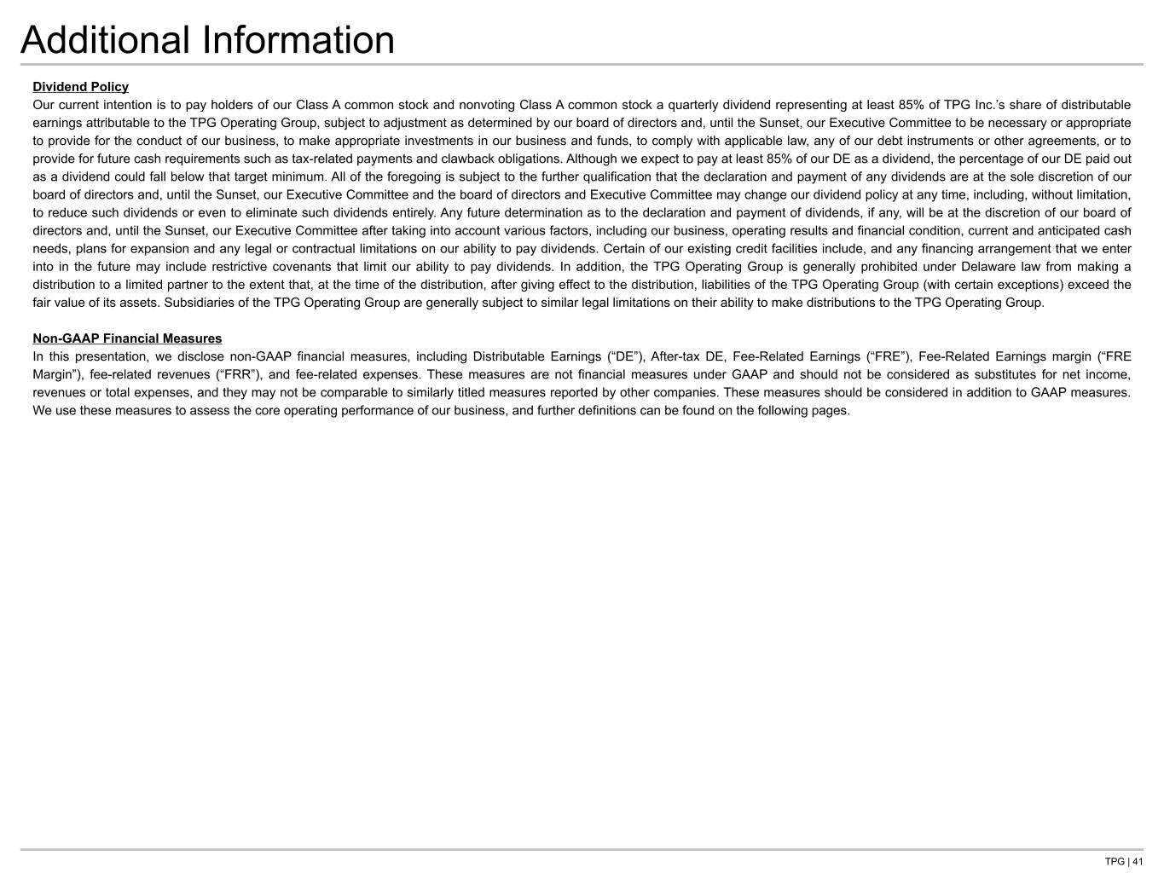
TPG | 41 Additional Information Dividend Policy Our current intention is to pay holders of our Class A common stock and nonvoting Class A common stock a quarterly dividend representing at least 85% of TPG Inc.’s share of distributable earnings attributable to the TPG Operating Group, subject to adjustment as determined by our board of directors and, until the Sunset, our Executive Committee to be necessary or appropriate to provide for the conduct of our business, to make appropriate investments in our business and funds, to comply with applicable law, any of our debt instruments or other agreements, or to provide for future cash requirements such as tax-related payments and clawback obligations. Although we expect to pay at least 85% of our DE as a dividend, the percentage of our DE paid out as a dividend could fall below that target minimum. All of the foregoing is subject to the further qualification that the declaration and payment of any dividends are at the sole discretion of our board of directors and, until the Sunset, our Executive Committee and the board of directors and Executive Committee may change our dividend policy at any time, including, without limitation, to reduce such dividends or even to eliminate such dividends entirely. Any future determination as to the declaration and payment of dividends, if any, will be at the discretion of our board of directors and, until the Sunset, our Executive Committee after taking into account various factors, including our business, operating results and financial condition, current and anticipated cash needs, plans for expansion and any legal or contractual limitations on our ability to pay dividends. Certain of our existing credit facilities include, and any financing arrangement that we enter into in the future may include restrictive covenants that limit our ability to pay dividends. In addition, the TPG Operating Group is generally prohibited under Delaware law from making a distribution to a limited partner to the extent that, at the time of the distribution, after giving effect to the distribution, liabilities of the TPG Operating Group (with certain exceptions) exceed the fair value of its assets. Subsidiaries of the TPG Operating Group are generally subject to similar legal limitations on their ability to make distributions to the TPG Operating Group. Non-GAAP Financial Measures In this presentation, we disclose non-GAAP financial measures, including Distributable Earnings (“DE”), After-tax DE, Fee-Related Earnings (“FRE”), Fee-Related Earnings margin (“FRE Margin”), fee-related revenues (“FRR”), and fee-related expenses. These measures are not financial measures under GAAP and should not be considered as substitutes for net income, revenues or total expenses, and they may not be comparable to similarly titled measures reported by other companies. These measures should be considered in addition to GAAP measures. We use these measures to assess the core operating performance of our business, and further definitions can be found on the following pages.

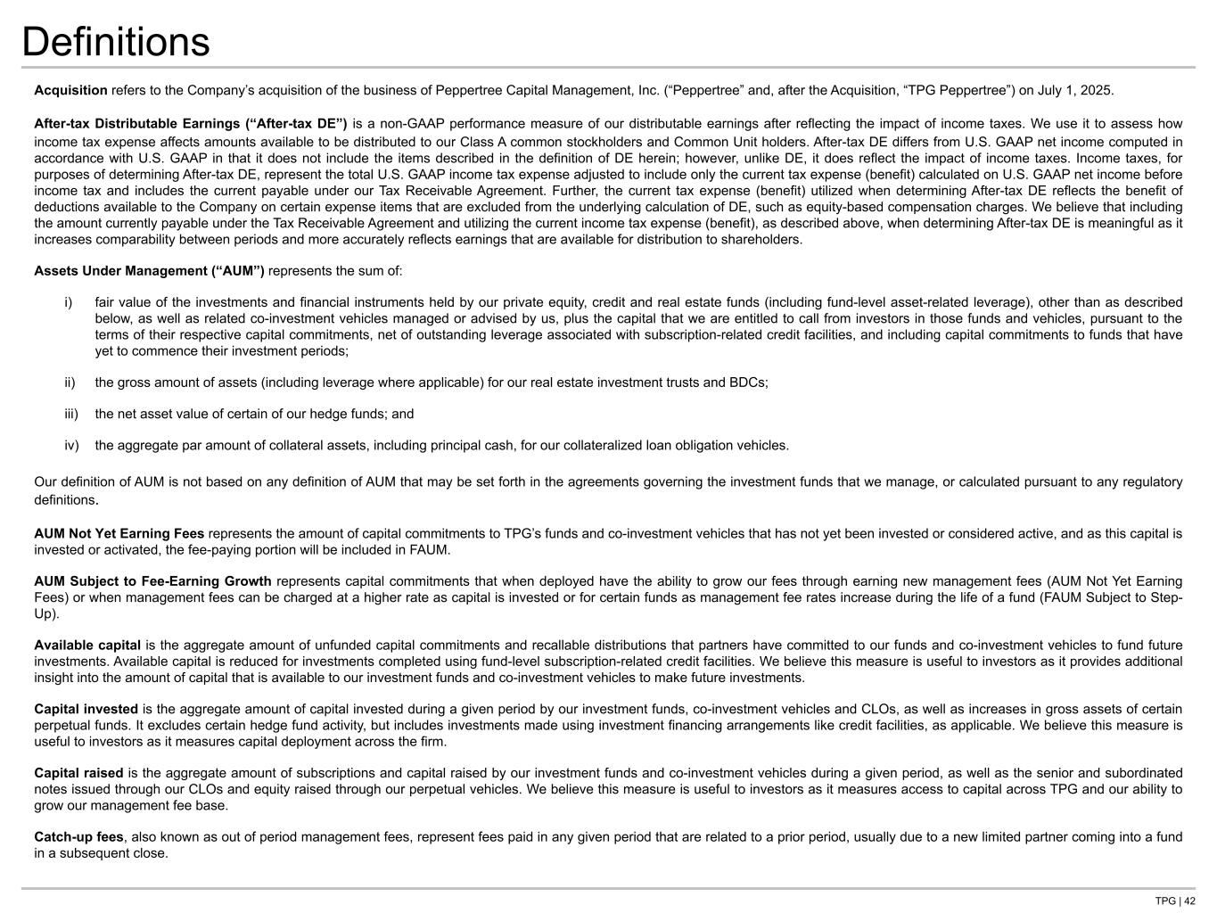
TPG | 42 Definitions Acquisition refers to the Company’s acquisition of the business of Peppertree Capital Management, Inc. (“Peppertree” and, after the Acquisition, “TPG Peppertree”) on July 1, 2025. After-tax Distributable Earnings (“After-tax DE”) is a non-GAAP performance measure of our distributable earnings after reflecting the impact of income taxes. We use it to assess how income tax expense affects amounts available to be distributed to our Class A common stockholders and Common Unit holders. After-tax DE differs from U.S. GAAP net income computed in accordance with U.S. GAAP in that it does not include the items described in the definition of DE herein; however, unlike DE, it does reflect the impact of income taxes. Income taxes, for purposes of determining After-tax DE, represent the total U.S. GAAP income tax expense adjusted to include only the current tax expense (benefit) calculated on U.S. GAAP net income before income tax and includes the current payable under our Tax Receivable Agreement. Further, the current tax expense (benefit) utilized when determining After-tax DE reflects the benefit of deductions available to the Company on certain expense items that are excluded from the underlying calculation of DE, such as equity-based compensation charges. We believe that including the amount currently payable under the Tax Receivable Agreement and utilizing the current income tax expense (benefit), as described above, when determining After-tax DE is meaningful as it increases comparability between periods and more accurately reflects earnings that are available for distribution to shareholders. Assets Under Management (“AUM”) represents the sum of: i) fair value of the investments and financial instruments held by our private equity, credit and real estate funds (including fund-level asset-related leverage), other than as described below, as well as related co-investment vehicles managed or advised by us, plus the capital that we are entitled to call from investors in those funds and vehicles, pursuant to the terms of their respective capital commitments, net of outstanding leverage associated with subscription-related credit facilities, and including capital commitments to funds that have yet to commence their investment periods; ii) the gross amount of assets (including leverage where applicable) for our real estate investment trusts and BDCs; iii) the net asset value of certain of our hedge funds; and iv) the aggregate par amount of collateral assets, including principal cash, for our collateralized loan obligation vehicles. Our definition of AUM is not based on any definition of AUM that may be set forth in the agreements governing the investment funds that we manage, or calculated pursuant to any regulatory definitions. AUM Not Yet Earning Fees represents the amount of capital commitments to TPG’s funds and co-investment vehicles that has not yet been invested or considered active, and as this capital is invested or activated, the fee-paying portion will be included in FAUM. AUM Subject to Fee-Earning Growth represents capital commitments that when deployed have the ability to grow our fees through earning new management fees (AUM Not Yet Earning Fees) or when management fees can be charged at a higher rate as capital is invested or for certain funds as management fee rates increase during the life of a fund (FAUM Subject to Step- Up). Available capital is the aggregate amount of unfunded capital commitments and recallable distributions that partners have committed to our funds and co-investment vehicles to fund future investments. Available capital is reduced for investments completed using fund-level subscription-related credit facilities. We believe this measure is useful to investors as it provides additional insight into the amount of capital that is available to our investment funds and co-investment vehicles to make future investments. Capital invested is the aggregate amount of capital invested during a given period by our investment funds, co-investment vehicles and CLOs, as well as increases in gross assets of certain perpetual funds. It excludes certain hedge fund activity, but includes investments made using investment financing arrangements like credit facilities, as applicable. We believe this measure is useful to investors as it measures capital deployment across the firm. Capital raised is the aggregate amount of subscriptions and capital raised by our investment funds and co-investment vehicles during a given period, as well as the senior and subordinated notes issued through our CLOs and equity raised through our perpetual vehicles. We believe this measure is useful to investors as it measures access to capital across TPG and our ability to grow our management fee base. Catch-up fees, also known as out of period management fees, represent fees paid in any given period that are related to a prior period, usually due to a new limited partner coming into a fund in a subsequent close.

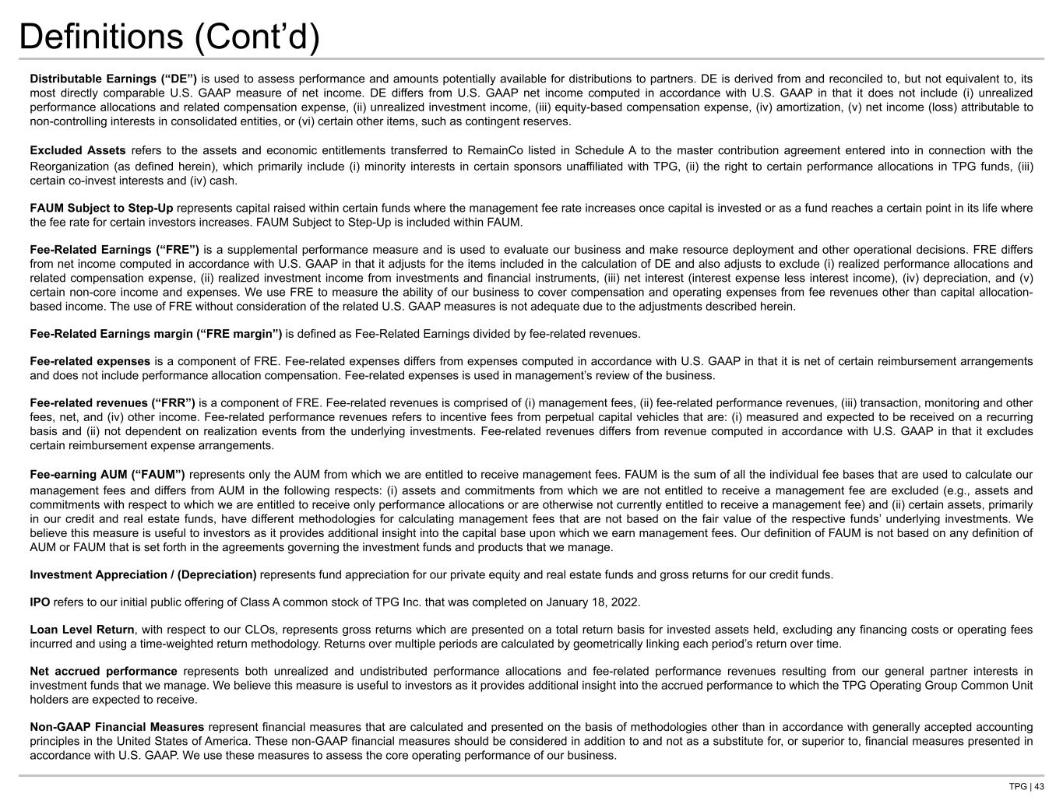
TPG | 43 Definitions (Cont’d) Distributable Earnings (“DE”) is used to assess performance and amounts potentially available for distributions to partners. DE is derived from and reconciled to, but not equivalent to, its most directly comparable U.S. GAAP measure of net income. DE differs from U.S. GAAP net income computed in accordance with U.S. GAAP in that it does not include (i) unrealized performance allocations and related compensation expense, (ii) unrealized investment income, (iii) equity-based compensation expense, (iv) amortization, (v) net income (loss) attributable to non-controlling interests in consolidated entities, or (vi) certain other items, such as contingent reserves. Excluded Assets refers to the assets and economic entitlements transferred to RemainCo listed in Schedule A to the master contribution agreement entered into in connection with the Reorganization (as defined herein), which primarily include (i) minority interests in certain sponsors unaffiliated with TPG, (ii) the right to certain performance allocations in TPG funds, (iii) certain co-invest interests and (iv) cash. FAUM Subject to Step-Up represents capital raised within certain funds where the management fee rate increases once capital is invested or as a fund reaches a certain point in its life where the fee rate for certain investors increases. FAUM Subject to Step-Up is included within FAUM. Fee-Related Earnings (“FRE”) is a supplemental performance measure and is used to evaluate our business and make resource deployment and other operational decisions. FRE differs from net income computed in accordance with U.S. GAAP in that it adjusts for the items included in the calculation of DE and also adjusts to exclude (i) realized performance allocations and related compensation expense, (ii) realized investment income from investments and financial instruments, (iii) net interest (interest expense less interest income), (iv) depreciation, and (v) certain non-core income and expenses. We use FRE to measure the ability of our business to cover compensation and operating expenses from fee revenues other than capital allocation- based income. The use of FRE without consideration of the related U.S. GAAP measures is not adequate due to the adjustments described herein. Fee-Related Earnings margin (“FRE margin”) is defined as Fee-Related Earnings divided by fee-related revenues. Fee-related expenses is a component of FRE. Fee-related expenses differs from expenses computed in accordance with U.S. GAAP in that it is net of certain reimbursement arrangements and does not include performance allocation compensation. Fee-related expenses is used in management’s review of the business. Fee-related revenues (“FRR”) is a component of FRE. Fee-related revenues is comprised of (i) management fees, (ii) fee-related performance revenues, (iii) transaction, monitoring and other fees, net, and (iv) other income. Fee-related performance revenues refers to incentive fees from perpetual capital vehicles that are: (i) measured and expected to be received on a recurring basis and (ii) not dependent on realization events from the underlying investments. Fee-related revenues differs from revenue computed in accordance with U.S. GAAP in that it excludes certain reimbursement expense arrangements. Fee-earning AUM (“FAUM”) represents only the AUM from which we are entitled to receive management fees. FAUM is the sum of all the individual fee bases that are used to calculate our management fees and differs from AUM in the following respects: (i) assets and commitments from which we are not entitled to receive a management fee are excluded (e.g., assets and commitments with respect to which we are entitled to receive only performance allocations or are otherwise not currently entitled to receive a management fee) and (ii) certain assets, primarily in our credit and real estate funds, have different methodologies for calculating management fees that are not based on the fair value of the respective funds’ underlying investments. We believe this measure is useful to investors as it provides additional insight into the capital base upon which we earn management fees. Our definition of FAUM is not based on any definition of AUM or FAUM that is set forth in the agreements governing the investment funds and products that we manage. Investment Appreciation / (Depreciation) represents fund appreciation for our private equity and real estate funds and gross returns for our credit funds. IPO refers to our initial public offering of Class A common stock of TPG Inc. that was completed on January 18, 2022. Loan Level Return, with respect to our CLOs, represents gross returns which are presented on a total return basis for invested assets held, excluding any financing costs or operating fees incurred and using a time-weighted return methodology. Returns over multiple periods are calculated by geometrically linking each period’s return over time. Net accrued performance represents both unrealized and undistributed performance allocations and fee-related performance revenues resulting from our general partner interests in investment funds that we manage. We believe this measure is useful to investors as it provides additional insight into the accrued performance to which the TPG Operating Group Common Unit holders are expected to receive. Non-GAAP Financial Measures represent financial measures that are calculated and presented on the basis of methodologies other than in accordance with generally accepted accounting principles in the United States of America. These non-GAAP financial measures should be considered in addition to and not as a substitute for, or superior to, financial measures presented in accordance with U.S. GAAP. We use these measures to assess the core operating performance of our business.

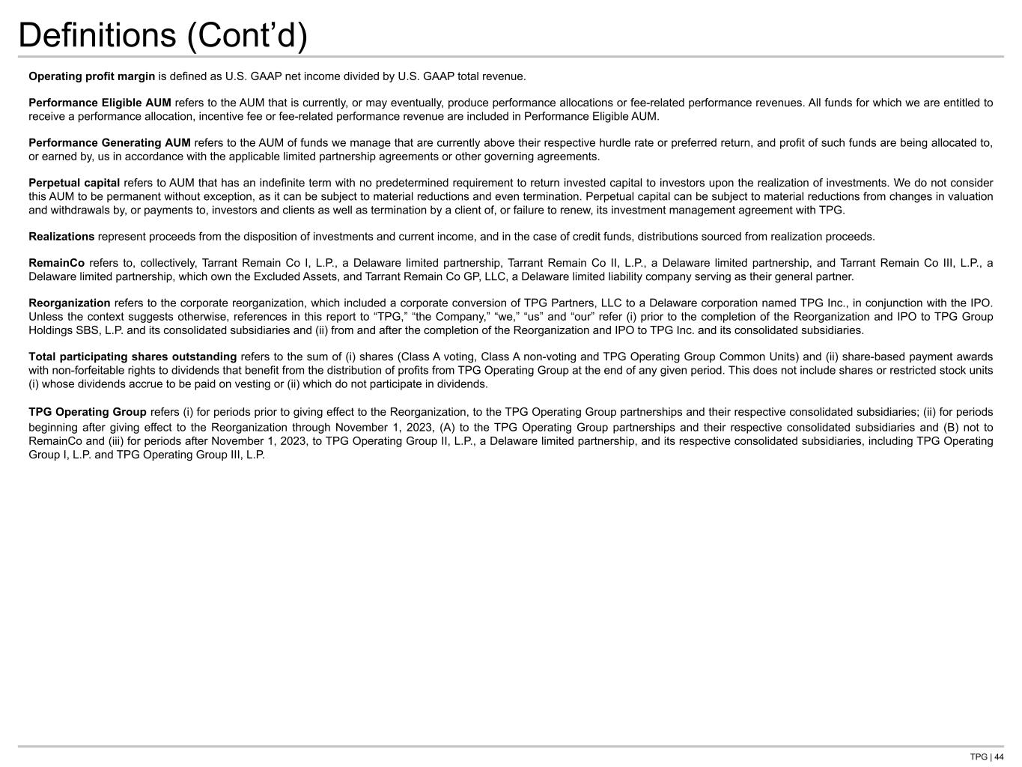
TPG | 44 Definitions (Cont’d) Operating profit margin is defined as U.S. GAAP net income divided by U.S. GAAP total revenue. Performance Eligible AUM refers to the AUM that is currently, or may eventually, produce performance allocations or fee-related performance revenues. All funds for which we are entitled to receive a performance allocation, incentive fee or fee-related performance revenue are included in Performance Eligible AUM. Performance Generating AUM refers to the AUM of funds we manage that are currently above their respective hurdle rate or preferred return, and profit of such funds are being allocated to, or earned by, us in accordance with the applicable limited partnership agreements or other governing agreements. Perpetual capital refers to AUM that has an indefinite term with no predetermined requirement to return invested capital to investors upon the realization of investments. We do not consider this AUM to be permanent without exception, as it can be subject to material reductions and even termination. Perpetual capital can be subject to material reductions from changes in valuation and withdrawals by, or payments to, investors and clients as well as termination by a client of, or failure to renew, its investment management agreement with TPG. Realizations represent proceeds from the disposition of investments and current income, and in the case of credit funds, distributions sourced from realization proceeds. RemainCo refers to, collectively, Tarrant Remain Co I, L.P., a Delaware limited partnership, Tarrant Remain Co II, L.P., a Delaware limited partnership, and Tarrant Remain Co III, L.P., a Delaware limited partnership, which own the Excluded Assets, and Tarrant Remain Co GP, LLC, a Delaware limited liability company serving as their general partner. Reorganization refers to the corporate reorganization, which included a corporate conversion of TPG Partners, LLC to a Delaware corporation named TPG Inc., in conjunction with the IPO. Unless the context suggests otherwise, references in this report to “TPG,” “the Company,” “we,” “us” and “our” refer (i) prior to the completion of the Reorganization and IPO to TPG Group Holdings SBS, L.P. and its consolidated subsidiaries and (ii) from and after the completion of the Reorganization and IPO to TPG Inc. and its consolidated subsidiaries. Total participating shares outstanding refers to the sum of (i) shares (Class A voting, Class A non-voting and TPG Operating Group Common Units) and (ii) share-based payment awards with non-forfeitable rights to dividends that benefit from the distribution of profits from TPG Operating Group at the end of any given period. This does not include shares or restricted stock units (i) whose dividends accrue to be paid on vesting or (ii) which do not participate in dividends. TPG Operating Group refers (i) for periods prior to giving effect to the Reorganization, to the TPG Operating Group partnerships and their respective consolidated subsidiaries; (ii) for periods beginning after giving effect to the Reorganization through November 1, 2023, (A) to the TPG Operating Group partnerships and their respective consolidated subsidiaries and (B) not to RemainCo and (iii) for periods after November 1, 2023, to TPG Operating Group II, L.P., a Delaware limited partnership, and its respective consolidated subsidiaries, including TPG Operating Group I, L.P. and TPG Operating Group III, L.P.

