UNITED STATES
SECURITIES AND EXCHANGE COMMISSION
WASHINGTON, D.C. 20549

FORM 8-K

Current Report
Pursuant to Section 13 or 15(d)
of the Securities Exchange Act of 1934

Date of Report (date of earliest event reported):
August 4, 2026

TPG Inc.
(Exact name of registrant as specified in its charter)

Delaware |  |  |  |  |  | 001-41222 |  |  | 87-2063362
(State or other jurisdiction  of incorporation) |  |  |  |  |  | (Commission File Number) |  |  | (IRS Employer  Identification No.)
301 Commerce Street, Suite 3300
Fort Worth, TX |  |  |  |  |  |  |  |  | 76102
(Address of principal executive offices) |  |  |  |  |  |  |  |  | (Zip Code)
(817) 871-4000
(Registrant’s telephone number, including area code)

Not Applicable
(Former Name or Former Address, if Changed Since Last Report)

Check the appropriate box below if the Form 8-K filing is intended to simultaneously satisfy the filing obligation of the registrant under any of the following provisions:
☐ Written communications pursuant to Rule 425 under the Securities Act (17 CFR 230.425)
☐ Soliciting material pursuant to Rule 14a-12 under the Exchange Act (17 CFR 240.14a-12)
☐ Pre-commencement communications pursuant to Rule 14d-2(b) under the Exchange Act (17 CFR 240.14d-2(b))
☐ Pre-commencement communications pursuant to Rule 13e-4(c) under the Exchange Act (17 CFR 240.13e-4(c))

Securities registered pursuant to Section 12(b) of the Act:
Title of each class |  |  |  |  |  | Trading Symbol(s) |  |  |  |  |  | Name of each exchange on which registered
Class A common stock |  |  |  |  |  | TPG |  |  |  |  |  | The Nasdaq Stock Market LLC  (Nasdaq Global Select Market)
6.950% Subordinated Notes due 2064 |  |  |  |  |  | TPGXL |  |  |  |  |  | The Nasdaq Stock Market LLC  (Nasdaq Global Market)
Indicate by check mark whether the registrant is an emerging growth company as defined in Rule 405 of the Securities Act of 1933 (§230.405 of this chapter) or Rule 12b-2 of the Securities Exchange Act of 1934 (§240.12b-2 of this chapter).
Emerging growth company ☐
If an emerging growth company, indicate by check mark if the registrant has elected not to use the extended transition period for complying with any new or revised financial accounting standards provided pursuant to Section 13(a) of the Exchange Act. ☐

Item 2.02 Results of Operations and Financial Condition.
On August 4, 2026, TPG Inc. issued a summary press release and a detailed earnings presentation announcing financial results for its second quarter ended June 30, 2026. The summary press release and the earnings presentation are furnished as Exhibits 99.1 and 99.2, respectively, to this report.
As provided in General Instruction B.2 of Form 8-K, the information in this Item 2.02 and Exhibits 99.1 and 99.2 incorporated in this Form 8-K shall not be deemed to be “filed” for purposes of Section 18 of the Securities Exchange Act of 1934, as amended (the “Exchange Act”), or otherwise subject to the liabilities of that section, nor shall such information or Exhibits 99.1 and 99.2 be deemed to be incorporated by reference in any filing under the Securities Act of 1933, as amended, or the Exchange Act, regardless of any general incorporation language in such filing.
Item 9.01 Financial Statements and Exhibits.
(d) Exhibits

Exhibit No. |  |  |  |  |  | Description
99.1 |  |  |  |  |  | Summary press release of TPG Inc., dated August 4, 2026.
99.2 |  |  |  |  |  | Earnings presentation of TPG Inc., dated August 4, 2026.
104 |  |  |  |  |  | Cover Page Interactive Data File (embedded within the Inline XBRL document).

SIGNATURES
Pursuant to the requirements of the Securities Exchange Act of 1934, the Registrant has duly caused this report to be signed on its behalf by the undersigned thereto duly authorized.

TPG INC.
By: |  |  |  |  |  | /s/ Axel André
Name: |  |  |  |  |  | Axel André
Title: |  |  |  |  |  | Chief Financial Officer
Date: August 4, 2026

TPG Reports Second Quarter 2026 Results

San Francisco and Fort Worth, Texas – August 4, 2026 – TPG Inc. (NASDAQ: TPG), a leading global alternative asset management firm, today reported its unaudited results for the second quarter ended June 30, 2026. A detailed presentation is available through the Investor Relations section of TPG’s website at shareholders.tpg.com.

"TPG delivered record results during the first half of 2026, reflecting the strength of our diversified and growing franchise,” said Jon Winkelried, Chief Executive Officer. "Our business model is designed to perform across market cycles, and the breadth of our platform, the strength of our investment performance, and the depth of our client relationships continue to support step-function growth across the firm. As clients increasingly partner with TPG for access to our differentiated offerings across strategies, we continue to see significant opportunities to further expand our platform and build long-term value for our shareholders."

Dividend
TPG has declared a quarterly dividend of $0.59 per share of Class A common stock to holders of record at the close of business on August 14, 2026, payable on August 28, 2026.

Conference Call
TPG will host a conference call and live webcast today at 11:00 am ET. It may be accessed by dialing (800) 245-3047 (US toll-free) or (203) 518-9765 (international), using the conference ID TPGQ226. The number should be dialed at least ten minutes prior to the start of the call. A simultaneous webcast will also be available and can be accessed through the Investor Relations section of TPG’s website at shareholders.tpg.com. A webcast replay will be made available on the Events page in the Investor Relations section of TPG’s website.

About TPG
TPG is a leading global alternative asset management firm, founded in San Francisco in 1992, with $327 billion of assets under management and investment and operational teams around the world. TPG invests across a broadly diversified set of strategies, including private equity, impact, credit, real estate, and market solutions, and our unique strategy is driven by collaboration, innovation, and inclusion. Our teams combine deep product and sector experience with broad capabilities and expertise to develop differentiated insights and add value for our fund investors, portfolio companies, management teams, and communities.

Shareholders |  |  | Media
Gary Stein and Evanny Huang |  |  | Luke Barrett and Julia Sottosanti
shareholders@tpg.com |  |  | media@tpg.com

Forward Looking Statements; No Offers
This document may contain “forward-looking” statements. Forward-looking statements can be identified by words such as “anticipates,” “intends,” “plans,” “seeks,” “believes,” “estimates,” “expects” and similar references to future periods, or by the inclusion of forecasts or projections. Examples of forward-looking statements include statements we make regarding the outlook for our future business and financial performance, estimated operational metrics, business strategy and plans and objectives of management for future operations, including, among other things, statements regarding expected growth, future capital expenditures, fund performance, dividends and dividend policy, and debt service obligations.

Forward-looking statements are based on our current expectations and assumptions regarding our business, the economy and other future conditions. Because forward-looking statements relate to the future, by their nature, they are subject to inherent uncertainties, risks and changes in circumstances that are difficult to predict. As a result, our actual results may differ materially from those contemplated by any

forward-looking statements. Important factors that could cause actual results to differ materially from those in the forward-looking statements include the inability to recognize the anticipated benefits, or unexpected costs related to the integration, of acquired companies; our ability to manage growth and execute our business plan; and regional, national or global political, economic, business, competitive, market and regulatory conditions and uncertainties, among various other risks discussed in the Company’s SEC filings.

For the reasons described above, we caution you against relying on any forward-looking statements, which should be read in conjunction with the other cautionary statements included elsewhere in this document and risk factors discussed from time to time in the Company’s filings with the SEC, which can be found at the SEC’s website at http://www.sec.gov. Any forward-looking statement in this document speaks only as of the date of this document. Factors or events that could cause our actual results to differ may emerge from time to time, and it is not possible for us to predict all of them. We undertake no obligation to update or revise any forward-looking statement after the date of this document, whether as a result of new information, future developments or otherwise, except as may be required by law. No recipient should, therefore, rely on these forward-looking statements as representing the views of the Company or its management as of any date subsequent to the date of the document.

This document does not constitute an offer of any TPG fund.
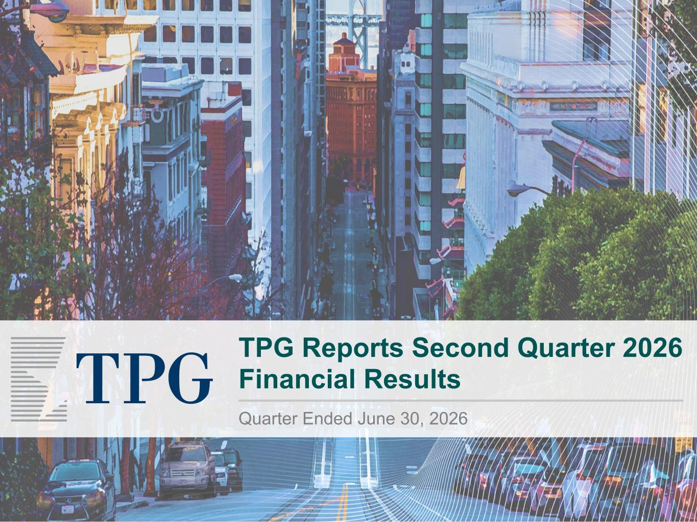

TPG Reports Second Quarter 2026 Financial Results Quarter Ended June 30, 2026

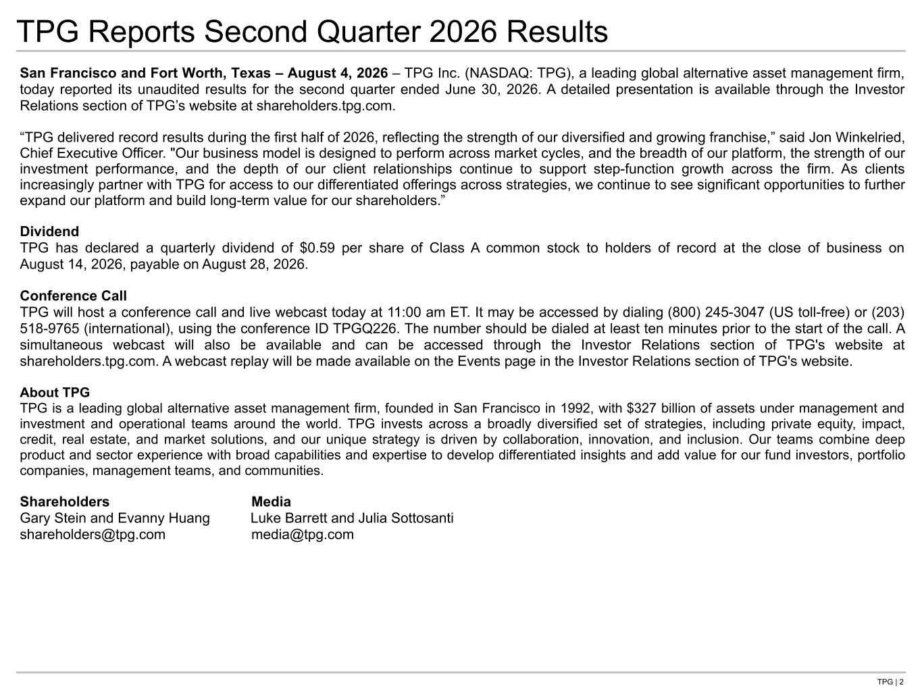
TPG | 2 San Francisco and Fort Worth, Texas – August 4, 2026 – TPG Inc. (NASDAQ: TPG), a leading global alternative asset management firm, today reported its unaudited results for the second quarter ended June 30, 2026. A detailed presentation is available through the Investor Relations section of TPG’s website at shareholders.tpg.com. “TPG delivered record results during the first half of 2026, reflecting the strength of our diversified and growing franchise,” said Jon Winkelried, Chief Executive Officer. "Our business model is designed to perform across market cycles, and the breadth of our platform, the strength of our investment performance, and the depth of our client relationships continue to support step-function growth across the firm. As clients increasingly partner with TPG for access to our differentiated offerings across strategies, we continue to see significant opportunities to further expand our platform and build long-term value for our shareholders.” Dividend TPG has declared a quarterly dividend of $0.59 per share of Class A common stock to holders of record at the close of business on August 14, 2026, payable on August 28, 2026. Conference Call TPG will host a conference call and live webcast today at 11:00 am ET. It may be accessed by dialing (800) 245-3047 (US toll-free) or (203) 518-9765 (international), using the conference ID TPGQ226. The number should be dialed at least ten minutes prior to the start of the call. A simultaneous webcast will also be available and can be accessed through the Investor Relations section of TPG's website at shareholders.tpg.com. A webcast replay will be made available on the Events page in the Investor Relations section of TPG's website. About TPG TPG is a leading global alternative asset management firm, founded in San Francisco in 1992, with $327 billion of assets under management and investment and operational teams around the world. TPG invests across a broadly diversified set of strategies, including private equity, impact, credit, real estate, and market solutions, and our unique strategy is driven by collaboration, innovation, and inclusion. Our teams combine deep product and sector experience with broad capabilities and expertise to develop differentiated insights and add value for our fund investors, portfolio companies, management teams, and communities. Shareholders Media Gary Stein and Evanny Huang Luke Barrett and Julia Sottosanti shareholders@tpg.com media@tpg.com TPG Reports Second Quarter 2026 Results

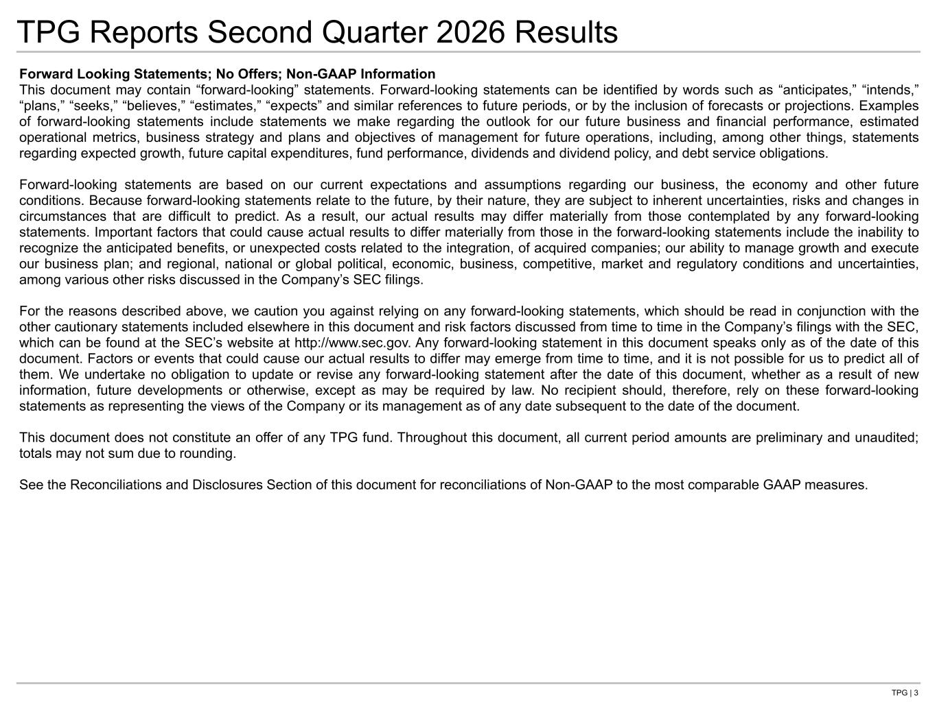
TPG | 3 TPG Reports Second Quarter 2026 Results Forward Looking Statements; No Offers; Non-GAAP Information This document may contain “forward-looking” statements. Forward-looking statements can be identified by words such as “anticipates,” “intends,” “plans,” “seeks,” “believes,” “estimates,” “expects” and similar references to future periods, or by the inclusion of forecasts or projections. Examples of forward-looking statements include statements we make regarding the outlook for our future business and financial performance, estimated operational metrics, business strategy and plans and objectives of management for future operations, including, among other things, statements regarding expected growth, future capital expenditures, fund performance, dividends and dividend policy, and debt service obligations. Forward-looking statements are based on our current expectations and assumptions regarding our business, the economy and other future conditions. Because forward-looking statements relate to the future, by their nature, they are subject to inherent uncertainties, risks and changes in circumstances that are difficult to predict. As a result, our actual results may differ materially from those contemplated by any forward-looking statements. Important factors that could cause actual results to differ materially from those in the forward-looking statements include the inability to recognize the anticipated benefits, or unexpected costs related to the integration, of acquired companies; our ability to manage growth and execute our business plan; and regional, national or global political, economic, business, competitive, market and regulatory conditions and uncertainties, among various other risks discussed in the Company’s SEC filings. For the reasons described above, we caution you against relying on any forward-looking statements, which should be read in conjunction with the other cautionary statements included elsewhere in this document and risk factors discussed from time to time in the Company’s filings with the SEC, which can be found at the SEC’s website at http://www.sec.gov. Any forward-looking statement in this document speaks only as of the date of this document. Factors or events that could cause our actual results to differ may emerge from time to time, and it is not possible for us to predict all of them. We undertake no obligation to update or revise any forward-looking statement after the date of this document, whether as a result of new information, future developments or otherwise, except as may be required by law. No recipient should, therefore, rely on these forward-looking statements as representing the views of the Company or its management as of any date subsequent to the date of the document. This document does not constitute an offer of any TPG fund. Throughout this document, all current period amounts are preliminary and unaudited; totals may not sum due to rounding. See the Reconciliations and Disclosures Section of this document for reconciliations of Non-GAAP to the most comparable GAAP measures.


Second Quarter 2026 Results

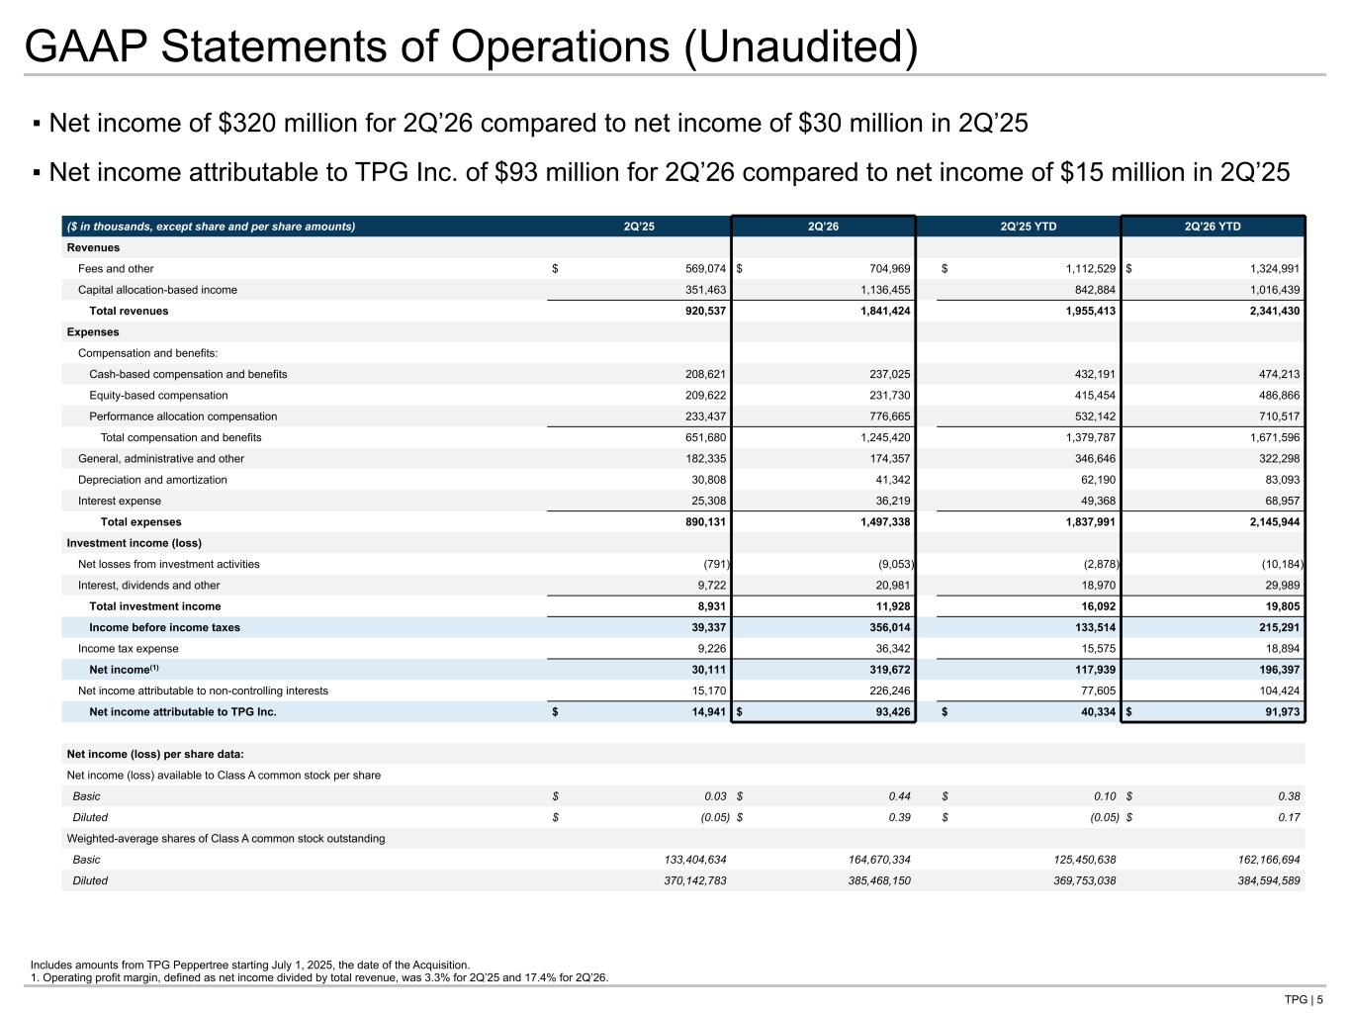
TPG | 5 ▪ Net income of $320 million for 2Q’26 compared to net income of $30 million in 2Q’25 ▪ Net income attributable to TPG Inc. of $93 million for 2Q’26 compared to net income of $15 million in 2Q’25 GAAP Statements of Operations (Unaudited) Includes amounts from TPG Peppertree starting July 1, 2025, the date of the Acquisition. 1. Operating profit margin, defined as net income divided by total revenue, was 3.3% for 2Q’25 and 17.4% for 2Q’26. ($ in thousands, except share and per share amounts) 2Q’25 2Q’26 2Q’25 YTD 2Q’26 YTD Revenues Fees and other $ 569,074 $ 704,969 $ 1,112,529 $ 1,324,991 Capital allocation-based income 351,463 1,136,455 842,884 1,016,439 Total revenues 920,537 1,841,424 1,955,413 2,341,430 Expenses Compensation and benefits: Cash-based compensation and benefits 208,621 237,025 432,191 474,213 Equity-based compensation 209,622 231,730 415,454 486,866 Performance allocation compensation 233,437 776,665 532,142 710,517 Total compensation and benefits 651,680 1,245,420 1,379,787 1,671,596 General, administrative and other 182,335 174,357 346,646 322,298 Depreciation and amortization 30,808 41,342 62,190 83,093 Interest expense 25,308 36,219 49,368 68,957 Total expenses 890,131 1,497,338 1,837,991 2,145,944 Investment income (loss) Net losses from investment activities (791) (9,053) (2,878) (10,184) Interest, dividends and other 9,722 20,981 18,970 29,989 Total investment income 8,931 11,928 16,092 19,805 Income before income taxes 39,337 356,014 133,514 215,291 Income tax expense 9,226 36,342 15,575 18,894 Net income(1) 30,111 319,672 117,939 196,397 Net income attributable to non-controlling interests 15,170 226,246 77,605 104,424 Net income attributable to TPG Inc. $ 14,941 $ 93,426 $ 40,334 $ 91,973 Net income (loss) per share data: Net income (loss) available to Class A common stock per share Basic $ 0.03 $ 0.44 $ 0.10 $ 0.38 Diluted $ (0.05) $ 0.39 $ (0.05) $ 0.17 Weighted-average shares of Class A common stock outstanding Basic 133,404,634 164,670,334 125,450,638 162,166,694 Diluted 370,142,783 385,468,150 369,753,038 384,594,589 Tie to Qtrly statements at back

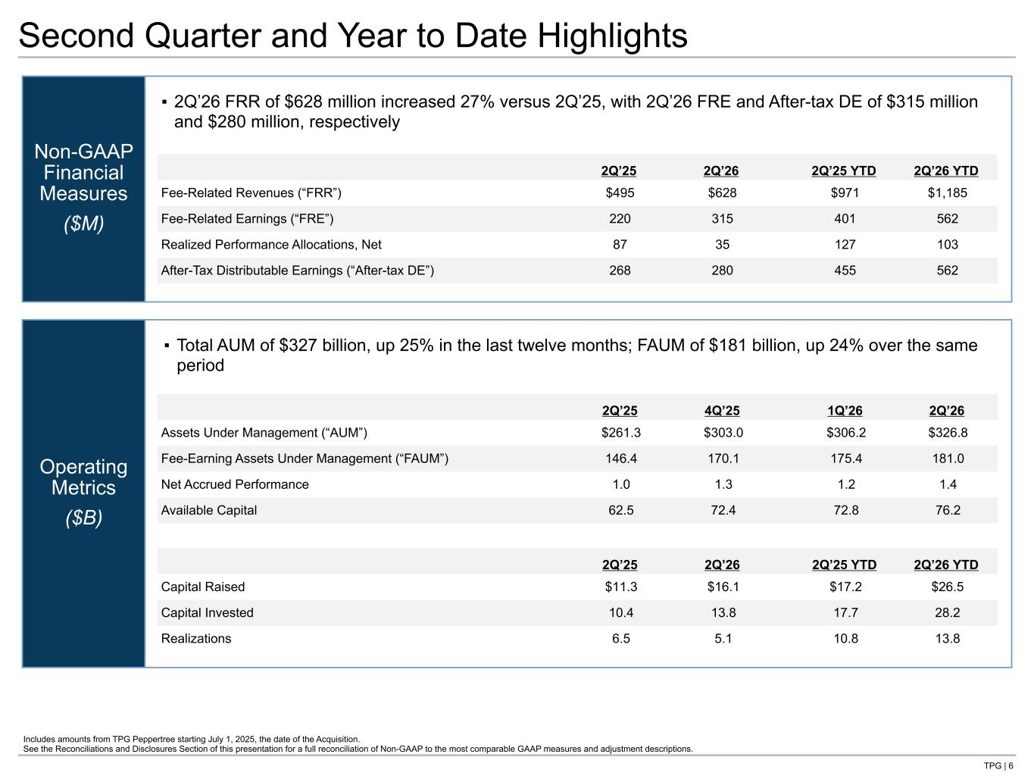
TPG | 6 Operating Metrics ($B) Non-GAAP Financial Measures ($M) Second Quarter and Year to Date Highlights 2Q’25 2Q’26 2Q’25 YTD 2Q’26 YTD Fee-Related Revenues (“FRR”) $495 $628 $971 $1,185 Fee-Related Earnings (“FRE”) 220 315 401 562 Realized Performance Allocations, Net 87 35 127 103 After-Tax Distributable Earnings (“After-tax DE”) 268 280 455 562 2Q’25 4Q’25 1Q’26 2Q’26 Assets Under Management (“AUM”) $261.3 $303.0 $306.2 $326.8 Fee-Earning Assets Under Management (“FAUM”) 146.4 170.1 175.4 181.0 Net Accrued Performance 1.0 1.3 1.2 1.4 Available Capital 62.5 72.4 72.8 76.2 2Q’25 2Q’26 2Q’25 YTD 2Q’26 YTD Capital Raised $11.3 $16.1 $17.2 $26.5 Capital Invested 10.4 13.8 17.7 28.2 Realizations 6.5 5.1 10.8 13.8 ▪ 2Q’26 FRR of $628 million increased 27% versus 2Q’25, with 2Q’26 FRE and After-tax DE of $315 million and $280 million, respectively ▪ Total AUM of $327 billion, up 25% in the last twelve months; FAUM of $181 billion, up 24% over the same period Includes amounts from TPG Peppertree starting July 1, 2025, the date of the Acquisition. See the Reconciliations and Disclosures Section of this presentation for a full reconciliation of Non-GAAP to the most comparable GAAP measures and adjustment descriptions. Tie to next page Tie to OM section

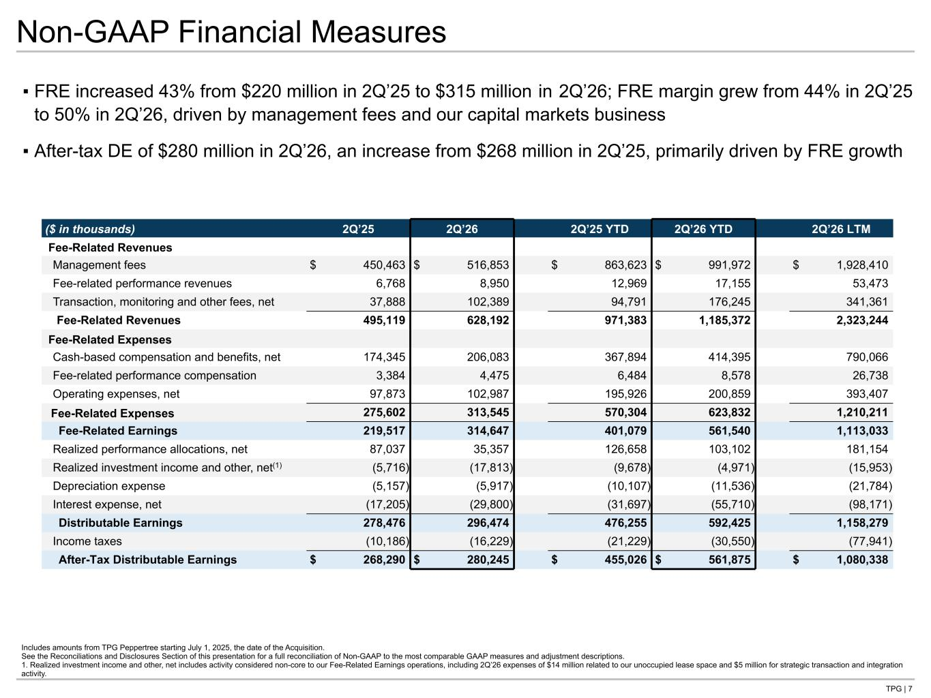
TPG | 7 Non-GAAP Financial Measures ▪ FRE increased 43% from $220 million in 2Q’25 to $315 million in 2Q’26; FRE margin grew from 44% in 2Q’25 to 50% in 2Q’26, driven by management fees and our capital markets business ▪ After-tax DE of $280 million in 2Q’26, an increase from $268 million in 2Q’25, primarily driven by FRE growth Includes amounts from TPG Peppertree starting July 1, 2025, the date of the Acquisition. See the Reconciliations and Disclosures Section of this presentation for a full reconciliation of Non-GAAP to the most comparable GAAP measures and adjustment descriptions. 1. Realized investment income and other, net includes activity considered non-core to our Fee-Related Earnings operations, including 2Q’26 expenses of $14 million related to our unoccupied lease space and $5 million for strategic transaction and integration activity. ($ in thousands) 2Q’25 2Q’26 2Q’25 YTD 2Q’26 YTD 2Q’26 LTM Fee-Related Revenues Management fees $ 450,463 $ 516,853 $ 863,623 $ 991,972 $ 1,928,410 Fee-related performance revenues 6,768 8,950 12,969 17,155 53,473 Transaction, monitoring and other fees, net 37,888 102,389 94,791 176,245 341,361 Fee-Related Revenues 495,119 628,192 971,383 1,185,372 2,323,244 Fee-Related Expenses Cash-based compensation and benefits, net 174,345 206,083 367,894 414,395 790,066 Fee-related performance compensation 3,384 4,475 6,484 8,578 26,738 Operating expenses, net 97,873 102,987 195,926 200,859 393,407 Fee-Related Expenses 275,602 313,545 570,304 623,832 1,210,211 Fee-Related Earnings 219,517 314,647 401,079 561,540 1,113,033 Realized performance allocations, net 87,037 35,357 126,658 103,102 181,154 Realized investment income and other, net(1) (5,716) (17,813) (9,678) (4,971) (15,953) Depreciation expense (5,157) (5,917) (10,107) (11,536) (21,784) Interest expense, net (17,205) (29,800) (31,697) (55,710) (98,171) Distributable Earnings 278,476 296,474 476,255 592,425 1,158,279 Income taxes (10,186) (16,229) (21,229) (30,550) (77,941) After-Tax Distributable Earnings $ 268,290 $ 280,245 $ 455,026 $ 561,875 $ 1,080,338 Tie to: -prior page -qtrly statement in back -G-NG qtrly statment in back

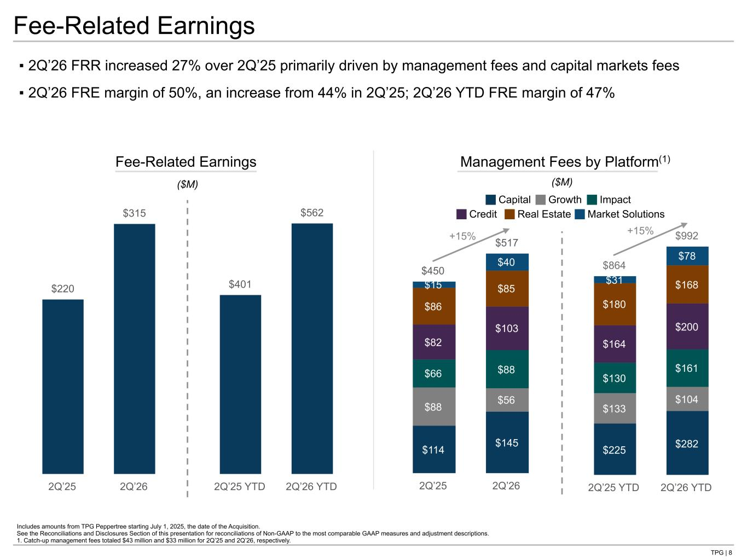
TPG | 8 $864 $992 $225 $282 $133 $104 $130 $161 $164 $200 $180 $168$31 $78 2Q’25 YTD 2Q’26 YTD $220 $315 2Q’25 2Q’26 $401 $562 2Q’25 YTD 2Q’26 YTD $450 $517 $114 $145 $88 $56 $66 $88 $82 $103 $86 $85$15 $40 2Q’25 2Q’26 ▪ 2Q’26 FRR increased 27% over 2Q’25 primarily driven by management fees and capital markets fees ▪ 2Q’26 FRE margin of 50%, an increase from 44% in 2Q’25; 2Q’26 YTD FRE margin of 47% Includes amounts from TPG Peppertree starting July 1, 2025, the date of the Acquisition. See the Reconciliations and Disclosures Section of this presentation for reconciliations of Non-GAAP to the most comparable GAAP measures and adjustment descriptions. 1. Catch-up management fees totaled $43 million and $33 million for 2Q’25 and 2Q’26, respectively. Fee-Related Earnings Management Fees by Platform(1) ($M) ($M) +15% Capital Growth Impact +15% Credit Real Estate Market Solutions Fee-Related Earnings

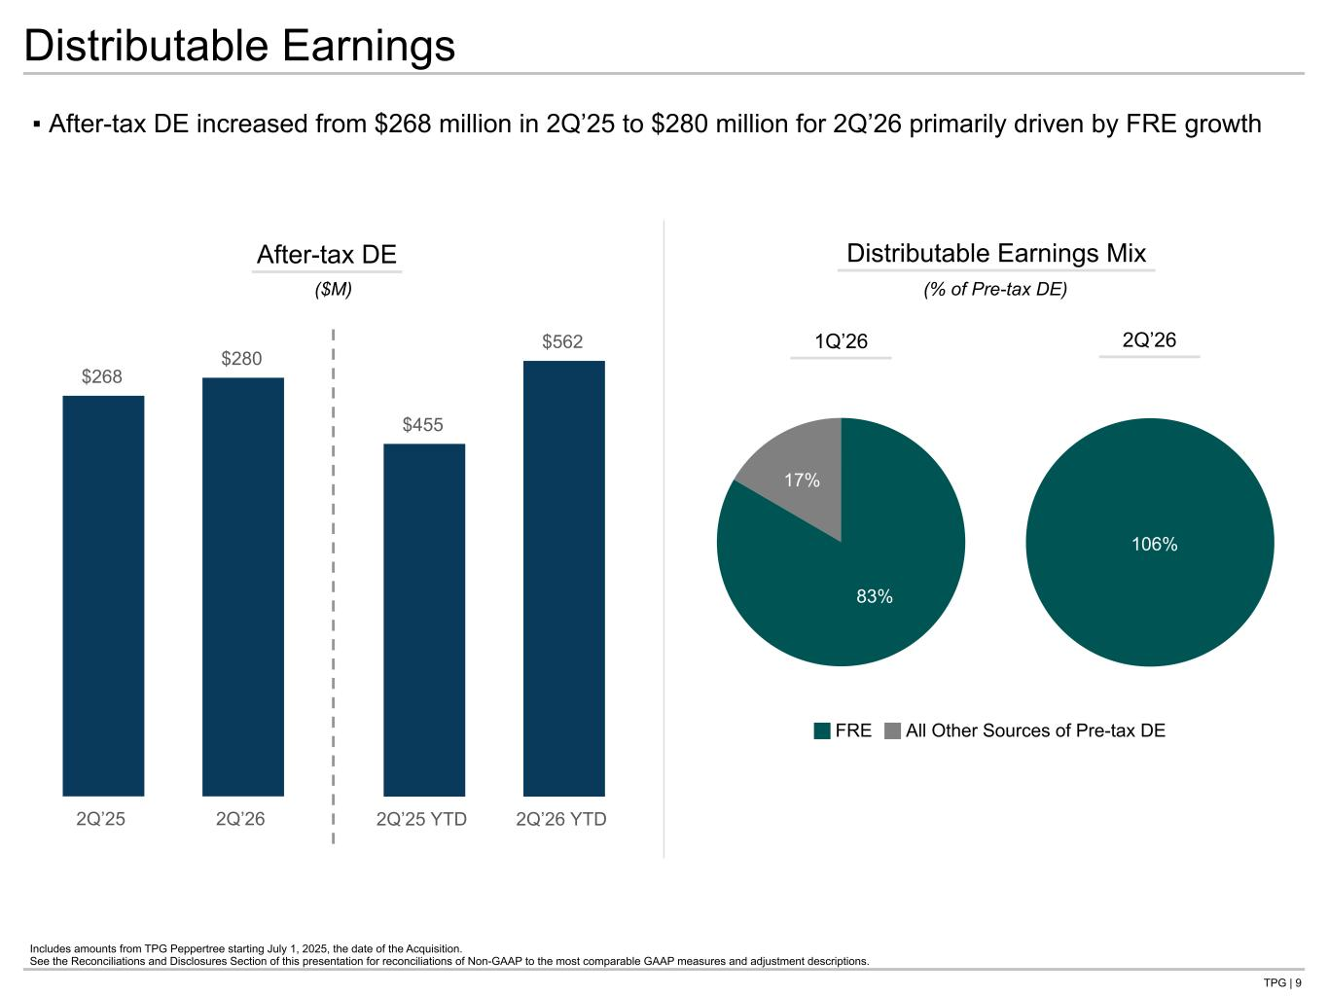
TPG | 9 $268 $280 2Q’25 2Q’26 $455 $562 2Q’25 YTD 2Q’26 YTD Distributable Earnings ▪ After-tax DE increased from $268 million in 2Q’25 to $280 million for 2Q’26 primarily driven by FRE growth After-tax DE ($M) Includes amounts from TPG Peppertree starting July 1, 2025, the date of the Acquisition. See the Reconciliations and Disclosures Section of this presentation for reconciliations of Non-GAAP to the most comparable GAAP measures and adjustment descriptions. Distributable Earnings Mix FRE All Other Sources of Pre-tax DE 83% 17% 106% 1Q’26 2Q’26 (% of Pre-tax DE)

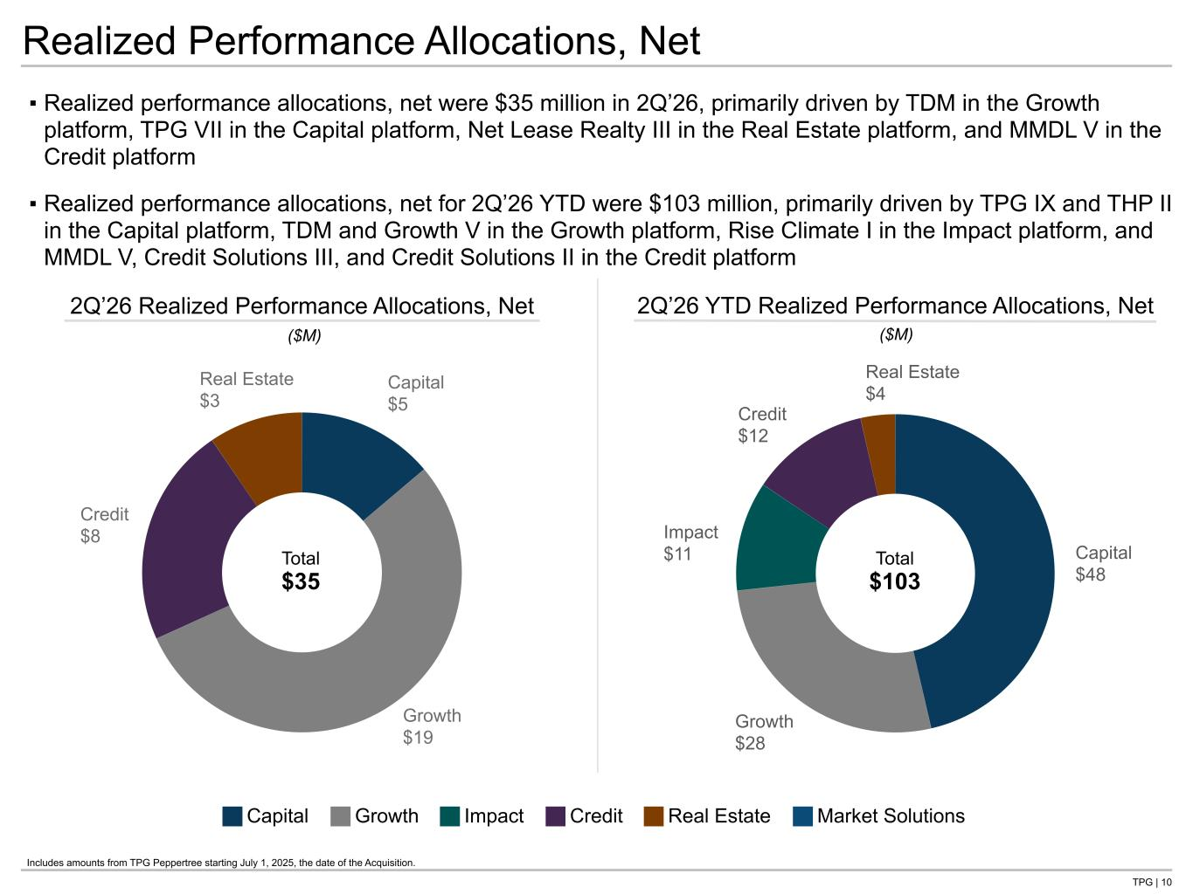
TPG | 10 Capital $48 Growth $28 Impact $11 Credit $12 Real Estate $4 2Q’26 YTD Realized Performance Allocations, Net Capital $5 Growth $19 Credit $8 Real Estate $3 ▪ Realized performance allocations, net were $35 million in 2Q’26, primarily driven by TDM in the Growth platform, TPG VII in the Capital platform, Net Lease Realty III in the Real Estate platform, and MMDL V in the Credit platform ▪ Realized performance allocations, net for 2Q’26 YTD were $103 million, primarily driven by TPG IX and THP II in the Capital platform, TDM and Growth V in the Growth platform, Rise Climate I in the Impact platform, and MMDL V, Credit Solutions III, and Credit Solutions II in the Credit platform Realized Performance Allocations, Net 2Q’26 Realized Performance Allocations, Net ($M) ($M) Total $103 Total $35 Capital Growth Impact Credit Real Estate Market Solutions Includes amounts from TPG Peppertree starting July 1, 2025, the date of the Acquisition.

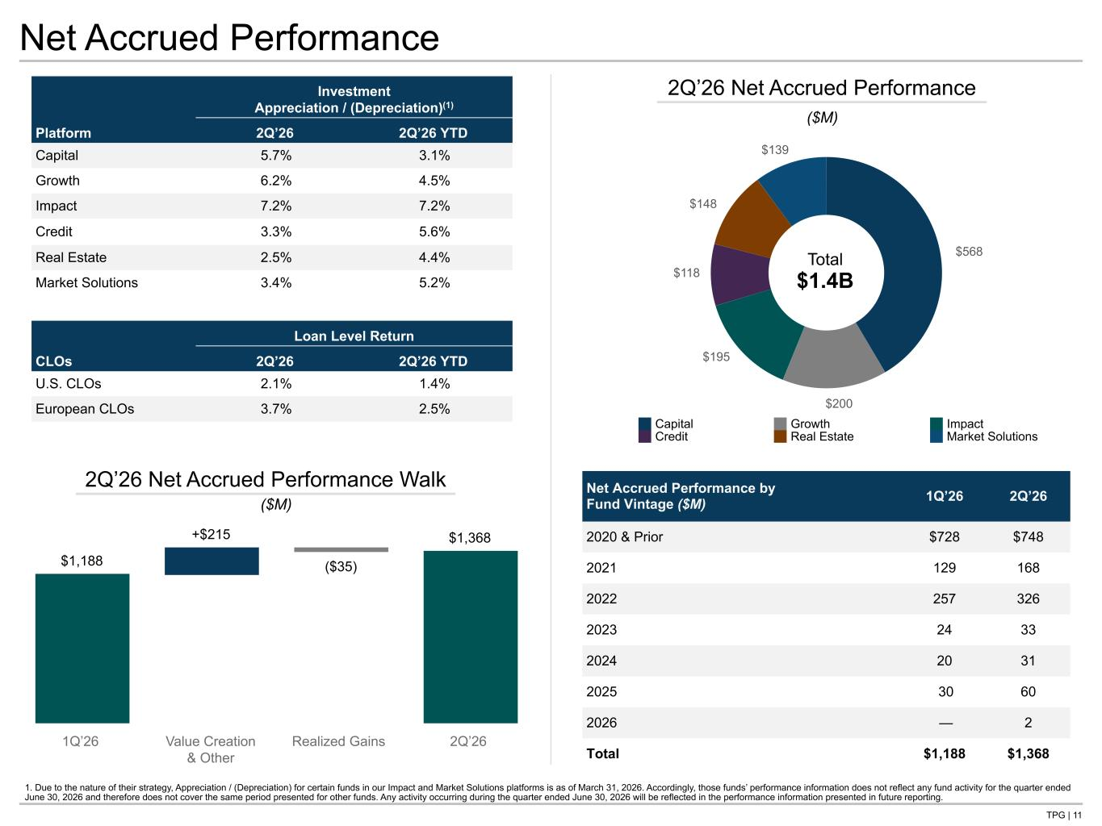
TPG | 11 $568 $200 $195 $118 $148 $139 Net Accrued Performance Net Accrued Performance by Fund Vintage ($M) 1Q’26 2Q’26 2020 & Prior $728 $748 2021 129 168 2022 257 326 2023 24 33 2024 20 31 2025 30 60 2026 — 2 Total $1,188 $1,368 2Q’26 Net Accrued Performance Total $1.4B ($M) $1,188 +$215 ($35) $1,368 1Q’26 Value Creation & Other Realized Gains 2Q’26 2Q’26 Net Accrued Performance Walk ($M) Investment Appreciation / (Depreciation)(1) Platform 2Q’26 2Q’26 YTD Capital 5.7% 3.1% Growth 6.2% 4.5% Impact 7.2% 7.2% Credit 3.3% 5.6% Real Estate 2.5% 4.4% Market Solutions 3.4% 5.2% Loan Level Return CLOs 2Q’26 2Q’26 YTD U.S. CLOs 2.1% 1.4% European CLOs 3.7% 2.5% 1. Due to the nature of their strategy, Appreciation / (Depreciation) for certain funds in our Impact and Market Solutions platforms is as of March 31, 2026. Accordingly, those funds’ performance information does not reflect any fund activity for the quarter ended June 30, 2026 and therefore does not cover the same period presented for other funds. Any activity occurring during the quarter ended June 30, 2026 will be reflected in the performance information presented in future reporting. Capital Growth Impact Credit Real Estate Market Solutions Tie all 3 Net APF totals to NG BS

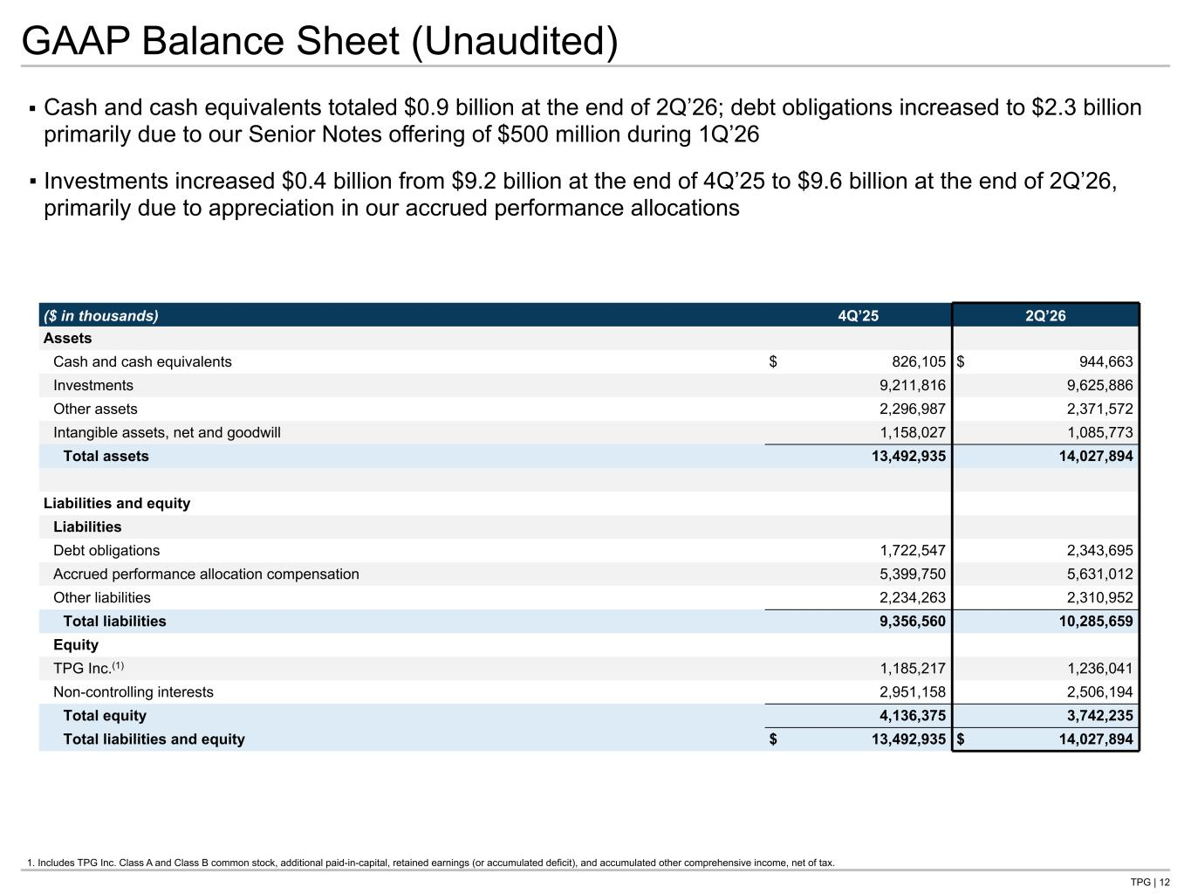
TPG | 12 GAAP Balance Sheet (Unaudited) ▪ Cash and cash equivalents totaled $0.9 billion at the end of 2Q’26; debt obligations increased to $2.3 billion primarily due to our Senior Notes offering of $500 million during 1Q’26 ▪ Investments increased $0.4 billion from $9.2 billion at the end of 4Q’25 to $9.6 billion at the end of 2Q’26, primarily due to appreciation in our accrued performance allocations 1. Includes TPG Inc. Class A and Class B common stock, additional paid-in-capital, retained earnings (or accumulated deficit), and accumulated other comprehensive income, net of tax. ($ in thousands) 4Q’25 2Q’26 Assets Cash and cash equivalents $ 826,105 $ 944,663 Investments 9,211,816 9,625,886 Other assets 2,296,987 2,371,572 Intangible assets, net and goodwill 1,158,027 1,085,773 Total assets 13,492,935 14,027,894 Liabilities and equity Liabilities Debt obligations 1,722,547 2,343,695 Accrued performance allocation compensation 5,399,750 5,631,012 Other liabilities 2,234,263 2,310,952 Total liabilities 9,356,560 10,285,659 Equity TPG Inc.(1) 1,185,217 1,236,041 Non-controlling interests 2,951,158 2,506,194 Total equity 4,136,375 3,742,235 Total liabilities and equity $ 13,492,935 $ 14,027,894 Tie to B/S G- NG in back

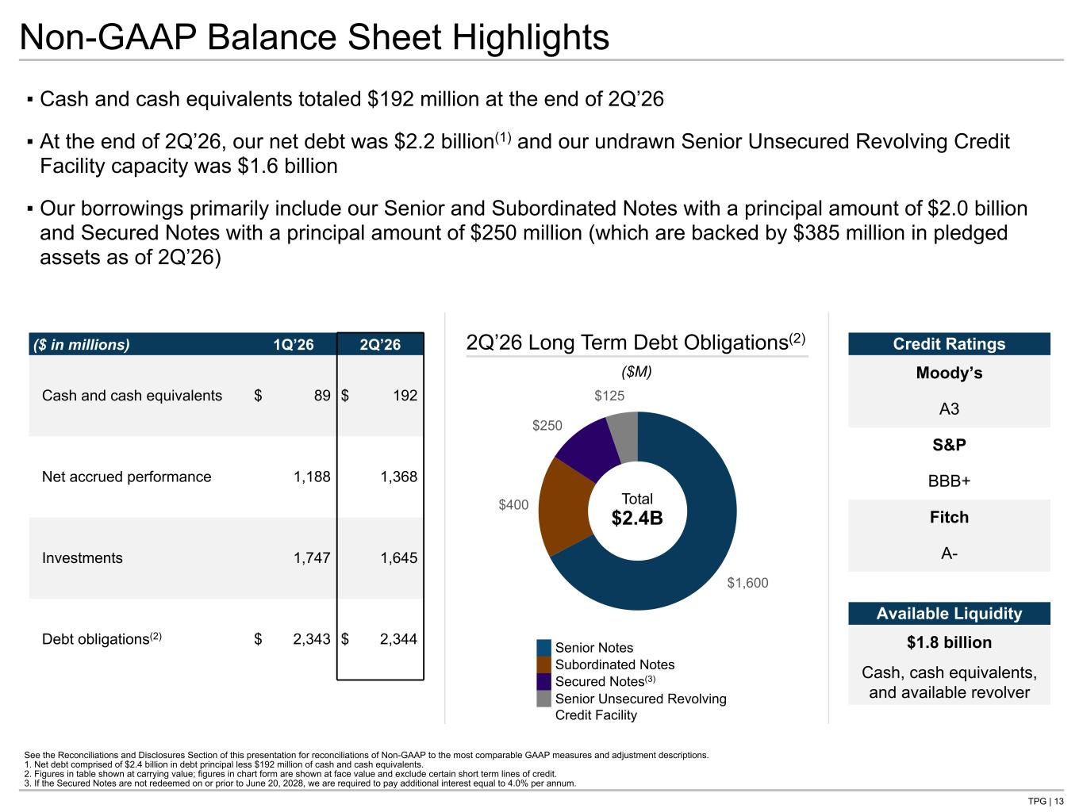
TPG | 13 ▪ Cash and cash equivalents totaled $192 million at the end of 2Q’26 ▪ At the end of 2Q’26, our net debt was $2.2 billion(1) and our undrawn Senior Unsecured Revolving Credit Facility capacity was $1.6 billion ▪ Our borrowings primarily include our Senior and Subordinated Notes with a principal amount of $2.0 billion and Secured Notes with a principal amount of $250 million (which are backed by $385 million in pledged assets as of 2Q’26) Senior Notes Subordinated Notes Secured Notes(3) Senior Unsecured Revolving Credit Facility Non-GAAP Balance Sheet Highlights See the Reconciliations and Disclosures Section of this presentation for reconciliations of Non-GAAP to the most comparable GAAP measures and adjustment descriptions. 1. Net debt comprised of $2.4 billion in debt principal less $192 million of cash and cash equivalents. 2. Figures in table shown at carrying value; figures in chart form are shown at face value and exclude certain short term lines of credit. 3. If the Secured Notes are not redeemed on or prior to June 20, 2028, we are required to pay additional interest equal to 4.0% per annum. ($ in millions) 1Q’26 2Q’26 Cash and cash equivalents $ 89 $ 192 Net accrued performance 1,188 1,368 Investments 1,747 1,645 Debt obligations(2) $ 2,343 $ 2,344 $1,600 $400 $250 $125 2Q’26 Long Term Debt Obligations(2) Total $2.4B ($M) Credit Ratings Moody’s A3 S&P BBB+ Fitch A- Available Liquidity $1.8 billion Cash, cash equivalents, and available revolver Tie to B/S G- NG in back


Operating Metrics

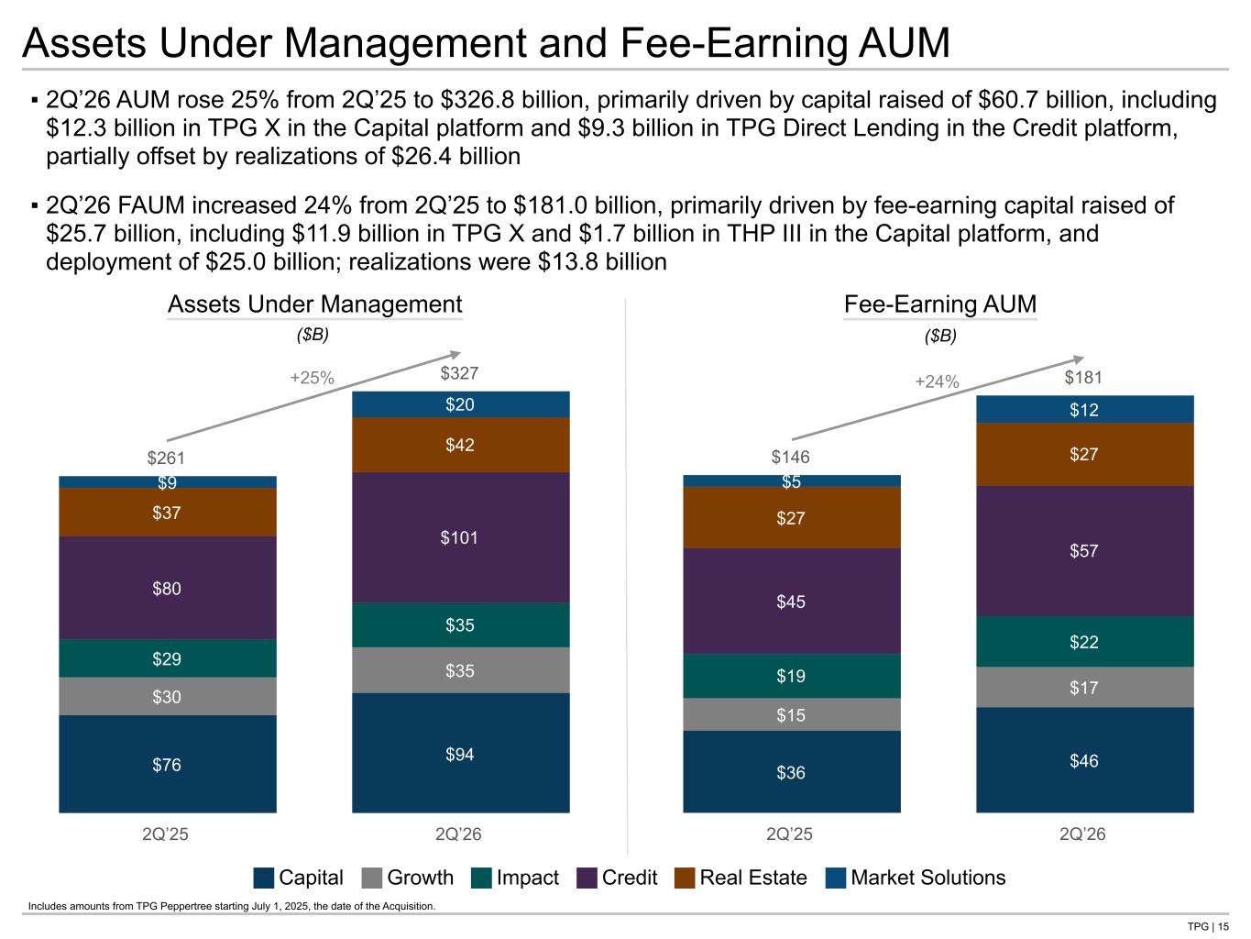
TPG | 15 $146 $181 $36 $46 $15 $17 $19 $22 $45 $57 $27 $27 $5 $12 2Q’25 2Q’26 $261 $327 $76 $94 $30 $35 $29 $35 $80 $101 $37 $42 $9 $20 2Q’25 2Q’26 Assets Under Management and Fee-Earning AUM ▪ 2Q’26 AUM rose 25% from 2Q’25 to $326.8 billion, primarily driven by capital raised of $60.7 billion, including $12.3 billion in TPG X in the Capital platform and $9.3 billion in TPG Direct Lending in the Credit platform, partially offset by realizations of $26.4 billion ▪ 2Q’26 FAUM increased 24% from 2Q’25 to $181.0 billion, primarily driven by fee-earning capital raised of $25.7 billion, including $11.9 billion in TPG X and $1.7 billion in THP III in the Capital platform, and deployment of $25.0 billion; realizations were $13.8 billion Assets Under Management Fee-Earning AUM ($B) ($B) +25% +24% Capital Growth Impact Credit Real Estate Market Solutions Includes amounts from TPG Peppertree starting July 1, 2025, the date of the Acquisition.

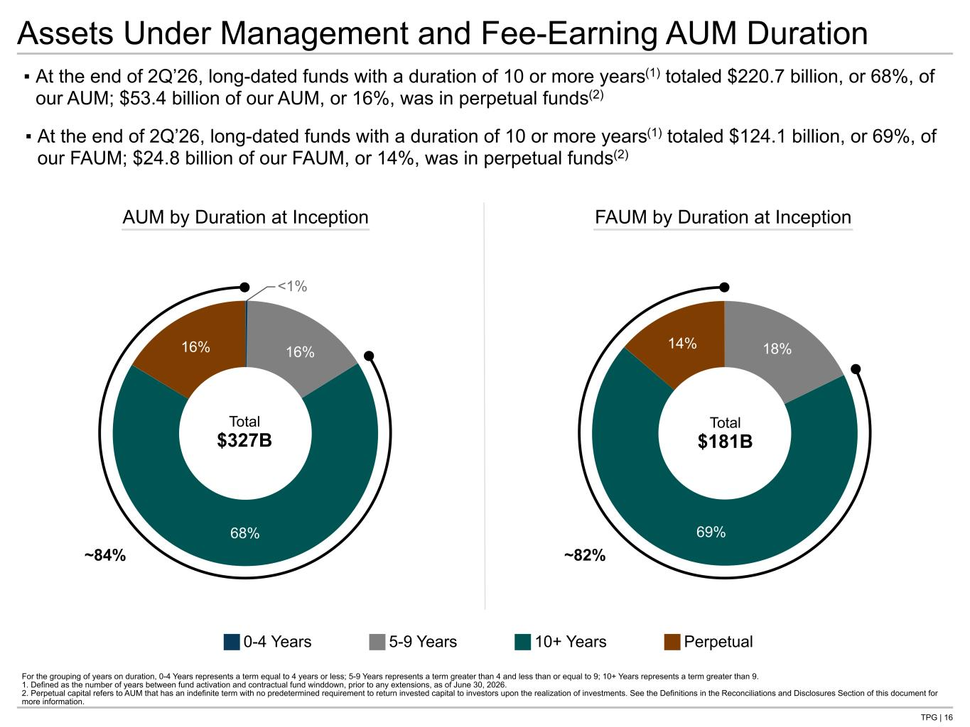
TPG | 16 Assets Under Management and Fee-Earning AUM Duration For the grouping of years on duration, 0-4 Years represents a term equal to 4 years or less; 5-9 Years represents a term greater than 4 and less than or equal to 9; 10+ Years represents a term greater than 9. 1. Defined as the number of years between fund activation and contractual fund winddown, prior to any extensions, as of June 30, 2026. 2. Perpetual capital refers to AUM that has an indefinite term with no predetermined requirement to return invested capital to investors upon the realization of investments. See the Definitions in the Reconciliations and Disclosures Section of this document for more information. ▪ At the end of 2Q’26, long-dated funds with a duration of 10 or more years(1) totaled $220.7 billion, or 68%, of our AUM; $53.4 billion of our AUM, or 16%, was in perpetual funds(2) ▪ At the end of 2Q’26, long-dated funds with a duration of 10 or more years(1) totaled $124.1 billion, or 69%, of our FAUM; $24.8 billion of our FAUM, or 14%, was in perpetual funds(2) 0-4 Years 5-9 Years 10+ Years Perpetual 18% 69% 14% 0.28% 16% 68% 16% AUM by Duration at Inception Total $327B FAUM by Duration at Inception Total $181B <1% ~84% ~82%

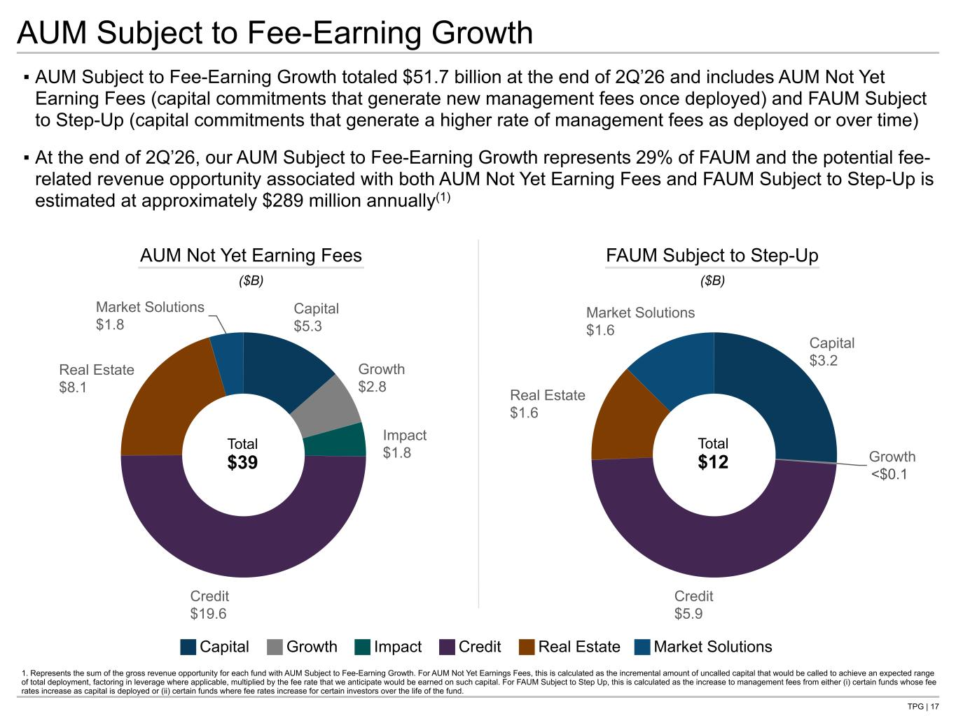
TPG | 17 Capital $3.2 Growth $0.0 Credit $5.9 Real Estate $1.6 Market Solutions $1.6 Capital $5.3 Growth $2.8 Impact $1.8 Credit $19.6 Real Estate $8.1 Market Solutions $1.8 ▪ AUM Subject to Fee-Earning Growth totaled $51.7 billion at the end of 2Q’26 and includes AUM Not Yet Earning Fees (capital commitments that generate new management fees once deployed) and FAUM Subject to Step-Up (capital commitments that generate a higher rate of management fees as deployed or over time) ▪ At the end of 2Q’26, our AUM Subject to Fee-Earning Growth represents 29% of FAUM and the potential fee- related revenue opportunity associated with both AUM Not Yet Earning Fees and FAUM Subject to Step-Up is estimated at approximately $289 million annually(1) AUM Not Yet Earning Fees FAUM Subject to Step-Up ($B) ($B) Total $39 Total $12 AUM Subject to Fee-Earning Growth 1. Represents the sum of the gross revenue opportunity for each fund with AUM Subject to Fee-Earning Growth. For AUM Not Yet Earnings Fees, this is calculated as the incremental amount of uncalled capital that would be called to achieve an expected range of total deployment, factoring in leverage where applicable, multiplied by the fee rate that we anticipate would be earned on such capital. For FAUM Subject to Step Up, this is calculated as the increase to management fees from either (i) certain funds whose fee rates increase as capital is deployed or (ii) certain funds where fee rates increase for certain investors over the life of the fund. Capital Growth Impact Credit Real Estate Market Solutions <$ .1

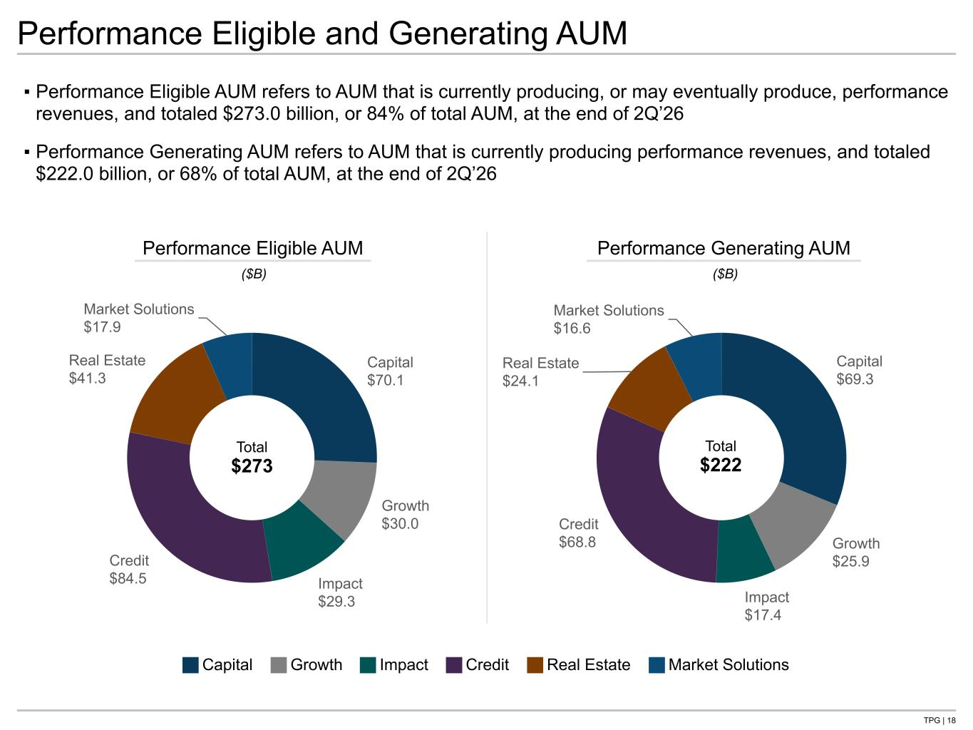
TPG | 18 Capital $69.3 Growth $25.9 Impact $17.4 Credit $68.8 Real Estate $24.1 Market Solutions $16.6 Capital $70.1 Growth $30.0 Impact $29.3 Credit $84.5 Real Estate $41.3 Market Solutions $17.9 ▪ Performance Eligible AUM refers to AUM that is currently producing, or may eventually produce, performance revenues, and totaled $273.0 billion, or 84% of total AUM, at the end of 2Q’26 ▪ Performance Generating AUM refers to AUM that is currently producing performance revenues, and totaled $222.0 billion, or 68% of total AUM, at the end of 2Q’26 Performance Eligible AUM Performance Generating AUM ($B) ($B) Total $273 Total $222 Performance Eligible and Generating AUM Capital Growth Impact Credit Real Estate Market Solutions

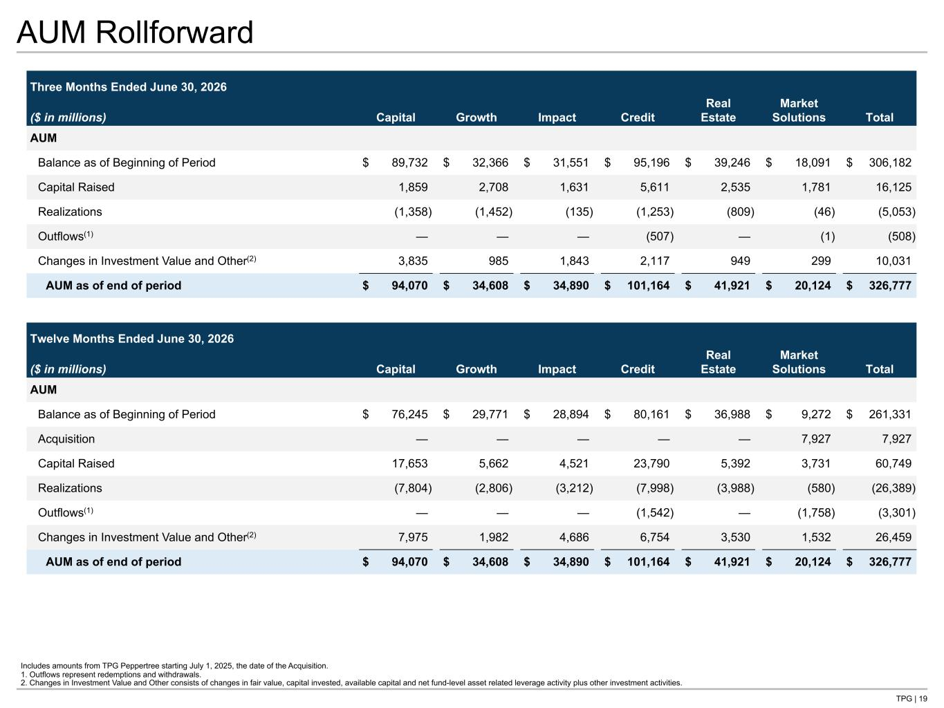
TPG | 19 AUM Rollforward Three Months Ended June 30, 2026 ($ in millions) Capital Growth Impact Credit Real Estate Market Solutions Total AUM Balance as of Beginning of Period $ 89,732 $ 32,366 $ 31,551 $ 95,196 $ 39,246 $ 18,091 $ 306,182 Capital Raised 1,859 2,708 1,631 5,611 2,535 1,781 16,125 Realizations (1,358) (1,452) (135) (1,253) (809) (46) (5,053) Outflows(1) — — — (507) — (1) (508) Changes in Investment Value and Other(2) 3,835 985 1,843 2,117 949 299 10,031 AUM as of end of period $ 94,070 $ 34,608 $ 34,890 $ 101,164 $ 41,921 $ 20,124 $ 326,777 Twelve Months Ended June 30, 2026 ($ in millions) Capital Growth Impact Credit Real Estate Market Solutions Total AUM Balance as of Beginning of Period $ 76,245 $ 29,771 $ 28,894 $ 80,161 $ 36,988 $ 9,272 $ 261,331 Acquisition — — — — — 7,927 7,927 Capital Raised 17,653 5,662 4,521 23,790 5,392 3,731 60,749 Realizations (7,804) (2,806) (3,212) (7,998) (3,988) (580) (26,389) Outflows(1) — — — (1,542) — (1,758) (3,301) Changes in Investment Value and Other(2) 7,975 1,982 4,686 6,754 3,530 1,532 26,459 AUM as of end of period $ 94,070 $ 34,608 $ 34,890 $ 101,164 $ 41,921 $ 20,124 $ 326,777 Includes amounts from TPG Peppertree starting July 1, 2025, the date of the Acquisition. 1. Outflows represent redemptions and withdrawals. 2. Changes in Investment Value and Other consists of changes in fair value, capital invested, available capital and net fund-level asset related leverage activity plus other investment activities. Tie to 4sq page

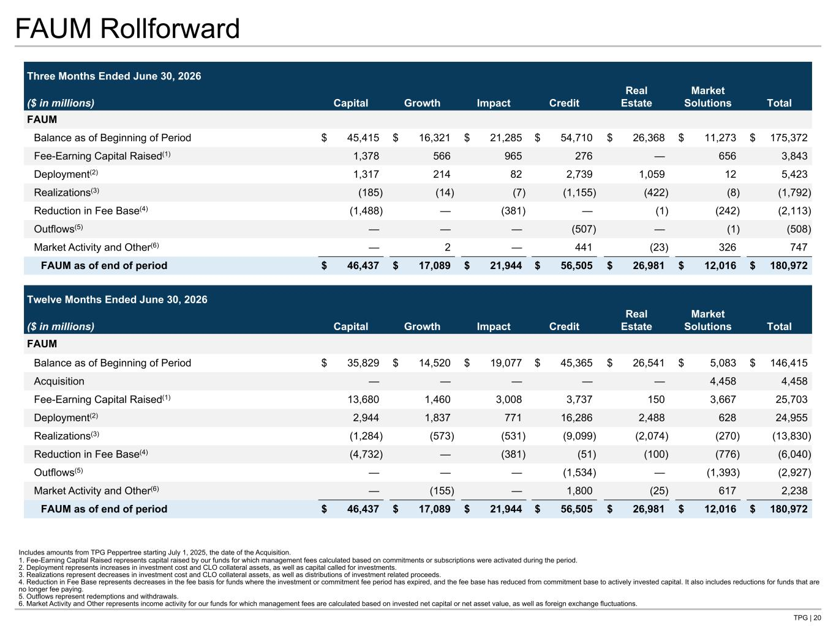
TPG | 20 FAUM Rollforward Three Months Ended June 30, 2026 ($ in millions) Capital Growth Impact Credit Real Estate Market Solutions Total FAUM Balance as of Beginning of Period $ 45,415 $ 16,321 $ 21,285 $ 54,710 $ 26,368 $ 11,273 $ 175,372 Fee-Earning Capital Raised(1) 1,378 566 965 276 — 656 3,843 Deployment(2) 1,317 214 82 2,739 1,059 12 5,423 Realizations(3) (185) (14) (7) (1,155) (422) (8) (1,792) Reduction in Fee Base(4) (1,488) — (381) — (1) (242) (2,113) Outflows(5) — — — (507) — (1) (508) Market Activity and Other(6) — 2 — 441 (23) 326 747 FAUM as of end of period $ 46,437 $ 17,089 $ 21,944 $ 56,505 $ 26,981 $ 12,016 $ 180,972 Twelve Months Ended June 30, 2026 ($ in millions) Capital Growth Impact Credit Real Estate Market Solutions Total FAUM Balance as of Beginning of Period $ 35,829 $ 14,520 $ 19,077 $ 45,365 $ 26,541 $ 5,083 $ 146,415 Acquisition — — — — — 4,458 4,458 Fee-Earning Capital Raised(1) 13,680 1,460 3,008 3,737 150 3,667 25,703 Deployment(2) 2,944 1,837 771 16,286 2,488 628 24,955 Realizations(3) (1,284) (573) (531) (9,099) (2,074) (270) (13,830) Reduction in Fee Base(4) (4,732) — (381) (51) (100) (776) (6,040) Outflows(5) — — — (1,534) — (1,393) (2,927) Market Activity and Other(6) — (155) — 1,800 (25) 617 2,238 FAUM as of end of period $ 46,437 $ 17,089 $ 21,944 $ 56,505 $ 26,981 $ 12,016 $ 180,972 Includes amounts from TPG Peppertree starting July 1, 2025, the date of the Acquisition. 1. Fee-Earning Capital Raised represents capital raised by our funds for which management fees calculated based on commitments or subscriptions were activated during the period. 2. Deployment represents increases in investment cost and CLO collateral assets, as well as capital called for investments. 3. Realizations represent decreases in investment cost and CLO collateral assets, as well as distributions of investment related proceeds. 4. Reduction in Fee Base represents decreases in the fee basis for funds where the investment or commitment fee period has expired, and the fee base has reduced from commitment base to actively invested capital. It also includes reductions for funds that are no longer fee paying. 5. Outflows represent redemptions and withdrawals. 6. Market Activity and Other represents income activity for our funds for which management fees are calculated based on invested net capital or net asset value, as well as foreign exchange fluctuations.

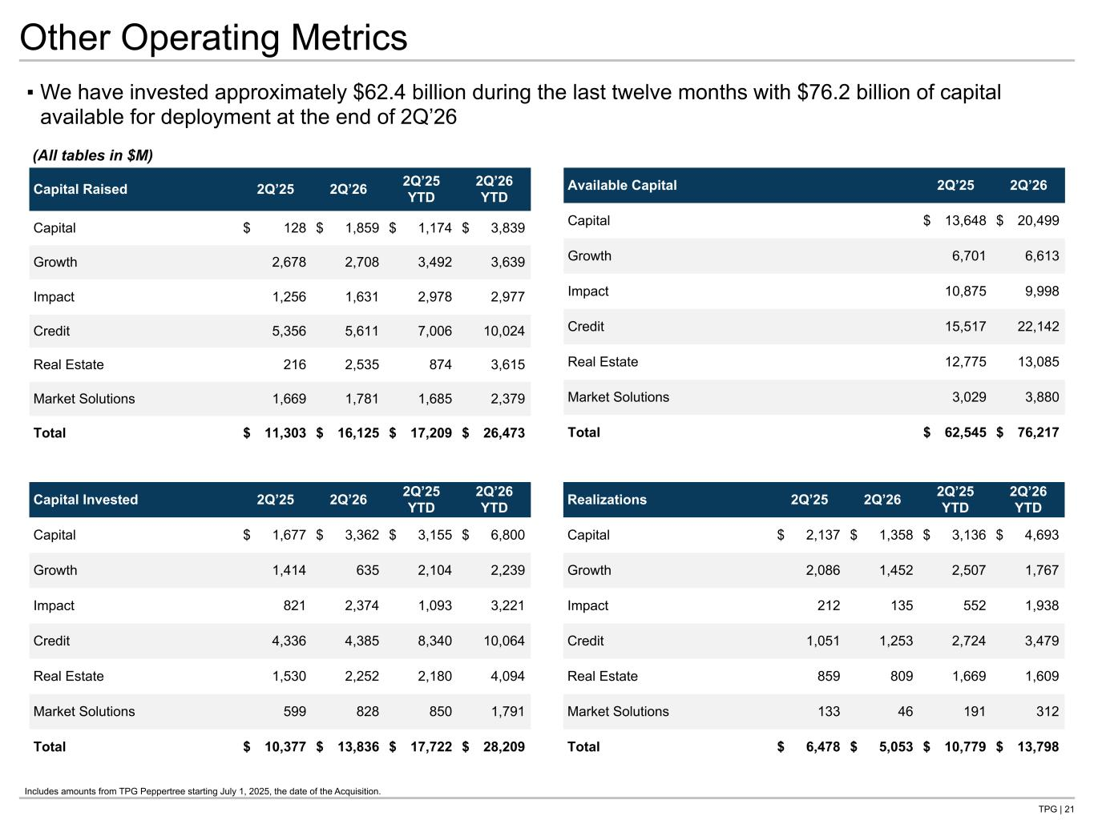
TPG | 21 Other Operating Metrics Capital Raised 2Q’25 2Q’26 2Q’25 YTD 2Q’26 YTD Capital $ 128 $ 1,859 $ 1,174 $ 3,839 Growth 2,678 2,708 3,492 3,639 Impact 1,256 1,631 2,978 2,977 Credit 5,356 5,611 7,006 10,024 Real Estate 216 2,535 874 3,615 Market Solutions 1,669 1,781 1,685 2,379 Total $ 11,303 $ 16,125 $ 17,209 $ 26,473 ▪ We have invested approximately $62.4 billion during the last twelve months with $76.2 billion of capital available for deployment at the end of 2Q’26 Available Capital 2Q’25 2Q’26 Capital $ 13,648 $ 20,499 Growth 6,701 6,613 Impact 10,875 9,998 Credit 15,517 22,142 Real Estate 12,775 13,085 Market Solutions 3,029 3,880 Total $ 62,545 $ 76,217 Capital Invested 2Q’25 2Q’26 2Q’25 YTD 2Q’26 YTD Capital $ 1,677 $ 3,362 $ 3,155 $ 6,800 Growth 1,414 635 2,104 2,239 Impact 821 2,374 1,093 3,221 Credit 4,336 4,385 8,340 10,064 Real Estate 1,530 2,252 2,180 4,094 Market Solutions 599 828 850 1,791 Total $ 10,377 $ 13,836 $ 17,722 $ 28,209 Realizations 2Q’25 2Q’26 2Q’25 YTD 2Q’26 YTD Capital $ 2,137 $ 1,358 $ 3,136 $ 4,693 Growth 2,086 1,452 2,507 1,767 Impact 212 135 552 1,938 Credit 1,051 1,253 2,724 3,479 Real Estate 859 809 1,669 1,609 Market Solutions 133 46 191 312 Total $ 6,478 $ 5,053 $ 10,779 $ 13,798 (All tables in $M) Tie to AUM roll Includes amounts from TPG Peppertree starting July 1, 2025, the date of the Acquisition.


Supplemental Details

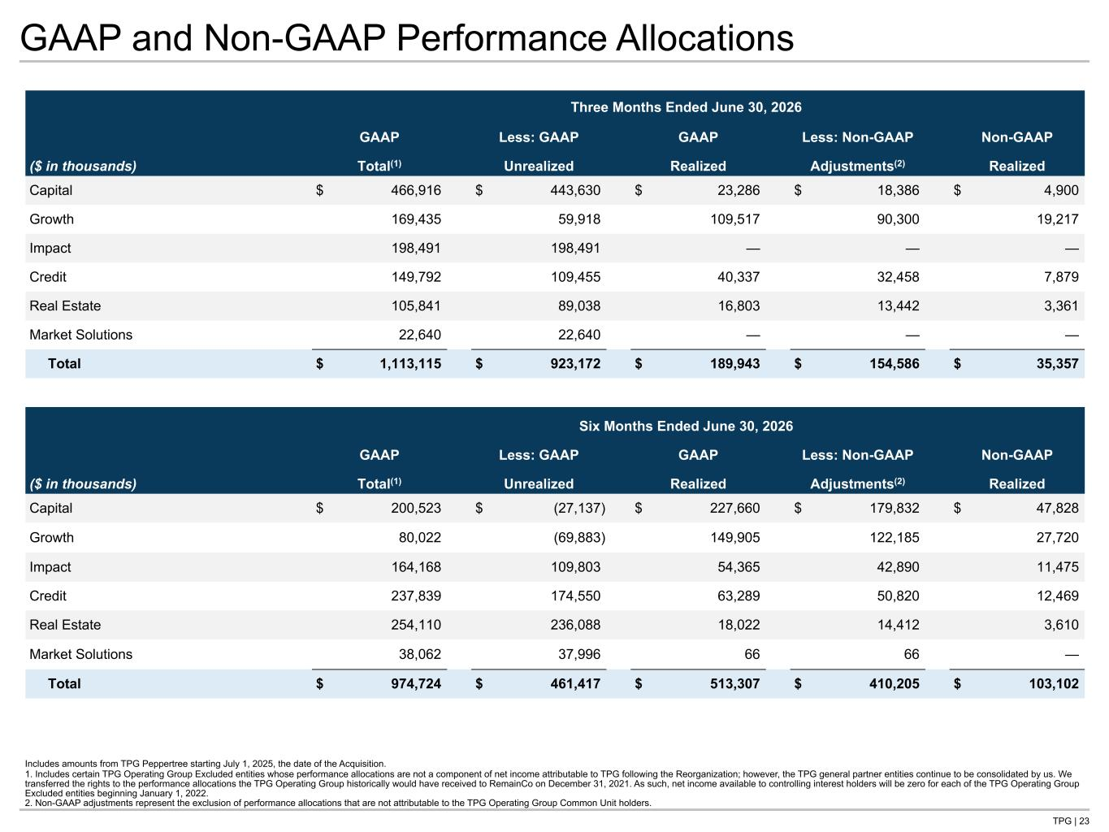
TPG | 23 GAAP and Non-GAAP Performance Allocations Includes amounts from TPG Peppertree starting July 1, 2025, the date of the Acquisition. 1. Includes certain TPG Operating Group Excluded entities whose performance allocations are not a component of net income attributable to TPG following the Reorganization; however, the TPG general partner entities continue to be consolidated by us. We transferred the rights to the performance allocations the TPG Operating Group historically would have received to RemainCo on December 31, 2021. As such, net income available to controlling interest holders will be zero for each of the TPG Operating Group Excluded entities beginning January 1, 2022. 2. Non-GAAP adjustments represent the exclusion of performance allocations that are not attributable to the TPG Operating Group Common Unit holders. Three Months Ended June 30, 2026 GAAP Less: GAAP GAAP Less: Non-GAAP Non-GAAP ($ in thousands) Total(1) Unrealized Realized Adjustments(2) Realized Capital $ 466,916 $ 443,630 $ 23,286 $ 18,386 $ 4,900 Growth 169,435 59,918 109,517 90,300 19,217 Impact 198,491 198,491 — — — Credit 149,792 109,455 40,337 32,458 7,879 Real Estate 105,841 89,038 16,803 13,442 3,361 Market Solutions 22,640 22,640 — — — Total $ 1,113,115 $ 923,172 $ 189,943 $ 154,586 $ 35,357 Six Months Ended June 30, 2026 GAAP Less: GAAP GAAP Less: Non-GAAP Non-GAAP ($ in thousands) Total(1) Unrealized Realized Adjustments(2) Realized Capital $ 200,523 $ (27,137) $ 227,660 $ 179,832 $ 47,828 Growth 80,022 (69,883) 149,905 122,185 27,720 Impact 164,168 109,803 54,365 42,890 11,475 Credit 237,839 174,550 63,289 50,820 12,469 Real Estate 254,110 236,088 18,022 14,412 3,610 Market Solutions 38,062 37,996 66 66 — Total $ 974,724 $ 461,417 $ 513,307 $ 410,205 $ 103,102 Tie to NG P&L, NG column needs to tie to 10Q table in NG MD&A

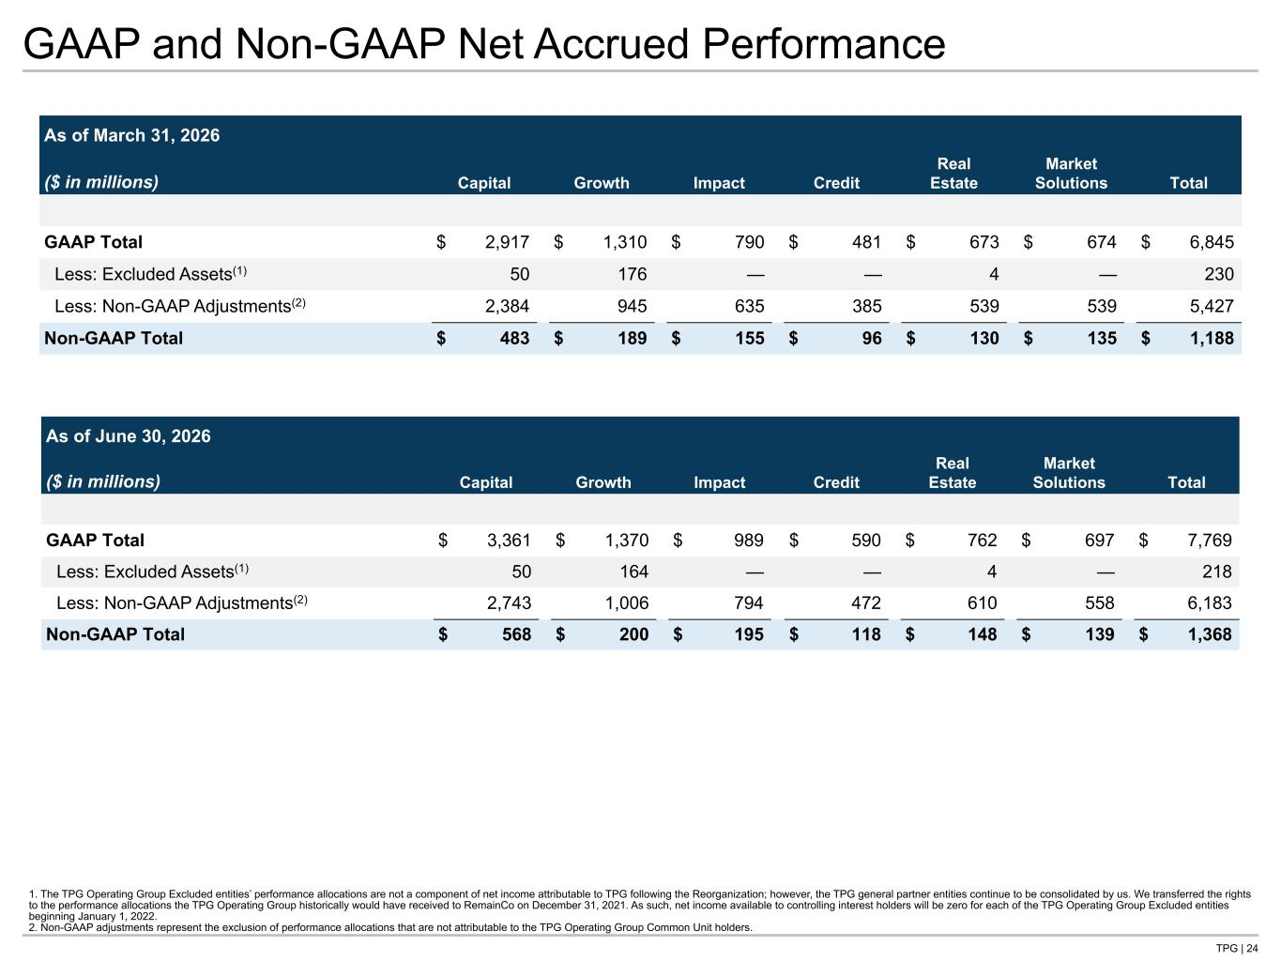
TPG | 24 GAAP and Non-GAAP Net Accrued Performance As of March 31, 2026 ($ in millions) Capital Growth Impact Credit Real Estate Market Solutions Total GAAP Total $ 2,917 $ 1,310 $ 790 $ 481 $ 673 $ 674 $ 6,845 Less: Excluded Assets(1) 50 176 — — 4 — 230 Less: Non-GAAP Adjustments(2) 2,384 945 635 385 539 539 5,427 Non-GAAP Total $ 483 $ 189 $ 155 $ 96 $ 130 $ 135 $ 1,188 1. The TPG Operating Group Excluded entities’ performance allocations are not a component of net income attributable to TPG following the Reorganization; however, the TPG general partner entities continue to be consolidated by us. We transferred the rights to the performance allocations the TPG Operating Group historically would have received to RemainCo on December 31, 2021. As such, net income available to controlling interest holders will be zero for each of the TPG Operating Group Excluded entities beginning January 1, 2022. 2. Non-GAAP adjustments represent the exclusion of performance allocations that are not attributable to the TPG Operating Group Common Unit holders. As of June 30, 2026 ($ in millions) Capital Growth Impact Credit Real Estate Market Solutions Total GAAP Total $ 3,361 $ 1,370 $ 989 $ 590 $ 762 $ 697 $ 7,769 Less: Excluded Assets(1) 50 164 — — 4 — 218 Less: Non-GAAP Adjustments(2) 2,743 1,006 794 472 610 558 6,183 Non-GAAP Total $ 568 $ 200 $ 195 $ 118 $ 148 $ 139 $ 1,368 Tie to Net Accrued Performance page

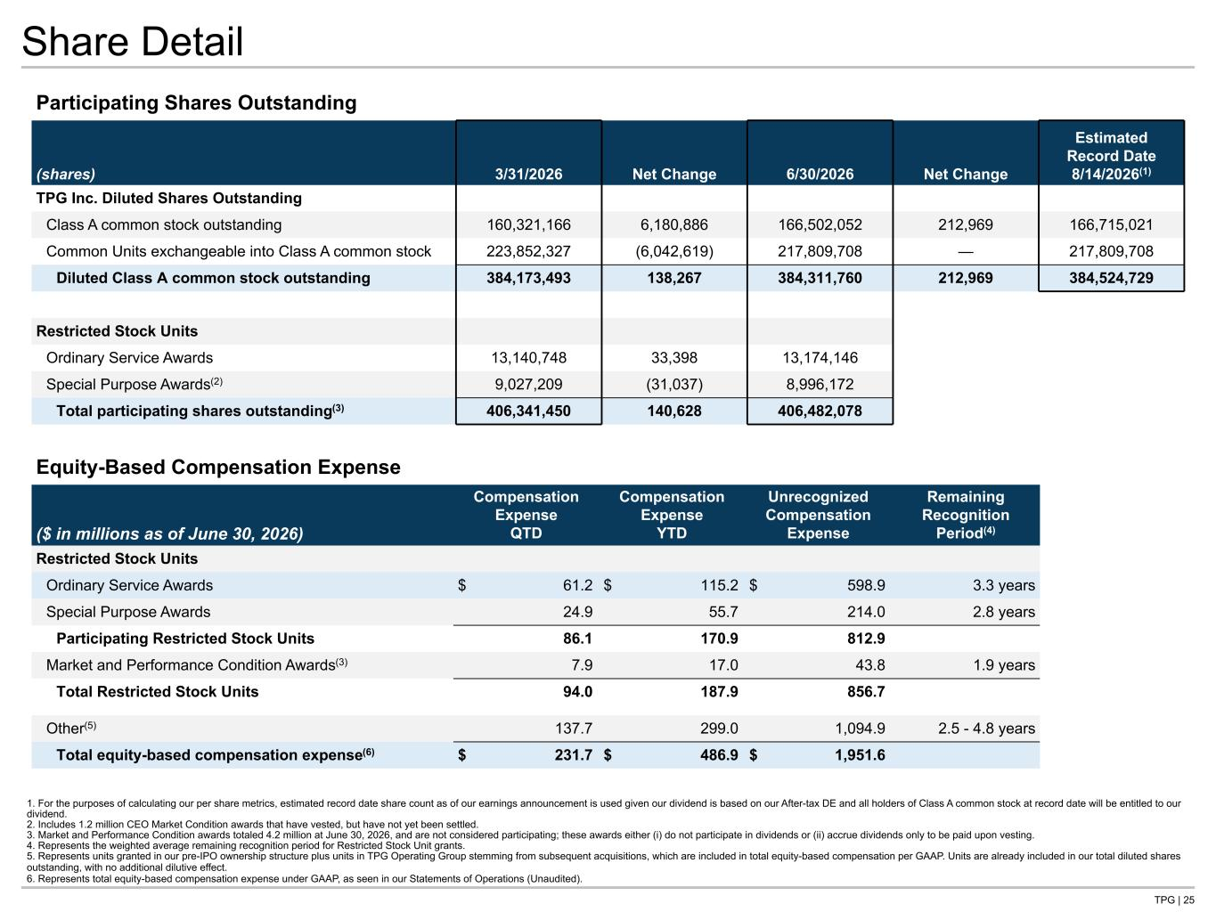
TPG | 25 Share Detail Participating Shares Outstanding (shares) 3/31/2026 Net Change 6/30/2026 Net Change Estimated Record Date 8/14/2026(1) TPG Inc. Diluted Shares Outstanding Class A common stock outstanding 160,321,166 6,180,886 166,502,052 212,969 166,715,021 Common Units exchangeable into Class A common stock 223,852,327 (6,042,619) 217,809,708 — 217,809,708 Diluted Class A common stock outstanding 384,173,493 138,267 384,311,760 212,969 384,524,729 Restricted Stock Units Ordinary Service Awards 13,140,748 33,398 13,174,146 Special Purpose Awards(2) 9,027,209 (31,037) 8,996,172 Total participating shares outstanding(3) 406,341,450 140,628 406,482,078 1. For the purposes of calculating our per share metrics, estimated record date share count as of our earnings announcement is used given our dividend is based on our After-tax DE and all holders of Class A common stock at record date will be entitled to our dividend. 2. Includes 1.2 million CEO Market Condition awards that have vested, but have not yet been settled. 3. Market and Performance Condition awards totaled 4.2 million at June 30, 2026, and are not considered participating; these awards either (i) do not participate in dividends or (ii) accrue dividends only to be paid upon vesting. 4. Represents the weighted average remaining recognition period for Restricted Stock Unit grants. 5. Represents units granted in our pre-IPO ownership structure plus units in TPG Operating Group stemming from subsequent acquisitions, which are included in total equity-based compensation per GAAP. Units are already included in our total diluted shares outstanding, with no additional dilutive effect. 6. Represents total equity-based compensation expense under GAAP, as seen in our Statements of Operations (Unaudited). Tie to Dividends page Equity-Based Compensation Expense ($ in millions as of June 30, 2026) Compensation Expense QTD Compensation Expense YTD Unrecognized Compensation Expense Remaining Recognition Period(4) Restricted Stock Units Ordinary Service Awards $ 61.2 $ 115.2 $ 598.9 3.3 years Special Purpose Awards 24.9 55.7 214.0 2.8 years Participating Restricted Stock Units 86.1 170.9 812.9 Market and Performance Condition Awards(3) 7.9 17.0 43.8 1.9 years Total Restricted Stock Units 94.0 187.9 856.7 Other(5) 137.7 299.0 1,094.9 2.5 - 4.8 years Total equity-based compensation expense(6) $ 231.7 $ 486.9 $ 1,951.6

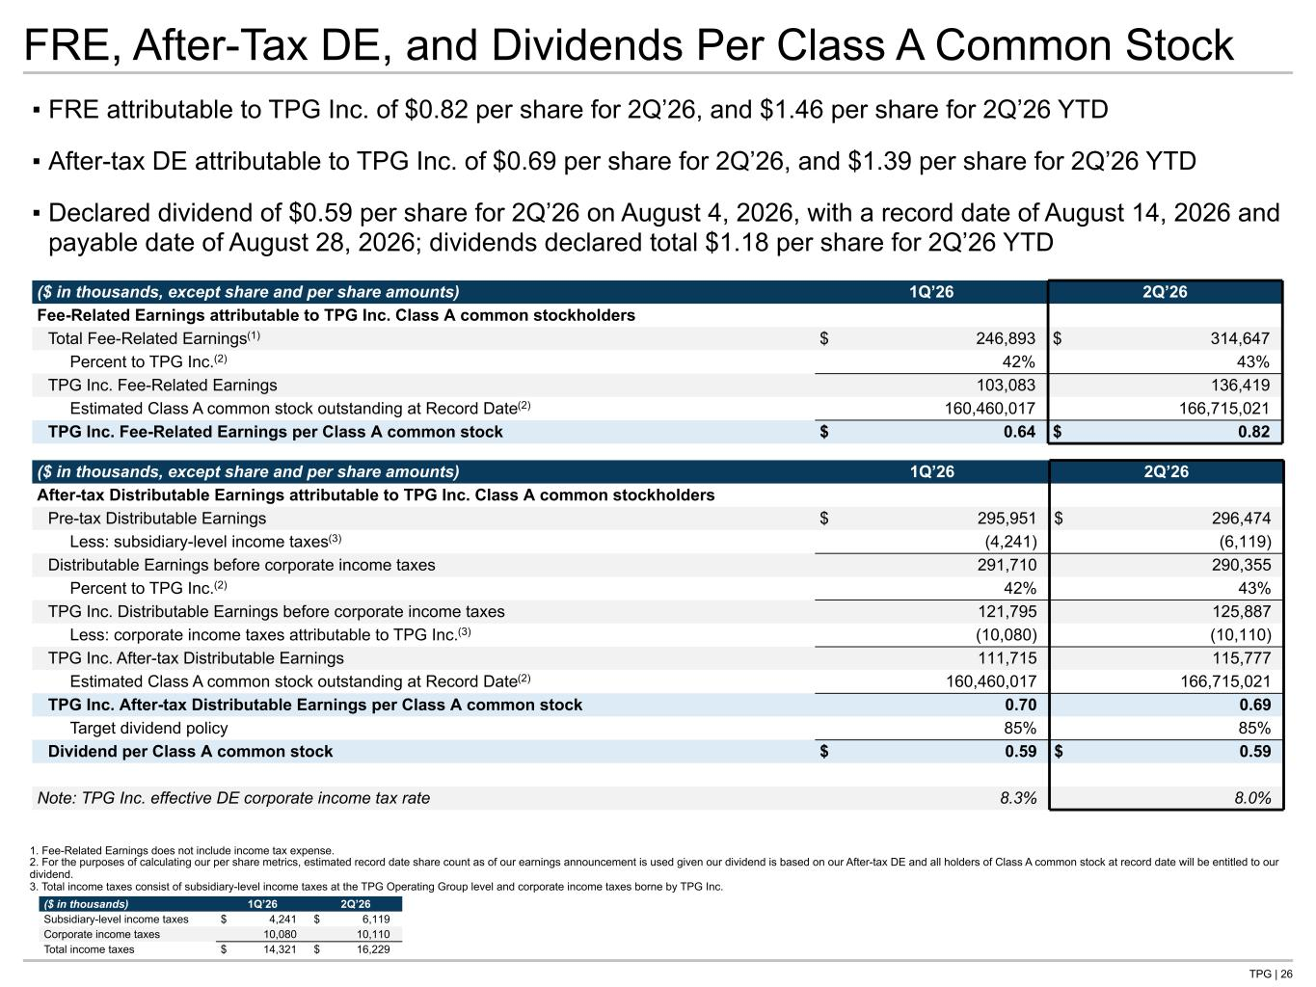
TPG | 26 FRE, After-Tax DE, and Dividends Per Class A Common Stock ▪ FRE attributable to TPG Inc. of $0.82 per share for 2Q’26, and $1.46 per share for 2Q’26 YTD ▪ After-tax DE attributable to TPG Inc. of $0.69 per share for 2Q’26, and $1.39 per share for 2Q’26 YTD ▪ Declared dividend of $0.59 per share for 2Q’26 on August 4, 2026, with a record date of August 14, 2026 and payable date of August 28, 2026; dividends declared total $1.18 per share for 2Q’26 YTD ($ in thousands, except share and per share amounts) 1Q’26 2Q’26 After-tax Distributable Earnings attributable to TPG Inc. Class A common stockholders Pre-tax Distributable Earnings $ 295,951 $ 296,474 Less: subsidiary-level income taxes(3) (4,241) (6,119) Distributable Earnings before corporate income taxes 291,710 290,355 Percent to TPG Inc.(2) 42% 43% TPG Inc. Distributable Earnings before corporate income taxes 121,795 125,887 Less: corporate income taxes attributable to TPG Inc.(3) (10,080) (10,110) TPG Inc. After-tax Distributable Earnings 111,715 115,777 Estimated Class A common stock outstanding at Record Date(2) 160,460,017 166,715,021 TPG Inc. After-tax Distributable Earnings per Class A common stock 0.70 0.69 Target dividend policy 85% 85% Dividend per Class A common stock $ 0.59 $ 0.59 Note: TPG Inc. effective DE corporate income tax rate 8.3% 8.0% 1. Fee-Related Earnings does not include income tax expense. 2. For the purposes of calculating our per share metrics, estimated record date share count as of our earnings announcement is used given our dividend is based on our After-tax DE and all holders of Class A common stock at record date will be entitled to our dividend. 3. Total income taxes consist of subsidiary-level income taxes at the TPG Operating Group level and corporate income taxes borne by TPG Inc. ($ in thousands) 1Q’26 2Q’26 Subsidiary-level income taxes $ 4,241 $ 6,119 Corporate income taxes 10,080 10,110 Total income taxes $ 14,321 $ 16,229 ($ in thousands, except share and per share amounts) 1Q’26 2Q’26 Fee-Related Earnings attributable to TPG Inc. Class A common stockholders Total Fee-Related Earnings(1) $ 246,893 $ 314,647 Percent to TPG Inc.(2) 42% 43% TPG Inc. Fee-Related Earnings 103,083 136,419 Estimated Class A common stock outstanding at Record Date(2) 160,460,017 166,715,021 TPG Inc. Fee-Related Earnings per Class A common stock $ 0.64 $ 0.82 Tie to: -Share Roll page for Shares -NG P&L for FRE, taxes, and Pretax DE

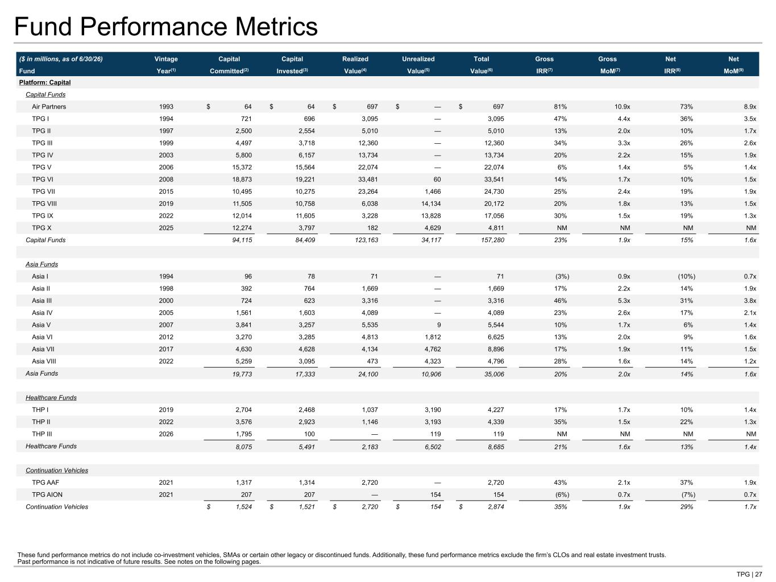
TPG | 27 Fund Performance Metrics ($ in millions, as of 6/30/26) Vintage Capital Capital Realized Unrealized Total Gross Gross Net Net Fund Year(1) Committed(2) Invested(3) Value(4) Value(5) Value(6) IRR(7) MoM(7) IRR(8) MoM(9) Platform: Capital Capital Funds Air Partners 1993 $ 64 $ 64 $ 697 $ — $ 697 81% 10.9x 73% 8.9x TPG I 1994 721 696 3,095 — 3,095 47% 4.4x 36% 3.5x TPG II 1997 2,500 2,554 5,010 — 5,010 13% 2.0x 10% 1.7x TPG III 1999 4,497 3,718 12,360 — 12,360 34% 3.3x 26% 2.6x TPG IV 2003 5,800 6,157 13,734 — 13,734 20% 2.2x 15% 1.9x TPG V 2006 15,372 15,564 22,074 — 22,074 6% 1.4x 5% 1.4x TPG VI 2008 18,873 19,221 33,481 60 33,541 14% 1.7x 10% 1.5x TPG VII 2015 10,495 10,275 23,264 1,466 24,730 25% 2.4x 19% 1.9x TPG VIII 2019 11,505 10,758 6,038 14,134 20,172 20% 1.8x 13% 1.5x TPG IX 2022 12,014 11,605 3,228 13,828 17,056 30% 1.5x 19% 1.3x TPG X 2025 12,274 3,797 182 4,629 4,811 NM NM NM NM Capital Funds 94,115 84,409 123,163 34,117 157,280 23% 1.9x 15% 1.6x Asia Funds Asia I 1994 96 78 71 — 71 (3%) 0.9x (10%) 0.7x Asia II 1998 392 764 1,669 — 1,669 17% 2.2x 14% 1.9x Asia III 2000 724 623 3,316 — 3,316 46% 5.3x 31% 3.8x Asia IV 2005 1,561 1,603 4,089 — 4,089 23% 2.6x 17% 2.1x Asia V 2007 3,841 3,257 5,535 9 5,544 10% 1.7x 6% 1.4x Asia VI 2012 3,270 3,285 4,813 1,812 6,625 13% 2.0x 9% 1.6x Asia VII 2017 4,630 4,628 4,134 4,762 8,896 17% 1.9x 11% 1.5x Asia VIII 2022 5,259 3,095 473 4,323 4,796 28% 1.6x 14% 1.2x Asia Funds 19,773 17,333 24,100 10,906 35,006 20% 2.0x 14% 1.6x Healthcare Funds THP I 2019 2,704 2,468 1,037 3,190 4,227 17% 1.7x 10% 1.4x THP II 2022 3,576 2,923 1,146 3,193 4,339 35% 1.5x 22% 1.3x THP III 2026 1,795 100 — 119 119 NM NM NM NM Healthcare Funds 8,075 5,491 2,183 6,502 8,685 21% 1.6x 13% 1.4x Continuation Vehicles TPG AAF 2021 1,317 1,314 2,720 — 2,720 43% 2.1x 37% 1.9x TPG AION 2021 207 207 — 154 154 (6%) 0.7x (7%) 0.7x Continuation Vehicles $ 1,524 $ 1,521 $ 2,720 $ 154 $ 2,874 35% 1.9x 29% 1.7x These fund performance metrics do not include co-investment vehicles, SMAs or certain other legacy or discontinued funds. Additionally, these fund performance metrics exclude the firm’s CLOs and real estate investment trusts. Past performance is not indicative of future results. See notes on the following pages.

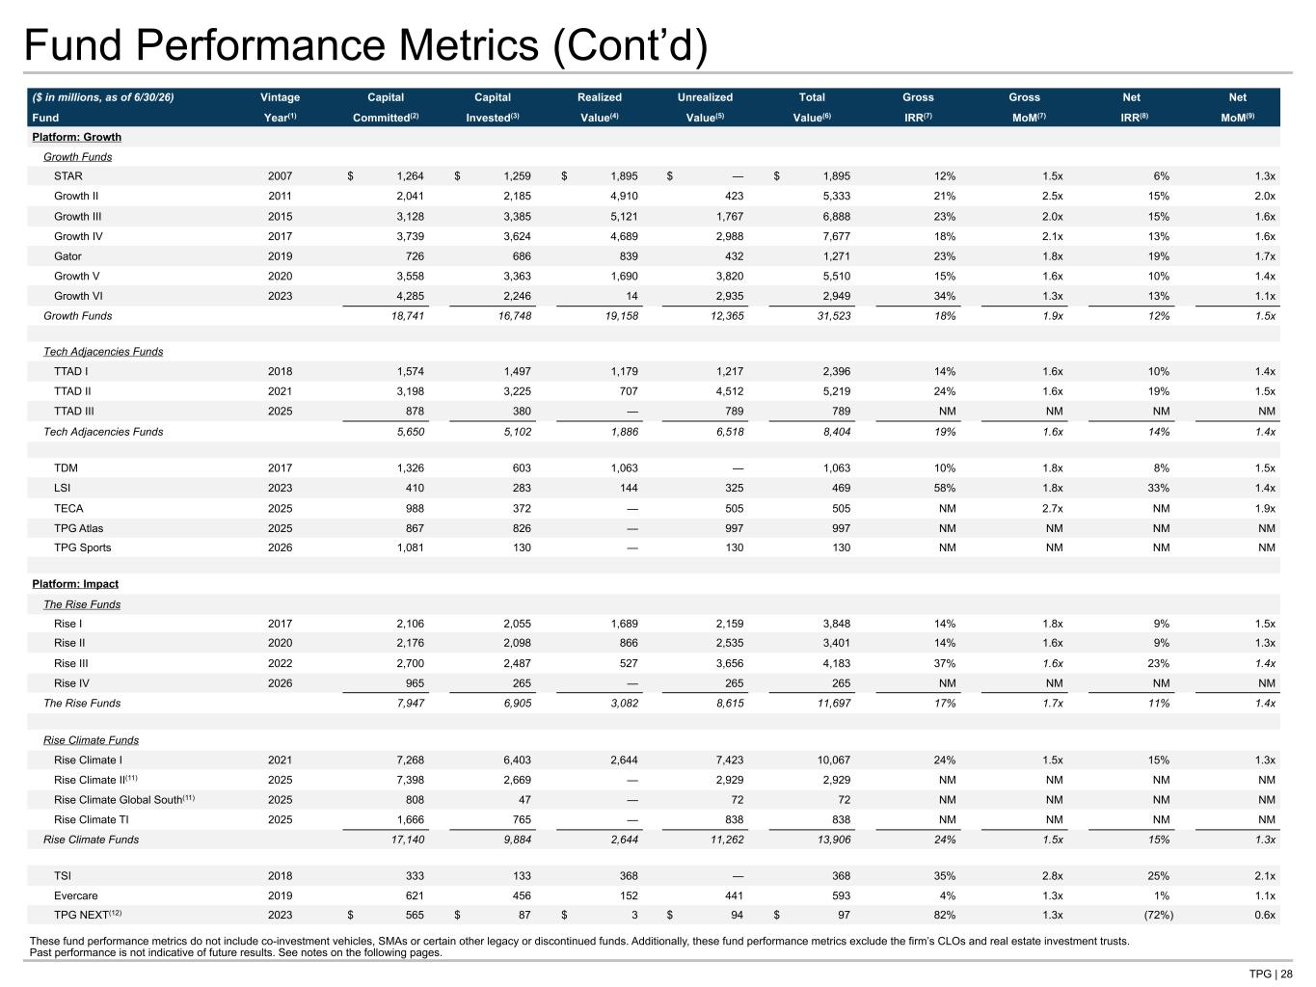
TPG | 28 Fund Performance Metrics (Cont’d) ($ in millions, as of 6/30/26) Vintage Capital Capital Realized Unrealized Total Gross Gross Net Net Fund Year(1) Committed(2) Invested(3) Value(4) Value(5) Value(6) IRR(7) MoM(7) IRR(8) MoM(9) Platform: Growth Growth Funds STAR 2007 $ 1,264 $ 1,259 $ 1,895 $ — $ 1,895 12% 1.5x 6% 1.3x Growth II 2011 2,041 2,185 4,910 423 5,333 21% 2.5x 15% 2.0x Growth III 2015 3,128 3,385 5,121 1,767 6,888 23% 2.0x 15% 1.6x Growth IV 2017 3,739 3,624 4,689 2,988 7,677 18% 2.1x 13% 1.6x Gator 2019 726 686 839 432 1,271 23% 1.8x 19% 1.7x Growth V 2020 3,558 3,363 1,690 3,820 5,510 15% 1.6x 10% 1.4x Growth VI 2023 4,285 2,246 14 2,935 2,949 34% 1.3x 13% 1.1x Growth Funds 18,741 16,748 19,158 12,365 31,523 18% 1.9x 12% 1.5x Tech Adjacencies Funds TTAD I 2018 1,574 1,497 1,179 1,217 2,396 14% 1.6x 10% 1.4x TTAD II 2021 3,198 3,225 707 4,512 5,219 24% 1.6x 19% 1.5x TTAD III 2025 878 380 — 789 789 NM NM NM NM Tech Adjacencies Funds 5,650 5,102 1,886 6,518 8,404 19% 1.6x 14% 1.4x TDM 2017 1,326 603 1,063 — 1,063 10% 1.8x 8% 1.5x LSI 2023 410 283 144 325 469 58% 1.8x 33% 1.4x TECA 2025 988 372 — 505 505 NM 2.7x NM 1.9x TPG Atlas 2025 867 826 — 997 997 NM NM NM NM TPG Sports 2026 1,081 130 — 130 130 NM NM NM NM Platform: Impact The Rise Funds Rise I 2017 2,106 2,055 1,689 2,159 3,848 14% 1.8x 9% 1.5x Rise II 2020 2,176 2,098 866 2,535 3,401 14% 1.6x 9% 1.3x Rise III 2022 2,700 2,487 527 3,656 4,183 37% 1.6x 23% 1.4x Rise IV 2026 965 265 — 265 265 NM NM NM NM The Rise Funds 7,947 6,905 3,082 8,615 11,697 17% 1.7x 11% 1.4x Rise Climate Funds Rise Climate I 2021 7,268 6,403 2,644 7,423 10,067 24% 1.5x 15% 1.3x Rise Climate II(11) 2025 7,398 2,669 — 2,929 2,929 NM NM NM NM Rise Climate Global South(11) 2025 808 47 — 72 72 NM NM NM NM Rise Climate TI 2025 1,666 765 — 838 838 NM NM NM NM Rise Climate Funds 17,140 9,884 2,644 11,262 13,906 24% 1.5x 15% 1.3x TSI 2018 333 133 368 — 368 35% 2.8x 25% 2.1x Evercare 2019 621 456 152 441 593 4% 1.3x 1% 1.1x TPG NEXT(12) 2023 $ 565 $ 87 $ 3 $ 94 $ 97 82% 1.3x (72%) 0.6x These fund performance metrics do not include co-investment vehicles, SMAs or certain other legacy or discontinued funds. Additionally, these fund performance metrics exclude the firm’s CLOs and real estate investment trusts. Past performance is not indicative of future results. See notes on the following pages.

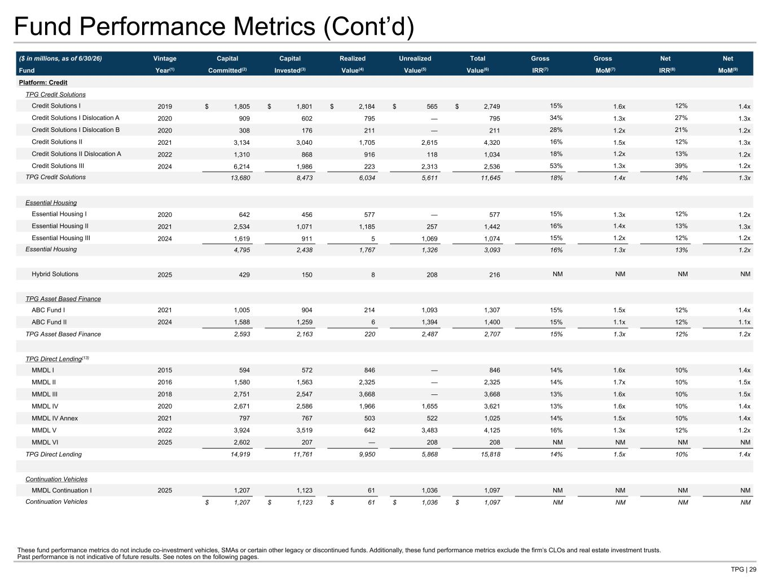
TPG | 29 Fund Performance Metrics (Cont’d) ($ in millions, as of 6/30/26) Vintage Capital Capital Realized Unrealized Total Gross Gross Net Net Fund Year(1) Committed(2) Invested(3) Value(4) Value(5) Value(6) IRR(7) MoM(7) IRR(8) MoM(9) Platform: Credit TPG Credit Solutions Credit Solutions I 2019 $ 1,805 $ 1,801 $ 2,184 $ 565 $ 2,749 15% 1.6x 12% 1.4x Credit Solutions I Dislocation A 2020 909 602 795 — 795 34% 1.3x 27% 1.3x Credit Solutions I Dislocation B 2020 308 176 211 — 211 28% 1.2x 21% 1.2x Credit Solutions II 2021 3,134 3,040 1,705 2,615 4,320 16% 1.5x 12% 1.3x Credit Solutions II Dislocation A 2022 1,310 868 916 118 1,034 18% 1.2x 13% 1.2x Credit Solutions III 2024 6,214 1,986 223 2,313 2,536 53% 1.3x 39% 1.2x TPG Credit Solutions 13,680 8,473 6,034 5,611 11,645 18% 1.4x 14% 1.3x Essential Housing Essential Housing I 2020 642 456 577 — 577 15% 1.3x 12% 1.2x Essential Housing II 2021 2,534 1,071 1,185 257 1,442 16% 1.4x 13% 1.3x Essential Housing III 2024 1,619 911 5 1,069 1,074 15% 1.2x 12% 1.2x Essential Housing 4,795 2,438 1,767 1,326 3,093 16% 1.3x 13% 1.2x Hybrid Solutions 2025 429 150 8 208 216 NM NM NM NM TPG Asset Based Finance ABC Fund I 2021 1,005 904 214 1,093 1,307 15% 1.5x 12% 1.4x ABC Fund II 2024 1,588 1,259 6 1,394 1,400 15% 1.1x 12% 1.1x TPG Asset Based Finance 2,593 2,163 220 2,487 2,707 15% 1.3x 12% 1.2x TPG Direct Lending(13) MMDL I 2015 594 572 846 — 846 14% 1.6x 10% 1.4x MMDL II 2016 1,580 1,563 2,325 — 2,325 14% 1.7x 10% 1.5x MMDL III 2018 2,751 2,547 3,668 — 3,668 13% 1.6x 10% 1.5x MMDL IV 2020 2,671 2,586 1,966 1,655 3,621 13% 1.6x 10% 1.4x MMDL IV Annex 2021 797 767 503 522 1,025 14% 1.5x 10% 1.4x MMDL V 2022 3,924 3,519 642 3,483 4,125 16% 1.3x 12% 1.2x MMDL VI 2025 2,602 207 — 208 208 NM NM NM NM TPG Direct Lending 14,919 11,761 9,950 5,868 15,818 14% 1.5x 10% 1.4x Continuation Vehicles MMDL Continuation I 2025 1,207 1,123 61 1,036 1,097 NM NM NM NM Continuation Vehicles $ 1,207 $ 1,123 $ 61 $ 1,036 $ 1,097 NM NM NM NM These fund performance metrics do not include co-investment vehicles, SMAs or certain other legacy or discontinued funds. Additionally, these fund performance metrics exclude the firm’s CLOs and real estate investment trusts. Past performance is not indicative of future results. See notes on the following pages.

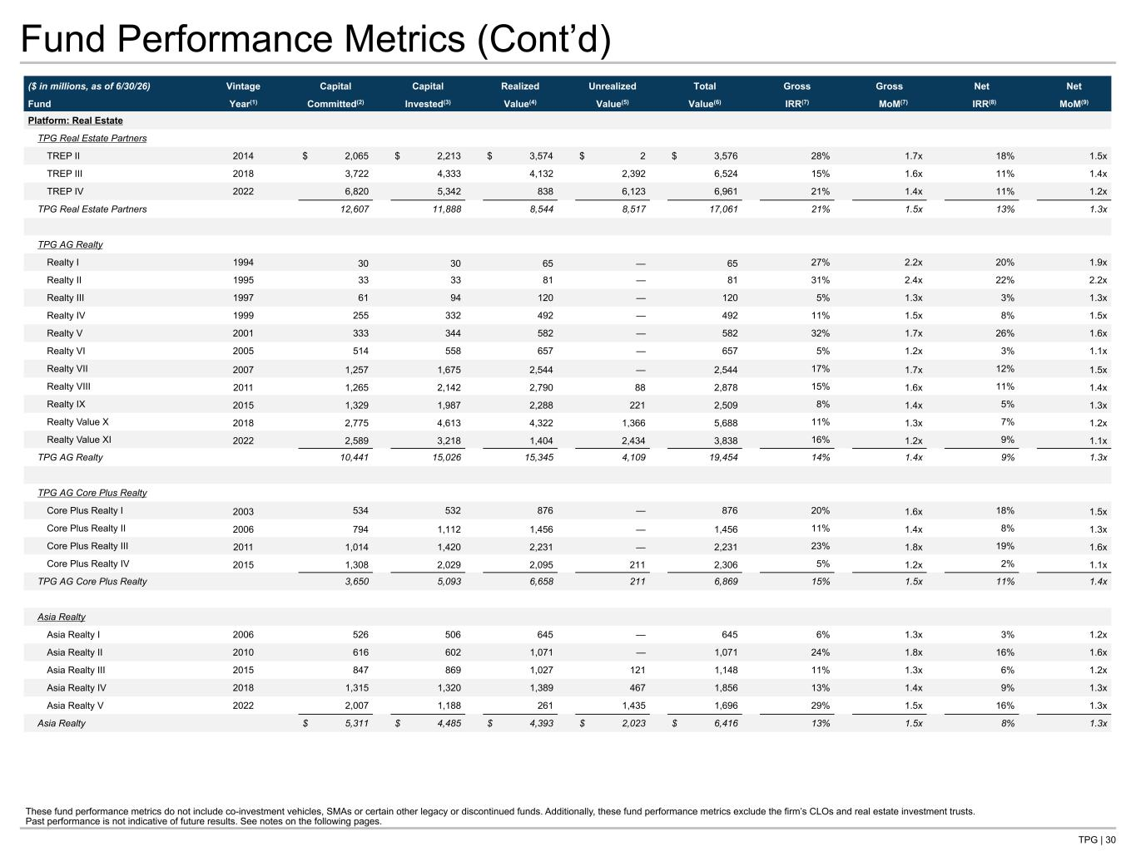
TPG | 30 Fund Performance Metrics (Cont’d) ($ in millions, as of 6/30/26) Vintage Capital Capital Realized Unrealized Total Gross Gross Net Net Fund Year(1) Committed(2) Invested(3) Value(4) Value(5) Value(6) IRR(7) MoM(7) IRR(8) MoM(9) Platform: Real Estate TPG Real Estate Partners TREP II 2014 $ 2,065 $ 2,213 $ 3,574 $ 2 $ 3,576 28% 1.7x 18% 1.5x TREP III 2018 3,722 4,333 4,132 2,392 6,524 15% 1.6x 11% 1.4x TREP IV 2022 6,820 5,342 838 6,123 6,961 21% 1.4x 11% 1.2x TPG Real Estate Partners 12,607 11,888 8,544 8,517 17,061 21% 1.5x 13% 1.3x TPG AG Realty Realty I 1994 30 30 65 — 65 27% 2.2x 20% 1.9x Realty II 1995 33 33 81 — 81 31% 2.4x 22% 2.2x Realty III 1997 61 94 120 — 120 5% 1.3x 3% 1.3x Realty IV 1999 255 332 492 — 492 11% 1.5x 8% 1.5x Realty V 2001 333 344 582 — 582 32% 1.7x 26% 1.6x Realty VI 2005 514 558 657 — 657 5% 1.2x 3% 1.1x Realty VII 2007 1,257 1,675 2,544 — 2,544 17% 1.7x 12% 1.5x Realty VIII 2011 1,265 2,142 2,790 88 2,878 15% 1.6x 11% 1.4x Realty IX 2015 1,329 1,987 2,288 221 2,509 8% 1.4x 5% 1.3x Realty Value X 2018 2,775 4,613 4,322 1,366 5,688 11% 1.3x 7% 1.2x Realty Value XI 2022 2,589 3,218 1,404 2,434 3,838 16% 1.2x 9% 1.1x TPG AG Realty 10,441 15,026 15,345 4,109 19,454 14% 1.4x 9% 1.3x TPG AG Core Plus Realty Core Plus Realty I 2003 534 532 876 — 876 20% 1.6x 18% 1.5x Core Plus Realty II 2006 794 1,112 1,456 — 1,456 11% 1.4x 8% 1.3x Core Plus Realty III 2011 1,014 1,420 2,231 — 2,231 23% 1.8x 19% 1.6x Core Plus Realty IV 2015 1,308 2,029 2,095 211 2,306 5% 1.2x 2% 1.1x TPG AG Core Plus Realty 3,650 5,093 6,658 211 6,869 15% 1.5x 11% 1.4x Asia Realty Asia Realty I 2006 526 506 645 — 645 6% 1.3x 3% 1.2x Asia Realty II 2010 616 602 1,071 — 1,071 24% 1.8x 16% 1.6x Asia Realty III 2015 847 869 1,027 121 1,148 11% 1.3x 6% 1.2x Asia Realty IV 2018 1,315 1,320 1,389 467 1,856 13% 1.4x 9% 1.3x Asia Realty V 2022 2,007 1,188 261 1,435 1,696 29% 1.5x 16% 1.3x Asia Realty $ 5,311 $ 4,485 $ 4,393 $ 2,023 $ 6,416 13% 1.5x 8% 1.3x These fund performance metrics do not include co-investment vehicles, SMAs or certain other legacy or discontinued funds. Additionally, these fund performance metrics exclude the firm’s CLOs and real estate investment trusts. Past performance is not indicative of future results. See notes on the following pages.

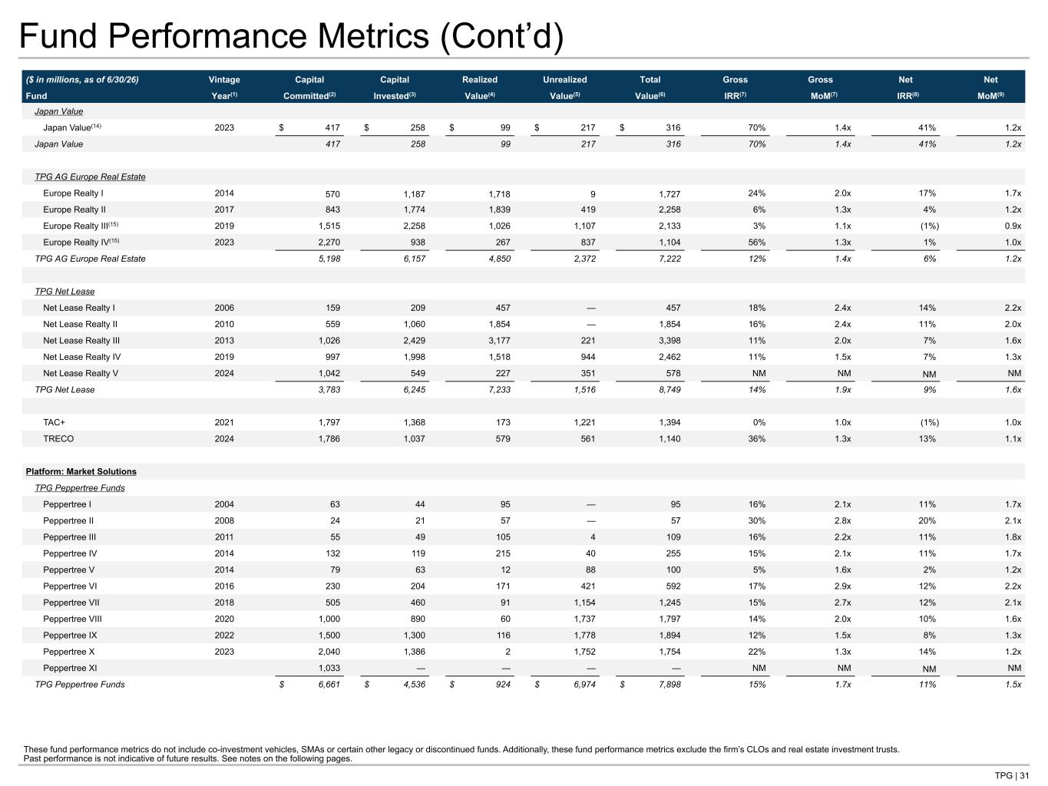
TPG | 31 Fund Performance Metrics (Cont’d) ($ in millions, as of 6/30/26) Vintage Capital Capital Realized Unrealized Total Gross Gross Net Net Fund Year(1) Committed(2) Invested(3) Value(4) Value(5) Value(6) IRR(7) MoM(7) IRR(8) MoM(9) Japan Value Japan Value(14) 2023 $ 417 $ 258 $ 99 $ 217 $ 316 70% 1.4x 41% 1.2x Japan Value 417 258 99 217 316 70% 1.4x 41% 1.2x TPG AG Europe Real Estate Europe Realty I 2014 570 1,187 1,718 9 1,727 24% 2.0x 17% 1.7x Europe Realty II 2017 843 1,774 1,839 419 2,258 6% 1.3x 4% 1.2x Europe Realty III(15) 2019 1,515 2,258 1,026 1,107 2,133 3% 1.1x (1%) 0.9x Europe Realty IV(15) 2023 2,270 938 267 837 1,104 56% 1.3x 1% 1.0x TPG AG Europe Real Estate 5,198 6,157 4,850 2,372 7,222 12% 1.4x 6% 1.2x TPG Net Lease Net Lease Realty I 2006 159 209 457 — 457 18% 2.4x 14% 2.2x Net Lease Realty II 2010 559 1,060 1,854 — 1,854 16% 2.4x 11% 2.0x Net Lease Realty III 2013 1,026 2,429 3,177 221 3,398 11% 2.0x 7% 1.6x Net Lease Realty IV 2019 997 1,998 1,518 944 2,462 11% 1.5x 7% 1.3x Net Lease Realty V 2024 1,042 549 227 351 578 NM NM NM NM TPG Net Lease 3,783 6,245 7,233 1,516 8,749 14% 1.9x 9% 1.6x TAC+ 2021 1,797 1,368 173 1,221 1,394 0% 1.0x (1%) 1.0x TRECO 2024 1,786 1,037 579 561 1,140 36% 1.3x 13% 1.1x Platform: Market Solutions TPG Peppertree Funds Peppertree I 2004 63 44 95 — 95 16% 2.1x 11% 1.7x Peppertree II 2008 24 21 57 — 57 30% 2.8x 20% 2.1x Peppertree III 2011 55 49 105 4 109 16% 2.2x 11% 1.8x Peppertree IV 2014 132 119 215 40 255 15% 2.1x 11% 1.7x Peppertree V 2014 79 63 12 88 100 5% 1.6x 2% 1.2x Peppertree VI 2016 230 204 171 421 592 17% 2.9x 12% 2.2x Peppertree VII 2018 505 460 91 1,154 1,245 15% 2.7x 12% 2.1x Peppertree VIII 2020 1,000 890 60 1,737 1,797 14% 2.0x 10% 1.6x Peppertree IX 2022 1,500 1,300 116 1,778 1,894 12% 1.5x 8% 1.3x Peppertree X 2023 2,040 1,386 2 1,752 1,754 22% 1.3x 14% 1.2x Peppertree XI 1,033 — — — — NM NM NM NM TPG Peppertree Funds $ 6,661 $ 4,536 $ 924 $ 6,974 $ 7,898 15% 1.7x 11% 1.5x These fund performance metrics do not include co-investment vehicles, SMAs or certain other legacy or discontinued funds. Additionally, these fund performance metrics exclude the firm’s CLOs and real estate investment trusts. Past performance is not indicative of future results. See notes on the following pages.

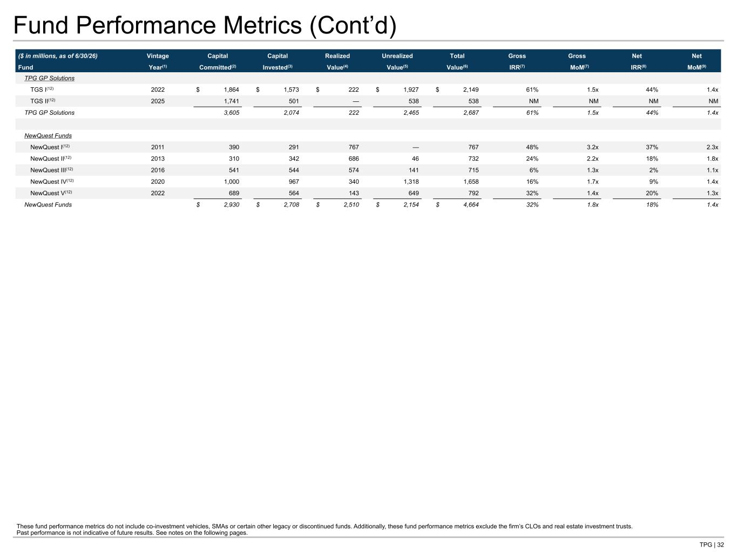
TPG | 32 Fund Performance Metrics (Cont’d) ($ in millions, as of 6/30/26) Vintage Capital Capital Realized Unrealized Total Gross Gross Net Net Fund Year(1) Committed(2) Invested(3) Value(4) Value(5) Value(6) IRR(7) MoM(7) IRR(8) MoM(9) TPG GP Solutions TGS I(12) 2022 $ 1,864 $ 1,573 $ 222 $ 1,927 $ 2,149 61% 1.5x 44% 1.4x TGS II(12) 2025 1,741 501 — 538 538 NM NM NM NM TPG GP Solutions 3,605 2,074 222 2,465 2,687 61% 1.5x 44% 1.4x NewQuest Funds NewQuest I(12) 2011 390 291 767 — 767 48% 3.2x 37% 2.3x NewQuest II(12) 2013 310 342 686 46 732 24% 2.2x 18% 1.8x NewQuest III(12) 2016 541 544 574 141 715 6% 1.3x 2% 1.1x NewQuest IV(12) 2020 1,000 967 340 1,318 1,658 16% 1.7x 9% 1.4x NewQuest V(12) 2022 689 564 143 649 792 32% 1.4x 20% 1.3x NewQuest Funds $ 2,930 $ 2,708 $ 2,510 $ 2,154 $ 4,664 32% 1.8x 18% 1.4x These fund performance metrics do not include co-investment vehicles, SMAs or certain other legacy or discontinued funds. Additionally, these fund performance metrics exclude the firm’s CLOs and real estate investment trusts. Past performance is not indicative of future results. See notes on the following pages.

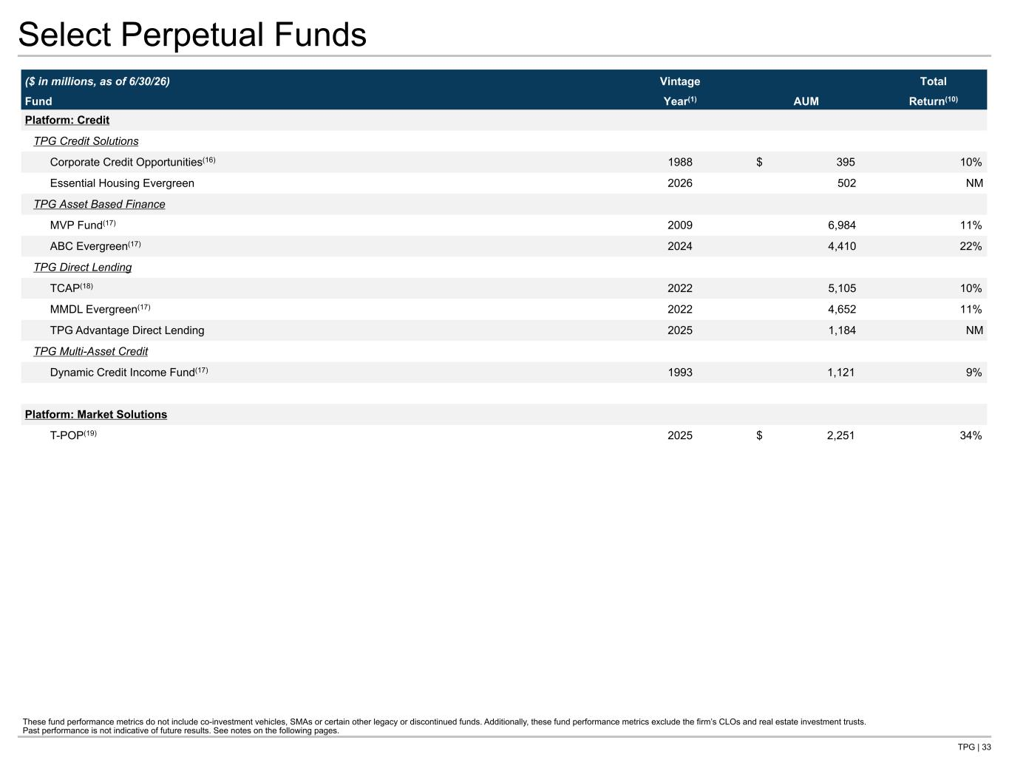
TPG | 33 Select Perpetual Funds ($ in millions, as of 6/30/26) Vintage AUM Total Fund Year(1) Return(10) Platform: Credit TPG Credit Solutions Corporate Credit Opportunities(16) 1988 $ 395 10% Essential Housing Evergreen 2026 502 NM TPG Asset Based Finance MVP Fund(17) 2009 6,984 11% ABC Evergreen(17) 2024 4,410 22% TPG Direct Lending TCAP(18) 2022 5,105 10% MMDL Evergreen(17) 2022 4,652 11% TPG Advantage Direct Lending 2025 1,184 NM TPG Multi-Asset Credit Dynamic Credit Income Fund(17) 1993 1,121 9% Platform: Market Solutions T-POP(19) 2025 $ 2,251 34% These fund performance metrics do not include co-investment vehicles, SMAs or certain other legacy or discontinued funds. Additionally, these fund performance metrics exclude the firm’s CLOs and real estate investment trusts. Past performance is not indicative of future results. See notes on the following pages.

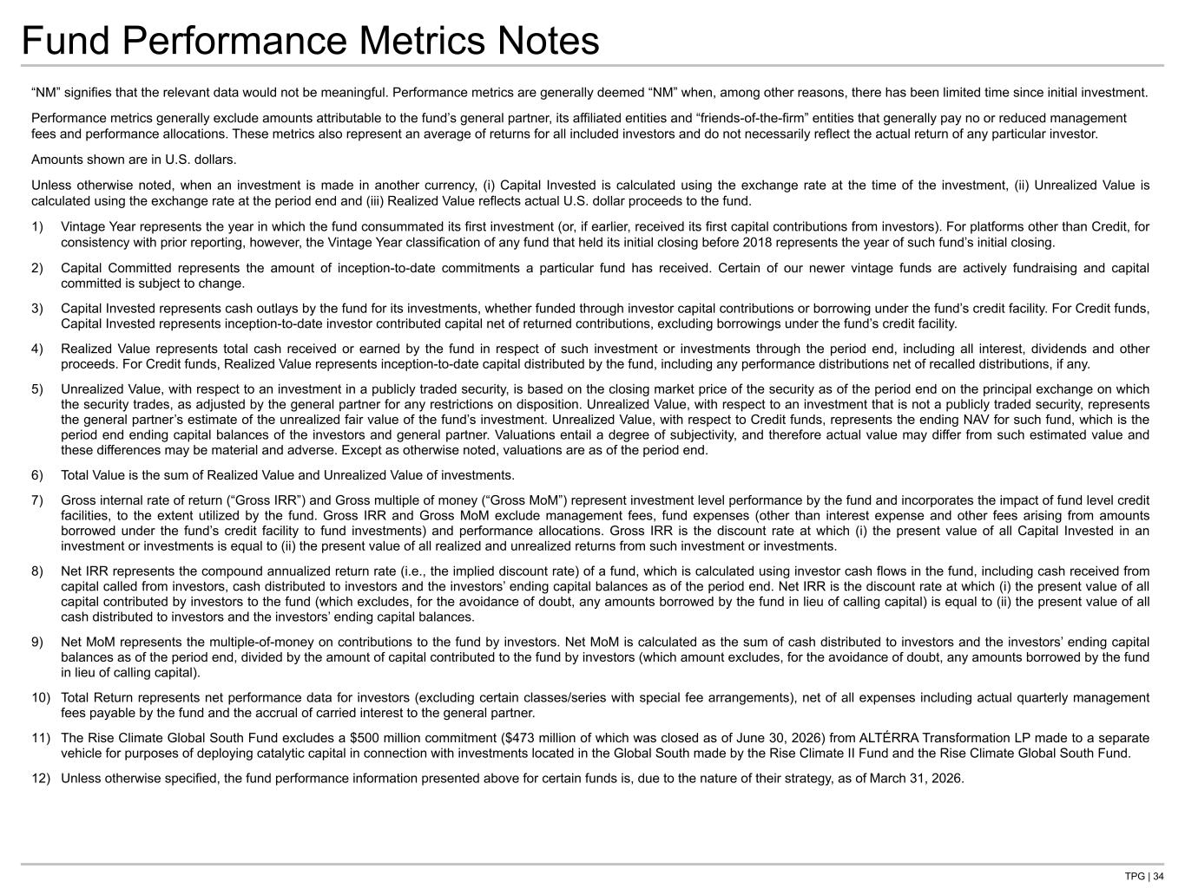
TPG | 34 Fund Performance Metrics Notes “NM” signifies that the relevant data would not be meaningful. Performance metrics are generally deemed “NM” when, among other reasons, there has been limited time since initial investment. Performance metrics generally exclude amounts attributable to the fund’s general partner, its affiliated entities and “friends-of-the-firm” entities that generally pay no or reduced management fees and performance allocations. These metrics also represent an average of returns for all included investors and do not necessarily reflect the actual return of any particular investor. Amounts shown are in U.S. dollars. Unless otherwise noted, when an investment is made in another currency, (i) Capital Invested is calculated using the exchange rate at the time of the investment, (ii) Unrealized Value is calculated using the exchange rate at the period end and (iii) Realized Value reflects actual U.S. dollar proceeds to the fund. 1) Vintage Year represents the year in which the fund consummated its first investment (or, if earlier, received its first capital contributions from investors). For platforms other than Credit, for consistency with prior reporting, however, the Vintage Year classification of any fund that held its initial closing before 2018 represents the year of such fund’s initial closing. 2) Capital Committed represents the amount of inception-to-date commitments a particular fund has received. Certain of our newer vintage funds are actively fundraising and capital committed is subject to change. 3) Capital Invested represents cash outlays by the fund for its investments, whether funded through investor capital contributions or borrowing under the fund’s credit facility. For Credit funds, Capital Invested represents inception-to-date investor contributed capital net of returned contributions, excluding borrowings under the fund’s credit facility. 4) Realized Value represents total cash received or earned by the fund in respect of such investment or investments through the period end, including all interest, dividends and other proceeds. For Credit funds, Realized Value represents inception-to-date capital distributed by the fund, including any performance distributions net of recalled distributions, if any. 5) Unrealized Value, with respect to an investment in a publicly traded security, is based on the closing market price of the security as of the period end on the principal exchange on which the security trades, as adjusted by the general partner for any restrictions on disposition. Unrealized Value, with respect to an investment that is not a publicly traded security, represents the general partner’s estimate of the unrealized fair value of the fund’s investment. Unrealized Value, with respect to Credit funds, represents the ending NAV for such fund, which is the period end ending capital balances of the investors and general partner. Valuations entail a degree of subjectivity, and therefore actual value may differ from such estimated value and these differences may be material and adverse. Except as otherwise noted, valuations are as of the period end. 6) Total Value is the sum of Realized Value and Unrealized Value of investments. 7) Gross internal rate of return (“Gross IRR”) and Gross multiple of money (“Gross MoM”) represent investment level performance by the fund and incorporates the impact of fund level credit facilities, to the extent utilized by the fund. Gross IRR and Gross MoM exclude management fees, fund expenses (other than interest expense and other fees arising from amounts borrowed under the fund’s credit facility to fund investments) and performance allocations. Gross IRR is the discount rate at which (i) the present value of all Capital Invested in an investment or investments is equal to (ii) the present value of all realized and unrealized returns from such investment or investments. 8) Net IRR represents the compound annualized return rate (i.e., the implied discount rate) of a fund, which is calculated using investor cash flows in the fund, including cash received from capital called from investors, cash distributed to investors and the investors’ ending capital balances as of the period end. Net IRR is the discount rate at which (i) the present value of all capital contributed by investors to the fund (which excludes, for the avoidance of doubt, any amounts borrowed by the fund in lieu of calling capital) is equal to (ii) the present value of all cash distributed to investors and the investors’ ending capital balances. 9) Net MoM represents the multiple-of-money on contributions to the fund by investors. Net MoM is calculated as the sum of cash distributed to investors and the investors’ ending capital balances as of the period end, divided by the amount of capital contributed to the fund by investors (which amount excludes, for the avoidance of doubt, any amounts borrowed by the fund in lieu of calling capital). 10) Total Return represents net performance data for investors (excluding certain classes/series with special fee arrangements), net of all expenses including actual quarterly management fees payable by the fund and the accrual of carried interest to the general partner. 11) The Rise Climate Global South Fund excludes a $500 million commitment ($473 million of which was closed as of June 30, 2026) from ALTÉRRA Transformation LP made to a separate vehicle for purposes of deploying catalytic capital in connection with investments located in the Global South made by the Rise Climate II Fund and the Rise Climate Global South Fund. 12) Unless otherwise specified, the fund performance information presented above for certain funds is, due to the nature of their strategy, as of March 31, 2026. Remember to check with PFT/FF on ALTERRA amount

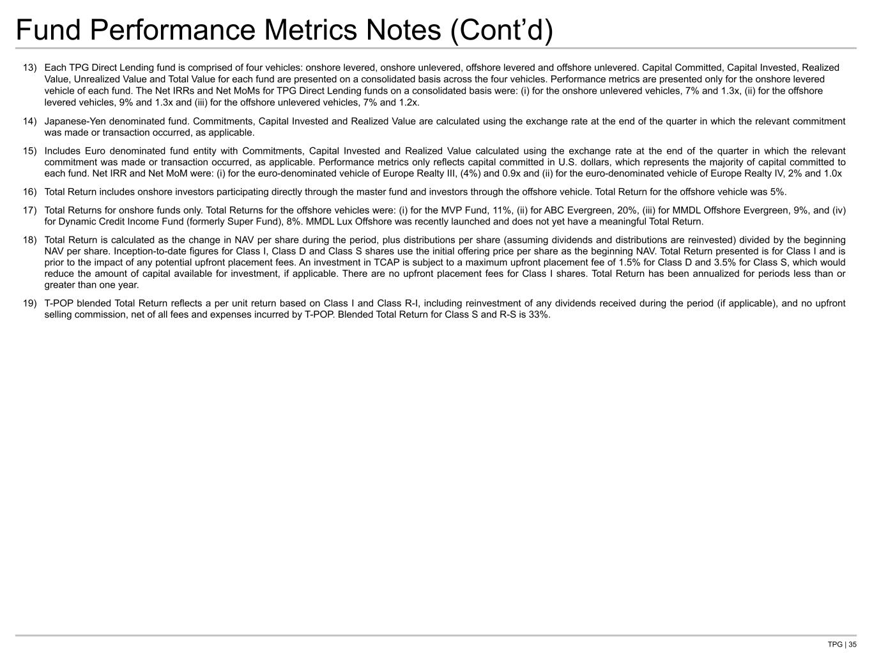
TPG | 35 Fund Performance Metrics Notes (Cont’d) 13) Each TPG Direct Lending fund is comprised of four vehicles: onshore levered, onshore unlevered, offshore levered and offshore unlevered. Capital Committed, Capital Invested, Realized Value, Unrealized Value and Total Value for each fund are presented on a consolidated basis across the four vehicles. Performance metrics are presented only for the onshore levered vehicle of each fund. The Net IRRs and Net MoMs for TPG Direct Lending funds on a consolidated basis were: (i) for the onshore unlevered vehicles, 7% and 1.3x, (ii) for the offshore levered vehicles, 9% and 1.3x and (iii) for the offshore unlevered vehicles, 7% and 1.2x. 14) Japanese-Yen denominated fund. Commitments, Capital Invested and Realized Value are calculated using the exchange rate at the end of the quarter in which the relevant commitment was made or transaction occurred, as applicable. 15) Includes Euro denominated fund entity with Commitments, Capital Invested and Realized Value calculated using the exchange rate at the end of the quarter in which the relevant commitment was made or transaction occurred, as applicable. Performance metrics only reflects capital committed in U.S. dollars, which represents the majority of capital committed to each fund. Net IRR and Net MoM were: (i) for the euro-denominated vehicle of Europe Realty III, (4%) and 0.9x and (ii) for the euro-denominated vehicle of Europe Realty IV, 2% and 1.0x 16) Total Return includes onshore investors participating directly through the master fund and investors through the offshore vehicle. Total Return for the offshore vehicle was 5%. 17) Total Returns for onshore funds only. Total Returns for the offshore vehicles were: (i) for the MVP Fund, 11%, (ii) for ABC Evergreen, 20%, (iii) for MMDL Offshore Evergreen, 9%, and (iv) for Dynamic Credit Income Fund (formerly Super Fund), 8%. MMDL Lux Offshore was recently launched and does not yet have a meaningful Total Return. 18) Total Return is calculated as the change in NAV per share during the period, plus distributions per share (assuming dividends and distributions are reinvested) divided by the beginning NAV per share. Inception-to-date figures for Class I, Class D and Class S shares use the initial offering price per share as the beginning NAV. Total Return presented is for Class I and is prior to the impact of any potential upfront placement fees. An investment in TCAP is subject to a maximum upfront placement fee of 1.5% for Class D and 3.5% for Class S, which would reduce the amount of capital available for investment, if applicable. There are no upfront placement fees for Class I shares. Total Return has been annualized for periods less than or greater than one year. 19) T-POP blended Total Return reflects a per unit return based on Class I and Class R-I, including reinvestment of any dividends received during the period (if applicable), and no upfront selling commission, net of all fees and expenses incurred by T-POP. Blended Total Return for Class S and R-S is 33%.

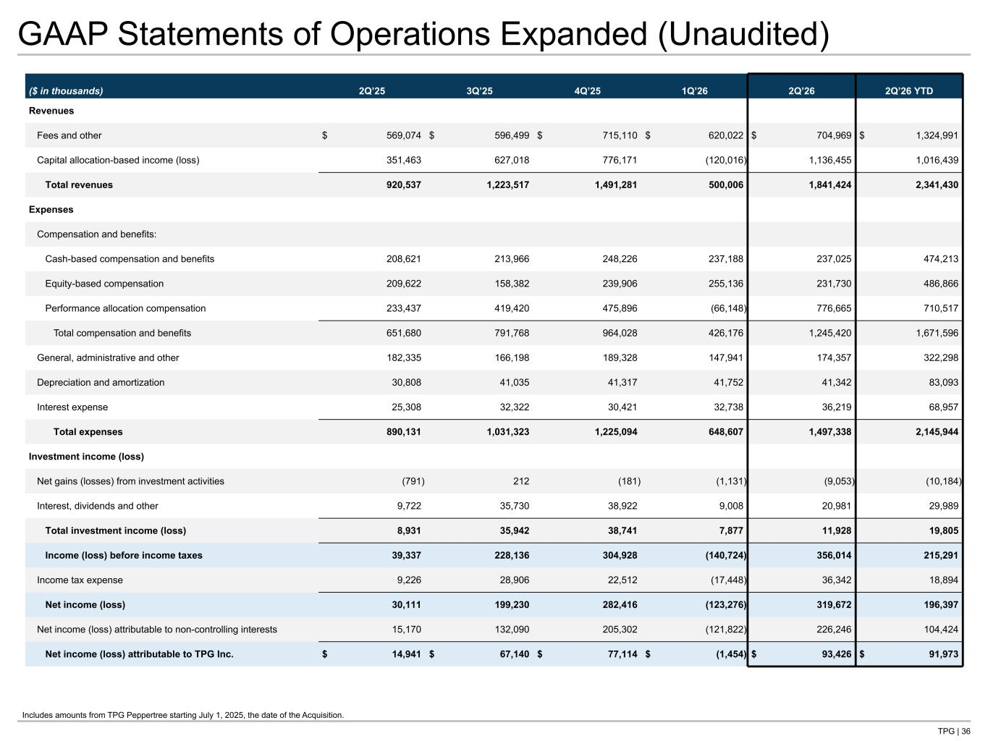
TPG | 36 GAAP Statements of Operations Expanded (Unaudited) ($ in thousands) 2Q’25 3Q’25 4Q’25 1Q’26 2Q’26 2Q’26 YTD Revenues Fees and other $ 569,074 $ 596,499 $ 715,110 $ 620,022 $ 704,969 $ 1,324,991 Capital allocation-based income (loss) 351,463 627,018 776,171 (120,016) 1,136,455 1,016,439 Total revenues 920,537 1,223,517 1,491,281 500,006 1,841,424 2,341,430 Expenses Compensation and benefits: Cash-based compensation and benefits 208,621 213,966 248,226 237,188 237,025 474,213 Equity-based compensation 209,622 158,382 239,906 255,136 231,730 486,866 Performance allocation compensation 233,437 419,420 475,896 (66,148) 776,665 710,517 Total compensation and benefits 651,680 791,768 964,028 426,176 1,245,420 1,671,596 General, administrative and other 182,335 166,198 189,328 147,941 174,357 322,298 Depreciation and amortization 30,808 41,035 41,317 41,752 41,342 83,093 Interest expense 25,308 32,322 30,421 32,738 36,219 68,957 Total expenses 890,131 1,031,323 1,225,094 648,607 1,497,338 2,145,944 Investment income (loss) Net gains (losses) from investment activities (791) 212 (181) (1,131) (9,053) (10,184) Interest, dividends and other 9,722 35,730 38,922 9,008 20,981 29,989 Total investment income (loss) 8,931 35,942 38,741 7,877 11,928 19,805 Income (loss) before income taxes 39,337 228,136 304,928 (140,724) 356,014 215,291 Income tax expense 9,226 28,906 22,512 (17,448) 36,342 18,894 Net income (loss) 30,111 199,230 282,416 (123,276) 319,672 196,397 Net income (loss) attributable to non-controlling interests 15,170 132,090 205,302 (121,822) 226,246 104,424 Net income (loss) attributable to TPG Inc. $ 14,941 $ 67,140 $ 77,114 $ (1,454) $ 93,426 $ 91,973 Tie to: -G P&L at front of deck -G-NG recon Make sure labels match Q and reflect any updates, many lines no longer linked to keep “gains (losses)” consistent Includes amounts from TPG Peppertree starting July 1, 2025, the date of the Acquisition.

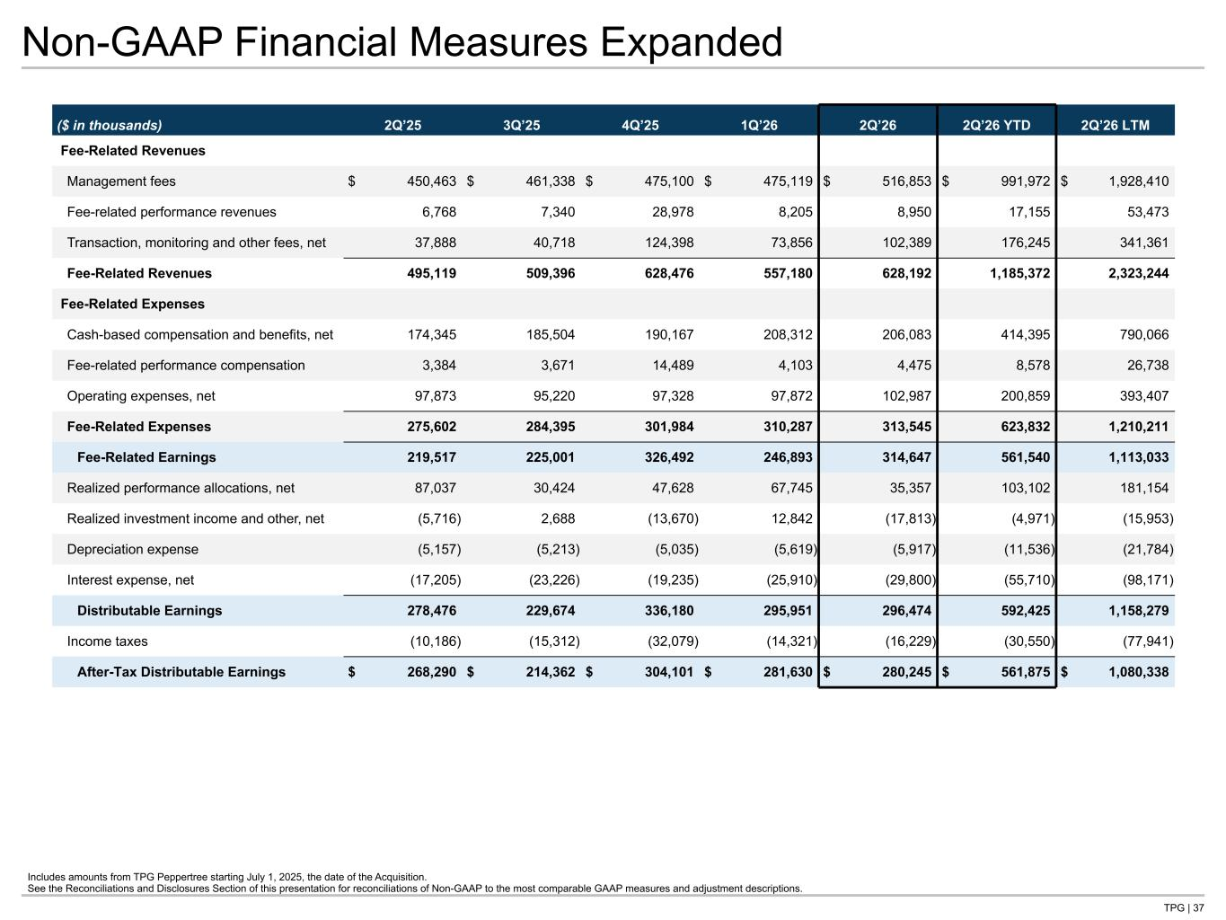
TPG | 37 Non-GAAP Financial Measures Expanded Includes amounts from TPG Peppertree starting July 1, 2025, the date of the Acquisition. See the Reconciliations and Disclosures Section of this presentation for reconciliations of Non-GAAP to the most comparable GAAP measures and adjustment descriptions. ($ in thousands) 2Q’25 3Q’25 4Q’25 1Q’26 2Q’26 2Q’26 YTD 2Q’26 LTM Fee-Related Revenues Management fees $ 450,463 $ 461,338 $ 475,100 $ 475,119 $ 516,853 $ 991,972 $ 1,928,410 Fee-related performance revenues 6,768 7,340 28,978 8,205 8,950 17,155 53,473 Transaction, monitoring and other fees, net 37,888 40,718 124,398 73,856 102,389 176,245 341,361 Fee-Related Revenues 495,119 509,396 628,476 557,180 628,192 1,185,372 2,323,244 Fee-Related Expenses Cash-based compensation and benefits, net 174,345 185,504 190,167 208,312 206,083 414,395 790,066 Fee-related performance compensation 3,384 3,671 14,489 4,103 4,475 8,578 26,738 Operating expenses, net 97,873 95,220 97,328 97,872 102,987 200,859 393,407 Fee-Related Expenses 275,602 284,395 301,984 310,287 313,545 623,832 1,210,211 Fee-Related Earnings 219,517 225,001 326,492 246,893 314,647 561,540 1,113,033 Realized performance allocations, net 87,037 30,424 47,628 67,745 35,357 103,102 181,154 Realized investment income and other, net (5,716) 2,688 (13,670) 12,842 (17,813) (4,971) (15,953) Depreciation expense (5,157) (5,213) (5,035) (5,619) (5,917) (11,536) (21,784) Interest expense, net (17,205) (23,226) (19,235) (25,910) (29,800) (55,710) (98,171) Distributable Earnings 278,476 229,674 336,180 295,951 296,474 592,425 1,158,279 Income taxes (10,186) (15,312) (32,079) (14,321) (16,229) (30,550) (77,941) After-Tax Distributable Earnings $ 268,290 $ 214,362 $ 304,101 $ 281,630 $ 280,245 $ 561,875 $ 1,080,338 Tie to: -NG P&L at front -G-NG qtrly in recon section


Reconciliations and Disclosures

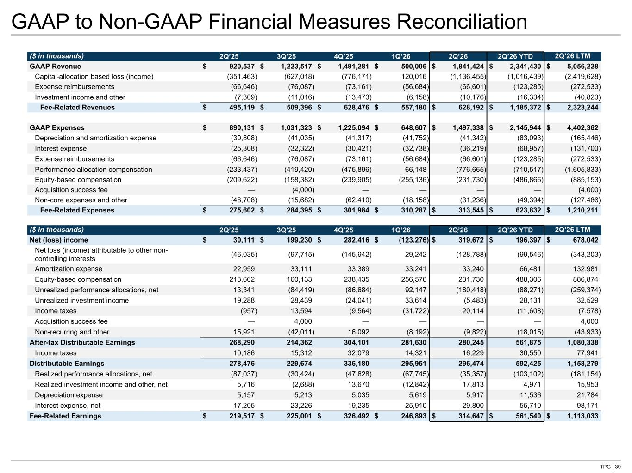
TPG | 39 GAAP to Non-GAAP Financial Measures Reconciliation ($ in thousands) 2Q’25 3Q’25 4Q’25 1Q’26 2Q’26 2Q’26 YTD 2Q’26 LTM GAAP Revenue $ 920,537 $ 1,223,517 $ 1,491,281 $ 500,006 $ 1,841,424 $ 2,341,430 $ 5,056,228 Capital-allocation based loss (income) (351,463) (627,018) (776,171) 120,016 (1,136,455) (1,016,439) (2,419,628) Expense reimbursements (66,646) (76,087) (73,161) (56,684) (66,601) (123,285) (272,533) Investment income and other (7,309) (11,016) (13,473) (6,158) (10,176) (16,334) (40,823) Fee-Related Revenues $ 495,119 $ 509,396 $ 628,476 $ 557,180 $ 628,192 $ 1,185,372 $ 2,323,244 GAAP Expenses $ 890,131 $ 1,031,323 $ 1,225,094 $ 648,607 $ 1,497,338 $ 2,145,944 $ 4,402,362 Depreciation and amortization expense (30,808) (41,035) (41,317) (41,752) (41,342) (83,093) (165,446) Interest expense (25,308) (32,322) (30,421) (32,738) (36,219) (68,957) (131,700) Expense reimbursements (66,646) (76,087) (73,161) (56,684) (66,601) (123,285) (272,533) Performance allocation compensation (233,437) (419,420) (475,896) 66,148 (776,665) (710,517) (1,605,833) Equity-based compensation (209,622) (158,382) (239,905) (255,136) (231,730) (486,866) (885,153) Acquisition success fee — (4,000) — — — — (4,000) Non-core expenses and other (48,708) (15,682) (62,410) (18,158) (31,236) (49,394) (127,486) Fee-Related Expenses $ 275,602 $ 284,395 $ 301,984 $ 310,287 $ 313,545 $ 623,832 $ 1,210,211 ($ in thousands) 2Q’25 3Q’25 4Q’25 1Q’26 2Q’26 2Q’26 YTD 2Q’26 LTM Net (loss) income $ 30,111 $ 199,230 $ 282,416 $ (123,276) $ 319,672 $ 196,397 $ 678,042 Net loss (income) attributable to other non- controlling interests (46,035) (97,715) (145,942) 29,242 (128,788) (99,546) (343,203) Amortization expense 22,959 33,111 33,389 33,241 33,240 66,481 132,981 Equity-based compensation 213,662 160,133 238,435 256,576 231,730 488,306 886,874 Unrealized performance allocations, net 13,341 (84,419) (86,684) 92,147 (180,418) (88,271) (259,374) Unrealized investment income 19,288 28,439 (24,041) 33,614 (5,483) 28,131 32,529 Income taxes (957) 13,594 (9,564) (31,722) 20,114 (11,608) (7,578) Acquisition success fee — 4,000 — — — — 4,000 Non-recurring and other 15,921 (42,011) 16,092 (8,192) (9,822) (18,015) (43,933) After-tax Distributable Earnings 268,290 214,362 304,101 281,630 280,245 561,875 1,080,338 Income taxes 10,186 15,312 32,079 14,321 16,229 30,550 77,941 Distributable Earnings 278,476 229,674 336,180 295,951 296,474 592,425 1,158,279 Realized performance allocations, net (87,037) (30,424) (47,628) (67,745) (35,357) (103,102) (181,154) Realized investment income and other, net 5,716 (2,688) 13,670 (12,842) 17,813 4,971 15,953 Depreciation expense 5,157 5,213 5,035 5,619 5,917 11,536 21,784 Interest expense, net 17,205 23,226 19,235 25,910 29,800 55,710 98,171 Fee-Related Earnings $ 219,517 $ 225,001 $ 326,492 $ 246,893 $ 314,647 $ 561,540 $ 1,113,033 Tie to: -NG P&L at front -NG qtrly P&L -G P&L at front -G qtrly P&L

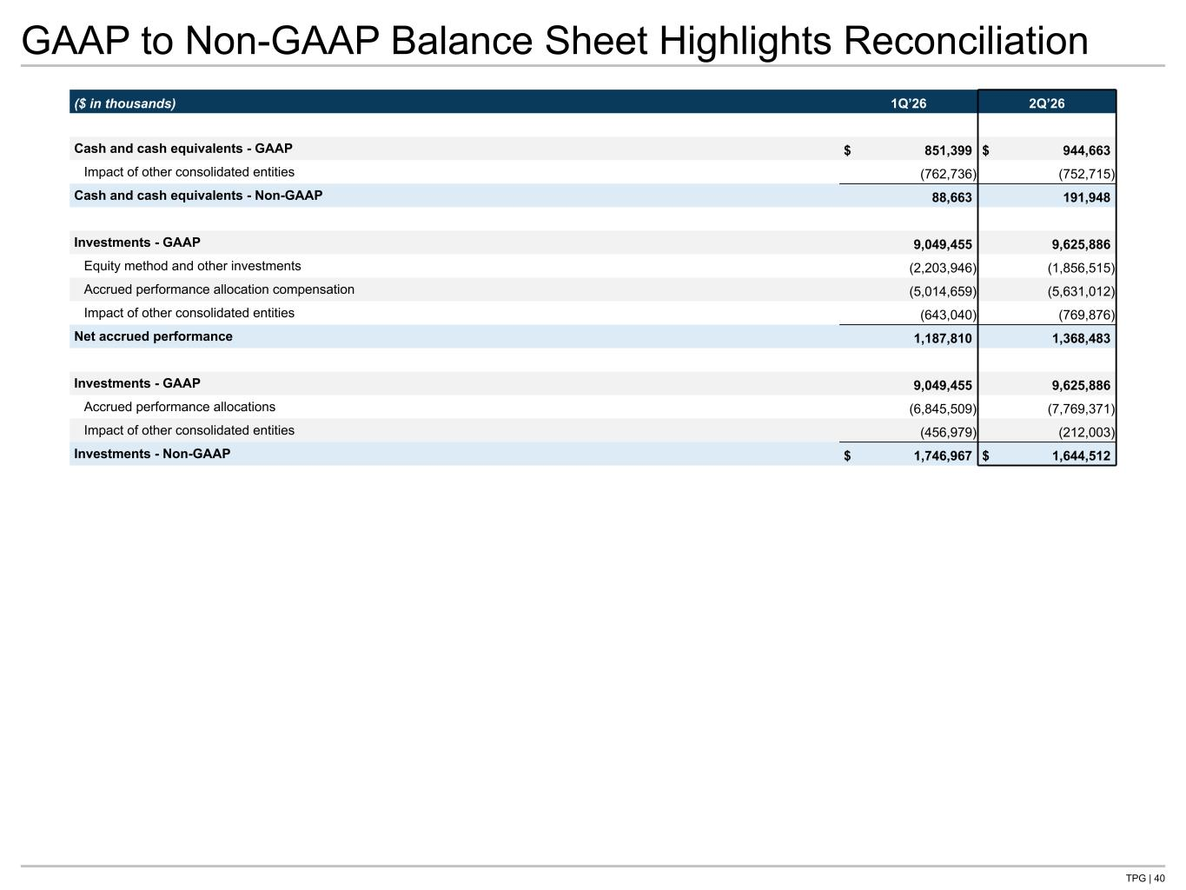
TPG | 40 GAAP to Non-GAAP Balance Sheet Highlights Reconciliation ($ in thousands) 1Q’26 2Q’26 Cash and cash equivalents - GAAP $ 851,399 $ 944,663 Impact of other consolidated entities (762,736) (752,715) Cash and cash equivalents - Non-GAAP 88,663 191,948 Investments - GAAP 9,049,455 9,625,886 Equity method and other investments (2,203,946) (1,856,515) Accrued performance allocation compensation (5,014,659) (5,631,012) Impact of other consolidated entities (643,040) (769,876) Net accrued performance 1,187,810 1,368,483 Investments - GAAP 9,049,455 9,625,886 Accrued performance allocations (6,845,509) (7,769,371) Impact of other consolidated entities (456,979) (212,003) Investments - Non-GAAP $ 1,746,967 $ 1,644,512 Tie to: -G B/S page -NG B/S page

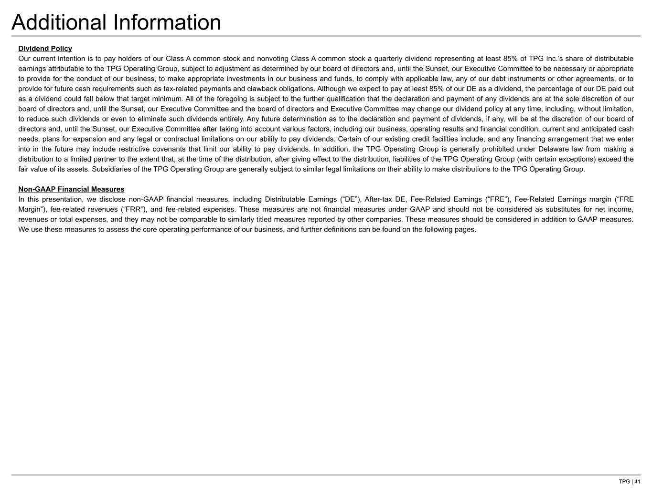
TPG | 41 Additional Information Dividend Policy Our current intention is to pay holders of our Class A common stock and nonvoting Class A common stock a quarterly dividend representing at least 85% of TPG Inc.’s share of distributable earnings attributable to the TPG Operating Group, subject to adjustment as determined by our board of directors and, until the Sunset, our Executive Committee to be necessary or appropriate to provide for the conduct of our business, to make appropriate investments in our business and funds, to comply with applicable law, any of our debt instruments or other agreements, or to provide for future cash requirements such as tax-related payments and clawback obligations. Although we expect to pay at least 85% of our DE as a dividend, the percentage of our DE paid out as a dividend could fall below that target minimum. All of the foregoing is subject to the further qualification that the declaration and payment of any dividends are at the sole discretion of our board of directors and, until the Sunset, our Executive Committee and the board of directors and Executive Committee may change our dividend policy at any time, including, without limitation, to reduce such dividends or even to eliminate such dividends entirely. Any future determination as to the declaration and payment of dividends, if any, will be at the discretion of our board of directors and, until the Sunset, our Executive Committee after taking into account various factors, including our business, operating results and financial condition, current and anticipated cash needs, plans for expansion and any legal or contractual limitations on our ability to pay dividends. Certain of our existing credit facilities include, and any financing arrangement that we enter into in the future may include restrictive covenants that limit our ability to pay dividends. In addition, the TPG Operating Group is generally prohibited under Delaware law from making a distribution to a limited partner to the extent that, at the time of the distribution, after giving effect to the distribution, liabilities of the TPG Operating Group (with certain exceptions) exceed the fair value of its assets. Subsidiaries of the TPG Operating Group are generally subject to similar legal limitations on their ability to make distributions to the TPG Operating Group. Non-GAAP Financial Measures In this presentation, we disclose non-GAAP financial measures, including Distributable Earnings (“DE”), After-tax DE, Fee-Related Earnings (“FRE”), Fee-Related Earnings margin (“FRE Margin”), fee-related revenues (“FRR”), and fee-related expenses. These measures are not financial measures under GAAP and should not be considered as substitutes for net income, revenues or total expenses, and they may not be comparable to similarly titled measures reported by other companies. These measures should be considered in addition to GAAP measures. We use these measures to assess the core operating performance of our business, and further definitions can be found on the following pages.

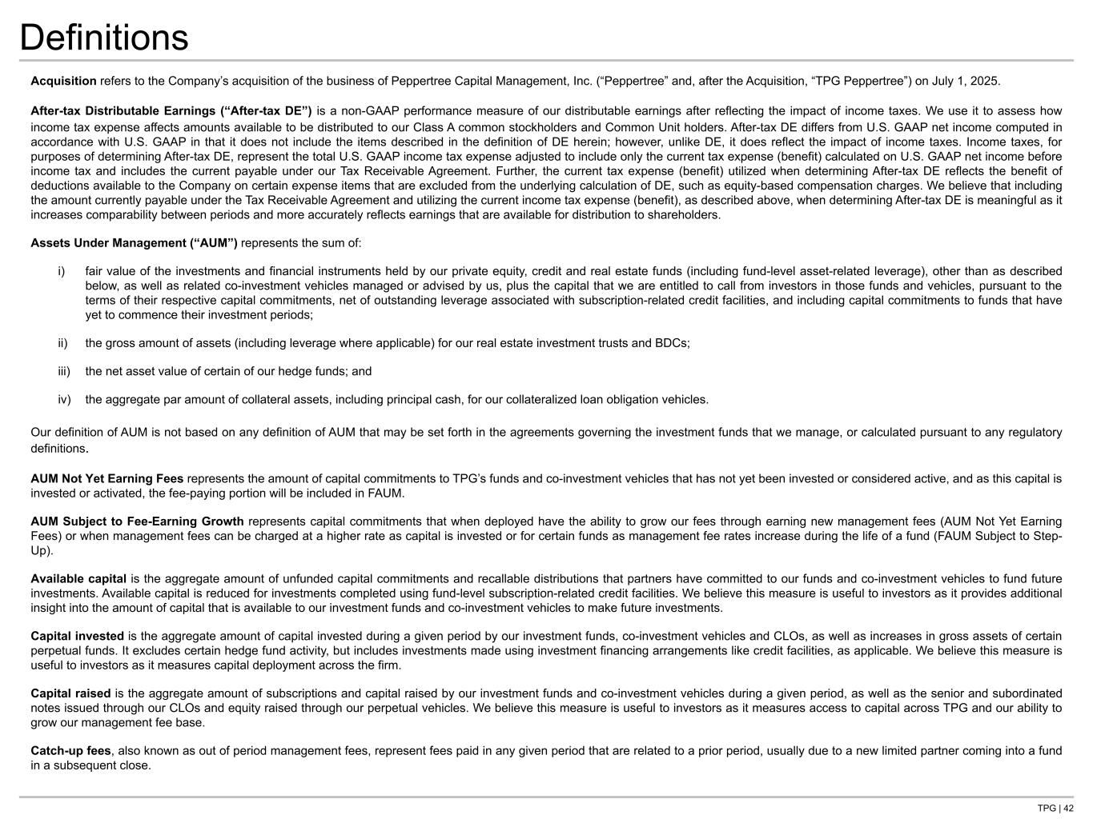
TPG | 42 Definitions Acquisition refers to the Company’s acquisition of the business of Peppertree Capital Management, Inc. (“Peppertree” and, after the Acquisition, “TPG Peppertree”) on July 1, 2025. After-tax Distributable Earnings (“After-tax DE”) is a non-GAAP performance measure of our distributable earnings after reflecting the impact of income taxes. We use it to assess how income tax expense affects amounts available to be distributed to our Class A common stockholders and Common Unit holders. After-tax DE differs from U.S. GAAP net income computed in accordance with U.S. GAAP in that it does not include the items described in the definition of DE herein; however, unlike DE, it does reflect the impact of income taxes. Income taxes, for purposes of determining After-tax DE, represent the total U.S. GAAP income tax expense adjusted to include only the current tax expense (benefit) calculated on U.S. GAAP net income before income tax and includes the current payable under our Tax Receivable Agreement. Further, the current tax expense (benefit) utilized when determining After-tax DE reflects the benefit of deductions available to the Company on certain expense items that are excluded from the underlying calculation of DE, such as equity-based compensation charges. We believe that including the amount currently payable under the Tax Receivable Agreement and utilizing the current income tax expense (benefit), as described above, when determining After-tax DE is meaningful as it increases comparability between periods and more accurately reflects earnings that are available for distribution to shareholders. Assets Under Management (“AUM”) represents the sum of: i) fair value of the investments and financial instruments held by our private equity, credit and real estate funds (including fund-level asset-related leverage), other than as described below, as well as related co-investment vehicles managed or advised by us, plus the capital that we are entitled to call from investors in those funds and vehicles, pursuant to the terms of their respective capital commitments, net of outstanding leverage associated with subscription-related credit facilities, and including capital commitments to funds that have yet to commence their investment periods; ii) the gross amount of assets (including leverage where applicable) for our real estate investment trusts and BDCs; iii) the net asset value of certain of our hedge funds; and iv) the aggregate par amount of collateral assets, including principal cash, for our collateralized loan obligation vehicles. Our definition of AUM is not based on any definition of AUM that may be set forth in the agreements governing the investment funds that we manage, or calculated pursuant to any regulatory definitions. AUM Not Yet Earning Fees represents the amount of capital commitments to TPG’s funds and co-investment vehicles that has not yet been invested or considered active, and as this capital is invested or activated, the fee-paying portion will be included in FAUM. AUM Subject to Fee-Earning Growth represents capital commitments that when deployed have the ability to grow our fees through earning new management fees (AUM Not Yet Earning Fees) or when management fees can be charged at a higher rate as capital is invested or for certain funds as management fee rates increase during the life of a fund (FAUM Subject to Step- Up). Available capital is the aggregate amount of unfunded capital commitments and recallable distributions that partners have committed to our funds and co-investment vehicles to fund future investments. Available capital is reduced for investments completed using fund-level subscription-related credit facilities. We believe this measure is useful to investors as it provides additional insight into the amount of capital that is available to our investment funds and co-investment vehicles to make future investments. Capital invested is the aggregate amount of capital invested during a given period by our investment funds, co-investment vehicles and CLOs, as well as increases in gross assets of certain perpetual funds. It excludes certain hedge fund activity, but includes investments made using investment financing arrangements like credit facilities, as applicable. We believe this measure is useful to investors as it measures capital deployment across the firm. Capital raised is the aggregate amount of subscriptions and capital raised by our investment funds and co-investment vehicles during a given period, as well as the senior and subordinated notes issued through our CLOs and equity raised through our perpetual vehicles. We believe this measure is useful to investors as it measures access to capital across TPG and our ability to grow our management fee base. Catch-up fees, also known as out of period management fees, represent fees paid in any given period that are related to a prior period, usually due to a new limited partner coming into a fund in a subsequent close.

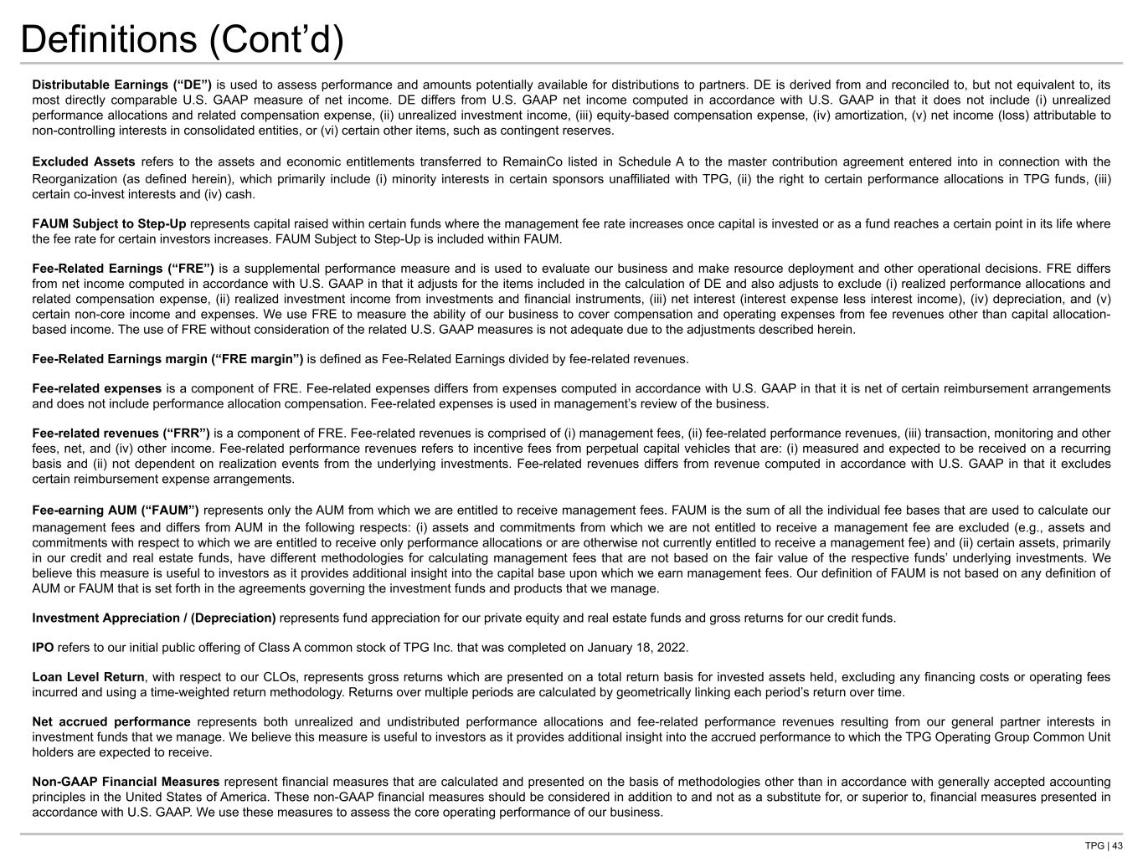
TPG | 43 Definitions (Cont’d) Distributable Earnings (“DE”) is used to assess performance and amounts potentially available for distributions to partners. DE is derived from and reconciled to, but not equivalent to, its most directly comparable U.S. GAAP measure of net income. DE differs from U.S. GAAP net income computed in accordance with U.S. GAAP in that it does not include (i) unrealized performance allocations and related compensation expense, (ii) unrealized investment income, (iii) equity-based compensation expense, (iv) amortization, (v) net income (loss) attributable to non-controlling interests in consolidated entities, or (vi) certain other items, such as contingent reserves. Excluded Assets refers to the assets and economic entitlements transferred to RemainCo listed in Schedule A to the master contribution agreement entered into in connection with the Reorganization (as defined herein), which primarily include (i) minority interests in certain sponsors unaffiliated with TPG, (ii) the right to certain performance allocations in TPG funds, (iii) certain co-invest interests and (iv) cash. FAUM Subject to Step-Up represents capital raised within certain funds where the management fee rate increases once capital is invested or as a fund reaches a certain point in its life where the fee rate for certain investors increases. FAUM Subject to Step-Up is included within FAUM. Fee-Related Earnings (“FRE”) is a supplemental performance measure and is used to evaluate our business and make resource deployment and other operational decisions. FRE differs from net income computed in accordance with U.S. GAAP in that it adjusts for the items included in the calculation of DE and also adjusts to exclude (i) realized performance allocations and related compensation expense, (ii) realized investment income from investments and financial instruments, (iii) net interest (interest expense less interest income), (iv) depreciation, and (v) certain non-core income and expenses. We use FRE to measure the ability of our business to cover compensation and operating expenses from fee revenues other than capital allocation- based income. The use of FRE without consideration of the related U.S. GAAP measures is not adequate due to the adjustments described herein. Fee-Related Earnings margin (“FRE margin”) is defined as Fee-Related Earnings divided by fee-related revenues. Fee-related expenses is a component of FRE. Fee-related expenses differs from expenses computed in accordance with U.S. GAAP in that it is net of certain reimbursement arrangements and does not include performance allocation compensation. Fee-related expenses is used in management’s review of the business. Fee-related revenues (“FRR”) is a component of FRE. Fee-related revenues is comprised of (i) management fees, (ii) fee-related performance revenues, (iii) transaction, monitoring and other fees, net, and (iv) other income. Fee-related performance revenues refers to incentive fees from perpetual capital vehicles that are: (i) measured and expected to be received on a recurring basis and (ii) not dependent on realization events from the underlying investments. Fee-related revenues differs from revenue computed in accordance with U.S. GAAP in that it excludes certain reimbursement expense arrangements. Fee-earning AUM (“FAUM”) represents only the AUM from which we are entitled to receive management fees. FAUM is the sum of all the individual fee bases that are used to calculate our management fees and differs from AUM in the following respects: (i) assets and commitments from which we are not entitled to receive a management fee are excluded (e.g., assets and commitments with respect to which we are entitled to receive only performance allocations or are otherwise not currently entitled to receive a management fee) and (ii) certain assets, primarily in our credit and real estate funds, have different methodologies for calculating management fees that are not based on the fair value of the respective funds’ underlying investments. We believe this measure is useful to investors as it provides additional insight into the capital base upon which we earn management fees. Our definition of FAUM is not based on any definition of AUM or FAUM that is set forth in the agreements governing the investment funds and products that we manage. Investment Appreciation / (Depreciation) represents fund appreciation for our private equity and real estate funds and gross returns for our credit funds. IPO refers to our initial public offering of Class A common stock of TPG Inc. that was completed on January 18, 2022. Loan Level Return, with respect to our CLOs, represents gross returns which are presented on a total return basis for invested assets held, excluding any financing costs or operating fees incurred and using a time-weighted return methodology. Returns over multiple periods are calculated by geometrically linking each period’s return over time. Net accrued performance represents both unrealized and undistributed performance allocations and fee-related performance revenues resulting from our general partner interests in investment funds that we manage. We believe this measure is useful to investors as it provides additional insight into the accrued performance to which the TPG Operating Group Common Unit holders are expected to receive. Non-GAAP Financial Measures represent financial measures that are calculated and presented on the basis of methodologies other than in accordance with generally accepted accounting principles in the United States of America. These non-GAAP financial measures should be considered in addition to and not as a substitute for, or superior to, financial measures presented in accordance with U.S. GAAP. We use these measures to assess the core operating performance of our business.

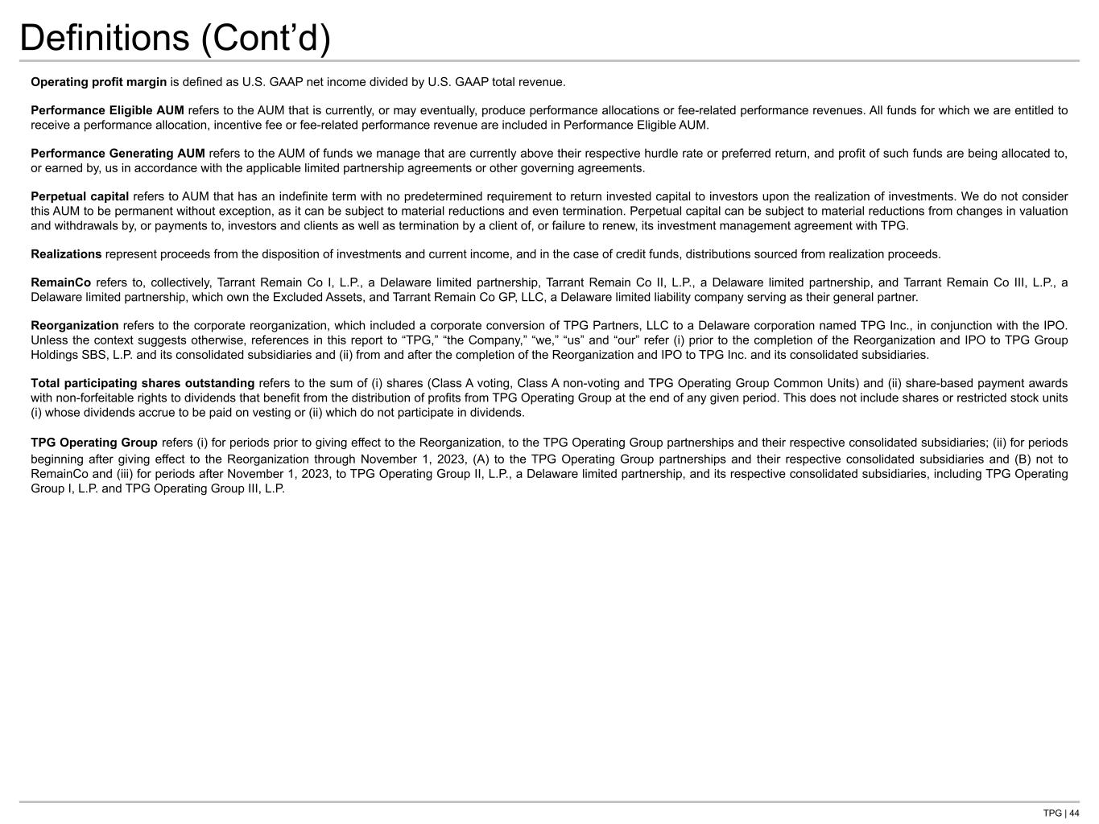
TPG | 44 Definitions (Cont’d) Operating profit margin is defined as U.S. GAAP net income divided by U.S. GAAP total revenue. Performance Eligible AUM refers to the AUM that is currently, or may eventually, produce performance allocations or fee-related performance revenues. All funds for which we are entitled to receive a performance allocation, incentive fee or fee-related performance revenue are included in Performance Eligible AUM. Performance Generating AUM refers to the AUM of funds we manage that are currently above their respective hurdle rate or preferred return, and profit of such funds are being allocated to, or earned by, us in accordance with the applicable limited partnership agreements or other governing agreements. Perpetual capital refers to AUM that has an indefinite term with no predetermined requirement to return invested capital to investors upon the realization of investments. We do not consider this AUM to be permanent without exception, as it can be subject to material reductions and even termination. Perpetual capital can be subject to material reductions from changes in valuation and withdrawals by, or payments to, investors and clients as well as termination by a client of, or failure to renew, its investment management agreement with TPG. Realizations represent proceeds from the disposition of investments and current income, and in the case of credit funds, distributions sourced from realization proceeds. RemainCo refers to, collectively, Tarrant Remain Co I, L.P., a Delaware limited partnership, Tarrant Remain Co II, L.P., a Delaware limited partnership, and Tarrant Remain Co III, L.P., a Delaware limited partnership, which own the Excluded Assets, and Tarrant Remain Co GP, LLC, a Delaware limited liability company serving as their general partner. Reorganization refers to the corporate reorganization, which included a corporate conversion of TPG Partners, LLC to a Delaware corporation named TPG Inc., in conjunction with the IPO. Unless the context suggests otherwise, references in this report to “TPG,” “the Company,” “we,” “us” and “our” refer (i) prior to the completion of the Reorganization and IPO to TPG Group Holdings SBS, L.P. and its consolidated subsidiaries and (ii) from and after the completion of the Reorganization and IPO to TPG Inc. and its consolidated subsidiaries. Total participating shares outstanding refers to the sum of (i) shares (Class A voting, Class A non-voting and TPG Operating Group Common Units) and (ii) share-based payment awards with non-forfeitable rights to dividends that benefit from the distribution of profits from TPG Operating Group at the end of any given period. This does not include shares or restricted stock units (i) whose dividends accrue to be paid on vesting or (ii) which do not participate in dividends. TPG Operating Group refers (i) for periods prior to giving effect to the Reorganization, to the TPG Operating Group partnerships and their respective consolidated subsidiaries; (ii) for periods beginning after giving effect to the Reorganization through November 1, 2023, (A) to the TPG Operating Group partnerships and their respective consolidated subsidiaries and (B) not to RemainCo and (iii) for periods after November 1, 2023, to TPG Operating Group II, L.P., a Delaware limited partnership, and its respective consolidated subsidiaries, including TPG Operating Group I, L.P. and TPG Operating Group III, L.P.

